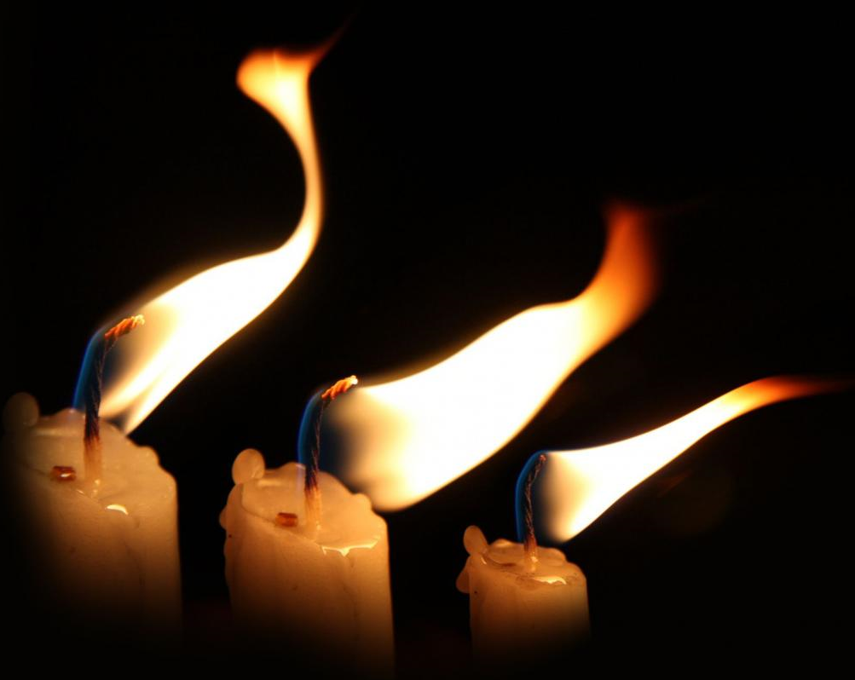

Tenebrae
Service of Light and Shadows

Resurrection Lutheran Church

740 West 10th Street, Juneau, Alaska 99801
Office: (907) 586-2380 rlcoffice@ak.net
Pastor: (907) 885-6824 (voice only) rlcpastor@ak.net
(808) 782-6653 (text and voice)

April 7, 2023 Good Friday: Service of Light and Shadows

prelude

Time to meditate and prepare for worship

Leader: Grace to you and peace from God our Father and the Lord Jesus Christ.
People: Amen
Leader: Blessed be the name of the Lord our God,
People: who redeems us from sin and death.
Leader: For us and for our salvation, Christ became obedient unto death,
even death on a cross.
People: Blessed be the name of the Lord.

Hymn: What Wondrous Love Is This?

Prayer of the Day
Lord Jesus, you carried our sins in your own body on the tree so that we might have life. May we and all who remember this day find new life in you now and in the world to come, where you live and reign with the Father and the Holy Spirit, now and forever.
Amen.

The Shadow of Anticipation
Reading Matthew 26:20-25

²⁰ When it was evening, he took his place with the twelve;²¹ and while they were eating, he said, “Truly I tell you, one of you will betray me.” ²² And they became greatly distressed and began to say to him one after another, “Surely not I, Lord?” ²³ He answered, “The one who has dipped his hand into the bowl with me will betray me. ²⁴ The Son of Man goes as it is written of him, but woe to that one by whom the Son of Man is betrayed! It would have been better for that one not to have been born.” ²⁵ Judas, who betrayed him, said, “Surely not I, Rabbi?” He replied, “You have said so.”

Let us pray, brothers and sisters, for those in distress.

Silent prayer

Almighty and eternal God, you give strength to the weary and new courage to those who have lost heart. Heal the sick, comfort the dying, give safety to travelers, free those unjustly deprived of liberty, and deliver your world from falsehood, hunger, and disease. Hear the prayers of all who call on you in any trouble, that they may have the joy of receiving your help in their need. We ask this through Christ our Lord.
Amen.

Two candles are extinguished

The Shadow of the Agony and Arrest
Reading Matthew 26:36-50

³⁶ Then Jesus went with them to a place called Gethsemane; and he said to his disciples, “Sit here while I go over there and pray.” ³⁷ He took with him Peter and the two sons of Zebedee and began to be grieved and agitated. ³⁸ Then he said to them, “I am deeply grieved, even to death; remain here, and stay awake with me.” ³⁹ And going a little farther, he threw himself on the ground and prayed, “My Father, if it is possible, let this cup pass from me; yet not what I want but what you want.” ⁴⁰ Then he came to the disciples and found them sleeping; and he said to Peter, “So, could you not stay awake with me one hour? ⁴¹ Stay awake and pray that you may not come into the time of trial;^{[a]} the spirit indeed is willing, but the flesh is weak.” ⁴² Again he went away for the second time and prayed, “My Father, if this cannot pass unless I drink it, your will be done.” ⁴³ Again he came and found them sleeping, for their eyes were heavy. ⁴⁴ So leaving them again, he went away and prayed for the third time, saying the same words. ⁴⁵ Then he came to the disciples and said to them, “Are you still sleeping and taking your rest? See, the hour is at hand, and the Son of Man is betrayed into the hands of sinners. ⁴⁶ Get up, let us be going. See, my betrayer is at hand.”
⁴⁷ While he was still speaking, Judas, one of the twelve, arrived; with him was a large crowd with swords and clubs, from the chief priests and the elders of the people. ⁴⁸ Now the betrayer had given them a sign, saying, “The one I will kiss is the man; arrest him.” ⁴⁹ At once he came up to Jesus and said, “Greetings, Rabbi!” and kissed him. ⁵⁰ Jesus said to him, “Friend, do what you are here to do.” Then they came and laid hands on Jesus and arrested him.
Let us pray, brothers and sisters, for our own weakness.

Silent prayer

Have mercy on me, O God, according to your steadfast love; according to your abundant mercy blot out my transgressions.

Wash me thoroughly from my iniquity, and cleanse me from my sin.

O Lord, open my lips, and my mouth will declare your praise.

For you have no delight in sacrifice; if I were to give a burnt offering,
you would not be pleased.

The sacrifice acceptable to God is a broken spirit; a broken and contrite heart,
O God, you will not despise.

Create in me a clean heart, O God, and put a new and right spirit within me.

Do not cast me away from your presence, and do not take your holy spirit from me.

Restore to me the joy of your salvation, and uphold me
with your free spirit.

We ask this through Christ our Lord. Amen.

Two candles are extinguished

The Shadow of Denial
Reading Matthew 26:69-75

⁶⁹ Now Peter was sitting outside in the courtyard. A servant-girl came to him and said, “You also were with Jesus the Galilean.” ⁷⁰ But he denied it before all of them, saying, “I do not know what you are talking about.” ⁷¹ When he went out to the porch, another servant-girl saw him, and she said to the bystanders, “This man was with Jesus of Nazareth.” ⁷² Again he denied it with an oath, “I do not know the man.” ⁷³ After a little while the bystanders came up and said to Peter, “Certainly you are also one of them, for your accent betrays you.” ⁷⁴ Then he began to curse, and he swore an oath, “I do not know the man!” At that moment the cock crowed. ⁷⁵ Then Peter remembered what Jesus had said: “Before the cock crows, you will deny me three times.” And he went out and wept bitterly.

Hymn: Ah, Holy Jesus

Two candles are extinguished

The Shadow of Accusation
Reading Matthew 27:11-14, 20-29

¹¹ Now Jesus stood before the governor; and the governor asked him, “Are you the King of the Jews?” Jesus said, “You say so.” ¹² But when he was accused by the chief priests and elders, he did not answer. ¹³ Then Pilate said to him, “Do you not hear how many accusations they make against you?” ¹⁴ But he gave him no answer, not even to a single charge, so that the governor was greatly amazed.

²⁰ Now the chief priests and the elders persuaded the crowds to ask for Barabbas and to have Jesus killed. ²¹ The governor again said to them, “Which of the two do you want me to release for you?” And they said, “Barabbas.” ²² Pilate said to them, “Then what should I do with Jesus who is called the Messiah?” All of them said, “Let him be crucified!” ²³ Then he asked, “Why, what evil has he done?” But they shouted all the more, “Let him be crucified!”

²⁴ So when Pilate saw that he could do nothing, but rather that a riot was beginning, he took some water and washed his hands before the crowd, saying, “I am innocent of this man’s blood; see to it yourselves.” ²⁵ Then the people as a whole answered, “His blood be on us and on our children!” ²⁶ So he released Barabbas for them; and after flogging Jesus, he handed him over to be crucified.

²⁷ Then the soldiers of the governor took Jesus into the governor’s headquarters, and they gathered the whole cohort around him. ²⁸ They stripped him and put a scarlet robe on him, ²⁹ and after twisting some thorns into a crown, they put it on his head. They put a reed in his right hand and knelt before him and mocked him, saying, “Hail, King of the Jews!”

Solemn Reproaches

O my people, O my church, what have I done to you?
How have I offended you? Answer me.

I led you out of slavery into freedom,
and delivered you through the waters of rebirth,
but you have prepared a cross for your Savior.

Response:
Holy God, holy and mighty, holy and immortal,
have mercy on us.

O my people, O my church, what more could I have done for you? Answer me.

Forty years I led you through the desert,
feeding you with manna on the way;
I saved you from the time of trial and gave you my body, the bread of heaven,
but you have prepared a cross for your Savior.

Response:
Holy God, holy and mighty, holy and immortal,
have mercy on us.

O my people, O my church, what more could I have done for you? Answer me.

I led you on your way in a pillar of cloud and fire,
but you led me to the judgment hall of Pilate;
I guided you by the light of the Holy Spirit,
but you have prepared a cross for your Savior.

Response:
Holy God, holy and mighty, holy and immortal,
have mercy on us.

O my people, O my church, what more could I have done for you? Answer me.

I planted you as my fairest vineyard, but you brought forth bitter fruit;
I made you branches of the vine and never left your side,
but you have prepared a cross for your Savior.

Response:
Holy God, holy and mighty, holy and immortal,
have mercy on us.

O my people, O my church, what more could I have done for you? Answer me.

I poured out saving water from the rock,
but you gave me vinegar to drink;
I poured out my life and gave you the new covenant in my blood,
but you have prepared a cross for you Savior.

Response:
Holy God, holy and mighty, holy and immortal,
have mercy on us.

Two candles are extinguished

The Shadow of Crucifixion and Humiliation
Reading Matthew 27:31-43

³¹ After mocking him, they stripped him of the robe and put his own clothes on him. Then they led him away to crucify him.³² As they went out, they came upon a man from Cyrene named Simon; they compelled this man to carry his cross. ³³ And when they came to a place called Golgotha (which means Place of a Skull), ³⁴ they offered him wine to drink, mixed with gall; but when he tasted it, he would not drink it. ³⁵ And when they had crucified him, they divided his clothes among themselves by casting lots; ³⁶ then they sat down there and kept watch over him. ³⁷ Over his head they put the charge against him, which read, “This is Jesus, the King of the Jews.” ³⁸ Then two bandits were crucified with him, one on his right and one on his left. ³⁹ Those who passed by derided^{[b]} him, shaking their heads ⁴⁰ and saying, “You who would destroy the temple and build it in three days, save yourself! If you are the Son of God, come down from the cross.” ⁴¹ In the same way the chief priests also, along with the scribes and elders, were mocking him, saying, ⁴² “He saved others; he cannot save himself.^{[c]} He is the King of Israel; let him come down from the cross now, and we will believe in him. ⁴³ He trusts in God; let God deliver him now, if he wants to; for he said, ‘I am God’s Son.’”

SOLEMN REPROACHES

O my people, O my church, what more could I have done for you? Answer me.

I gave you a royal scepter, but you gave me a crown of thorns;
I gave you the kingdom and crowned you with eternal life,
but you have prepared a cross for your Savior.

Response:
Holy God, holy and mighty, holy and immortal,
have mercy on us.

O my people, O my church, what more could I have done for You? Answer me.

I struck down your enemies, but you struck my head with a reed;
I gave you my peace, but you draw the sword in my name,
and you have prepared a cross for your Savior.

Response:
Holy God, holy and mighty, holy and immortal,
have mercy on us.

O my people, O my church, what more could I have done for You? Answer me.

I opened the waters to lead you to the promised land,
but you opened my side with a spear;
I washed your feet as a sign of my love,
but you have prepared a cross for you Savior.

Response:
Holy God, holy and mighty, holy and immortal,
have mercy on us.

O my people, O my church, what more could I have done for You? Answer me.

I lifted you up to the heights,
but you lifted me high on a cross;
I raised you from death and prepared for you the tree of life,
but you have prepared a cross for your Savior.

Response:
Holy God, holy and mighty, holy and immortal,
have mercy on us.

O my people, O my church, what more could I have done for You? Answer me.

I grafted you into my people Israel,
But you made them scapegoats for your own guilt,
and you have prepared a cross for your Savior.

Response:
Holy God, holy and mighty, holy and immortal,
have mercy on us.

O my people, O my church, what more could I have done for You? Answer me.

I came to you in the least of your brothers and sisters,
but I was hungry and you gave me no food,
thirsty and you gave me no drink,
a stranger and you did not welcome me,
naked and you did not clothe me,
sick and in prison and you did not visit me,
and you have prepared a cross for your Savior.

Response:
Holy God, holy and mighty, holy and immortal,
have mercy on us.

The Shadow of Death

Reading Matthew 27:45-54

⁴⁵ From noon on, darkness came over the whole land until three in the afternoon. ⁴⁶ And about three o’clock Jesus cried with a loud voice, “Eli, Eli, lema sabachthani?” that is, “My God, my God, why have you forsaken me?” ⁴⁷ When some of the bystanders heard it, they said, “This man is calling for Elijah.” ⁴⁸ At once one of them ran and got a sponge, filled it with sour wine, put it on a stick, and gave it to him to drink. ⁴⁹ But the others said, “Wait, let us see whether Elijah will come to save him.” ⁵⁰ Then Jesus cried again with a loud voice and breathed his last.
⁵¹ At that moment the curtain of the temple was torn in two, from top to bottom. The earth shook, and the rocks were split. ⁵² The tombs also were opened, and many bodies of the saints who had fallen asleep were raised. ⁵³ After his resurrection they came out of the tombs and entered the holy city and appeared to many. ⁵⁴ Now when the centurion and those with him, who were keeping watch over Jesus, saw the earthquake and what took place, they were terrified and said, “Truly this man was God’s Son!”

Two candles are extinguished

Hymn: O Sacred Head, Now Wounded (vv 1-3)

The Shadow of Burial

Reading Matthew 27:57-60

⁵⁷ When it was evening, there came a rich man from Arimathea, named Joseph, who was also a disciple of Jesus. ⁵⁸ He went to Pilate and asked for the body of Jesus; then Pilate ordered it to be given to him. ⁵⁹ So Joseph took the body and wrapped it in a clean linen cloth ⁶⁰ and laid it in his own new tomb, which he had hewn in the rock. He then rolled a great stone to the door of the tomb and went away.

Hymn: Were You There? (soloist vv 1-2; all v 3)

Two candles are extinguished

Silent meditation

We glory in your cross, O Lord, and we praise your holy resurrection,
for by your cross joy has come into the world.

May God be merciful and bless us;
may the light of God’s face shine upon us.
Let your way be known upon the earth,
your saving health among all nations.
We glory in your cross, O Lord, and we praise your holy resurrection, for by your cross joy has come into the world.

Let the peoples praise you, O God; let all the peoples praise you. May God give us blessing, and may all the ends of the earth stand in awe.

We glory in your cross, O Lord, and we praise your holy resurrection, for by your cross joy has come into the world.

The Christ Candle is restored

We adore you, O Christ, and we bless you.
By your holy cross you have redeemed the world.

Hymn: O Sacred Head, Now Wounded (v 4)

The Shadow of Hope

Be merciful to me, O God, be merciful,
for in you my soul takes refuge.
In the shadow of your wings I will take refuge,
until the destroying storms pass by.
I cry to the God Most High,
to God who is with me to the end.
God will send from heaven and save me.
God will send forth steadfast love and faithfulness. (from Psalm 57)

Two candles are extinguished

Dismissal
Leader: May Jesus Christ
who for our sakes became obedient unto death,
even death on a cross,
keep you and strengthen you.
People: Amen.

From sundaysandseasons.com. Copyright © 2019 Augsburg Fortress. All rights reserved. Used by permission.

