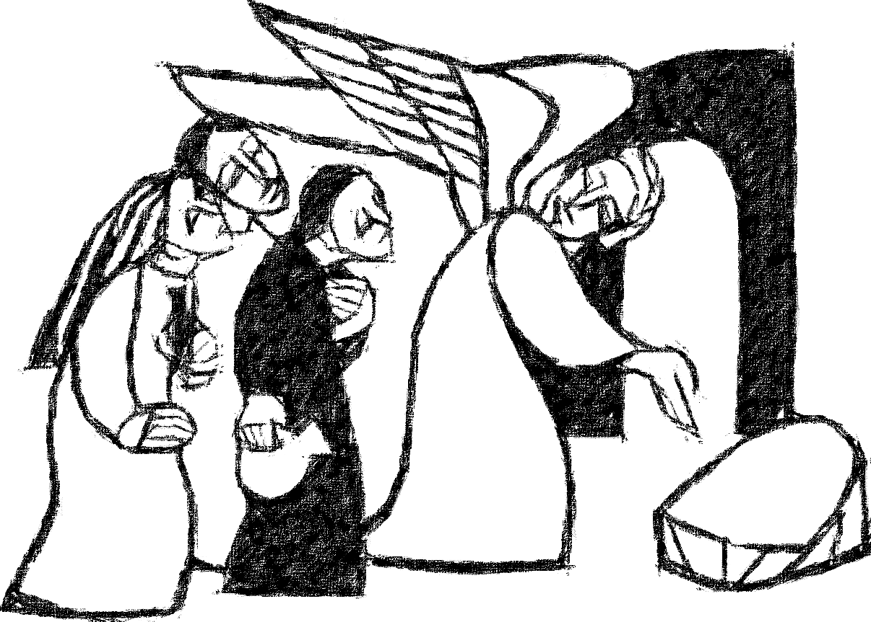

**Welcome to**

**Resurrection Lutheran Church**

740 West 10th Street, Juneau, Alaska 99801

Office: (907) 586-2380 [rlcoffice@ak.net](mailto:rlcoffice@ak.net)

Pastor: (907) 885-6824 (voice only) [rlcpastor@ak.net](mailto:rlcpastor@ak.net)

(808) 782-6653 (text and voice)

[www.rlcjuneau.org](http://www.rlcjuneau.org) [www.rlclive.org](http://www.rlclive.org)

**April 9, 2023 Easter Sunday, Resurrection of Our Lord/Lec A**

**Introduction to the day**

*This is the day the Lord has made! Christ is risen, and through him all creation is made new! Indeed, “God shows no partiality” (Acts 10:34): Christ’s resurrection truly brings life to everyone. We sing hymns of praise, gather around sacred words, and proclaim God’s faithfulness, power, and love in the feast of holy communion. With the women at the tomb, we are astonished, elated, and grateful. We depart with joy to proclaim the good news of God’s endless love.*

**Welcome and Announcements**

**Prelude**: **Now The Green Blade Rises** Celebration Ringers

**GATHERING**

The Holy Spirit calls us together as the people of God.

Alleluia! Christ is risen.

**Christ is risen indeed. Alleluia!**

Alleluia! Christ is risen.

**Christ is risen indeed. Alleluia!**

Alleluia! Christ is risen.

**Christ is risen indeed. Alleluia!**

### Thanksgiving for Baptism

Blessed be the holy Trinity, ☩ one God,

who is eager to forgive

and who loves us beyond our days.

**Amen.**

Blessed be the holy Trinity, ☩ one God,

by whose hand we are given new birth,

by whose speaking we are given new life.

**Amen.**

Joined to Christ in the waters of baptism,

we are welcomed, restored, and supported

as citizens of the new creation.

Let us give thanks for the gift of baptism.

Holy God,

holy and merciful,

holy and mighty,

you are the river of life,

you are the everlasting wellspring.

In mercy and might you have freed us from death

and raised us with Jesus, the firstborn of the dead.

In baptismal waters our old life is washed away,

and in them we are born anew.

*Water may be poured into the font as the presiding minister continues.*

Glory to you for oceans and lakes,

for rivers and streams.

Honor to you for waters that wash us clean,

quench our thirst, and nurture both crops and creatures.

Praise to you for the life-giving water of baptism,

the outpouring of the Spirit of the new creation.

**Wash away our sin and all that separates us from you.**

**Empower our witness to your resurrection.**

**Strengthen our resolve in seeking justice for all.**

Satisfy the world’s need through this living water.

Where drought dries the earth, bring refreshment.

Where despair prevails, grant hope.

Where chaos reigns, bring peace.

We ask this through Christ,

who with you and the Spirit reigns forever.

**Amen.**

**Gathering hymn: Jesus Christ is Ris’n Today**

**Gathering Song: Christ Is Risen! Alleluia!**



**Greeting**

The grace of our Lord Jesus Christ, the love of God,

and the communion of the Holy Spirit be with you all.

**And also with you.**

**Kyrie** *(Ghana)*





**Hymn of Praise** *(Great Britain)*

**Prayer of the Day**

The Lord be with you.

**And also with you.**

Let us pray.

O God, you gave your only Son to suffer death on the cross for our redemption, and by his glorious resurrection you delivered us from the power of death. Make us die every day to sin, that we may live with him forever in the joy of the resurrection, through your Son, Jesus Christ our Lord, who lives and reigns with you and the Holy Spirit, one God, now and forever.

**Amen.**

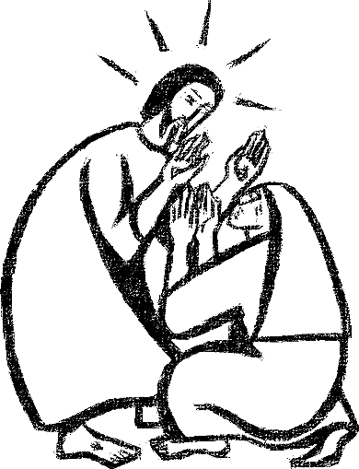

**WORD**

God speaks to us in scripture reading, preaching, and song.

**First Reading: Acts 10:34-43**

*Peter’s sermon, delivered at the home of Cornelius, a Roman army officer, is a summary of the essential message of Christianity: Everyone who believes in Jesus, whose life, death, and resurrection fulfilled the words of the prophets, “receives forgiveness of sins through his name.”*

A reading from Acts.

34Peter began to speak to [the people]: “I truly understand that God shows no partiality, 35but in every nation anyone who fears him and does what is right is acceptable to him. 36You know the message he sent to the people of Israel, preaching peace by Jesus Christ—he is Lord of all. 37That message spread throughout Judea, beginning in Galilee after the baptism that John announced: 38how God anointed Jesus of Nazareth with the Holy Spirit and with power; how he went about doing good and healing all who were oppressed by the devil, for God was with him. 39We are witnesses to all that he did both in Judea and in Jerusalem. They put him to death by hanging him on a tree; 40but God raised him on the third day and allowed him to appear, 41not to all the people but to us who were chosen by God as witnesses, and who ate and drank with him after he rose from the dead. 42He commanded us to preach to the people and to testify that he is the one ordained by God as judge of the living and the dead. 43All the prophets testify about him that everyone who believes in him receives forgiveness of sins through his name.”

The word of the Lord.

**Thanks be to God.**

**Psalm: Psalm 118:1-2, 14-24**

*On this day the LORD has acted; we will rejoice and be glad in it (Ps. 118:24*

1Give thanks to the Lord, for he is good;

  his mercy endures forever.

2**Let Israel now proclaim,**

**“His mercy endures forever.”**

14The Lord is my strength and my song,

  and he has become my salvation.

15**There is a sound of exultation and victory**

**in the tents of the righteous:**

16“The right hand of the Lord has triumphed!

  The right hand of the Lord is exalted!

The right hand of the Lord has triumphed!”

17**I shall not die, but live,**

**and declare the works of the Lord.** R

18The Lord has punished me sorely,

  but he did not hand me over to death.

19**Open for me the gates of righteousness;**

**I will enter them; I will offer thanks to the Lord.**

20“This is the gate of the Lord;

  he who is righteous may enter.”

21**I will give thanks to you, for you answered me**

**and have become my salvation.** R

22The same stone which the builders rejected

  has become the chief cornerstone.

23**This is the Lord’s doing,**

**and it is marvelous in our eyes.**

24On this day the Lord has acted;

  we will rejoice and be glad in it. R

SPECIAL MUSIC: Victory Celebration Ringers Ensemble

**Second Reading: Colossians 3:1-4**

*Easter means new life for us as it first meant new life for Christ. His resurrection reshapes the entire focus and motivation for our lives since we are now hidden with the risen Christ in God.*

A reading from Colossians.

1If you have been raised with Christ, seek the things that are above, where Christ is, seated at the right hand of God. 2Set your minds on things that are above, not on things that are on earth, 3for you have died, and your life is hidden with Christ in God. 4When Christ who is your life is revealed, then you also will be revealed with him in glory.

The word of the Lord.

**Thanks be to God.**

**Children’s’ Time** Amanda Beebe-Bay

**Gospel Acclamation** (*Caribbean)*



**Gospel: Matthew 28:1-15a**

*Sorrow gives way to “fear and great joy” when two women are sent by an angel to proclaim the good news: Jesus is risen!*

The Holy Gospel according to St. Matthew, the 28th chapter.

**Glory to you, O Lord.**

1After the sabbath, as the first day of the week was dawning, Mary Magdalene and the other Mary went to see the tomb. 2And suddenly there was a great earthquake; for an angel of the Lord, descending from heaven, came and rolled back the stone and sat on it. 3His appearance was like lightning, and his clothing white as snow. 4For fear of him the guards shook and became like dead men. 5But the angel said to the women, “Do not be afraid; I know that you are looking for Jesus who was crucified. 6He is not here; for he has been raised, as he said. Come, see the place where he lay. 7Then go quickly and tell his disciples, ‘He has been raised from the dead, and indeed he is going ahead of you to Galilee; there you will see him.’ This is my message for you.” 8So they left the tomb quickly with fear and great joy, and ran to tell his disciples. 9Suddenly Jesus met them and said, “Greetings!” And they came to him, took hold of his feet, and worshiped him. 10Then Jesus said to them, “Do not be afraid; go and tell my brothers to go to Galilee; there they will see me.”

11While they were going, some of the guard went into the city and told the chief priests everything that had happened. 12After the priests had assembled with the elders, they devised a plan to give a large sum of money to the soldiers, 13telling them, "You must say, 'His disciples came by night and stole him away while we were asleep.' 14If this comes to the governor's ears, we will satisfy him and keep you out of trouble." 15So they took the money and did as they were directed.

The Gospel of the Lord.

**Praise to you, O Christ.**

**sermon**  Rev. Karen Perkins

**Hymn of the Day: Now All The Vault Of Heaven Resounds**

**Nicene Creed**

**We believe in one God,**

**the Father, the Almighty,**

**maker of heaven and earth,**

**of all that is, seen and unseen.**

**We believe in one Lord, Jesus Christ,**

**the only Son of God,**

**eternally begotten of the Father,**

**God from God, Light from Light,**

**true God from true God,**

**begotten, not made,**

**of one Being with the Father.**

**Through him all things were made.**

**For us and for our salvation**

**he came down from heaven;**

**by the power of the Holy Spirit**

**he became incarnate from the virgin Mary,**

**and was made man.**

**For our sake he was crucified under Pontius Pilate;**

**he suffered death and was buried.**

**On the third day he rose again**

**in accordance with the Scriptures;**

**he ascended into heaven**

**and is seated at the right hand of the Father.**

**He will come again in glory to judge the living and the dead,**

**and his kingdom will have no end.**

**We believe in the Holy Spirit, the Lord, the giver of life,**

**who proceeds from the Father and the Son.**

**With the Father and the Son he is worshiped and glorified.**

**He has spoken through the prophets.**

**We believe in one holy catholic and apostolic Church.**

**We acknowledge one Baptism for the forgiveness of sins.**

**We look for the resurrection of the dead,**

**and the life of the world to come. Amen**

**Prayer Refrain: Abba, Abba, Hear Us** (*Korea*)





**The Prayers**

United in the hope and joy of the resurrection, let us pray for the church, the world, and all in need.

You call your church to witness to your salvation. We give thanks for Dietrich Bonhoeffer and all theologians, preachers, and teachers who proclaim your gospel. Equip all the baptized to share the joy of the resurrection in all we say and do. Risen Lord, in your mercy,

**hear our prayer.**

You bring abundant life throughout creation. The green blade rises, and all creation greets the resurrection dawn. Preserve vineyards and orchards and those who tend to them. Feed us with the fruits of creation. Risen Lord, in your mercy,

**hear our prayer.**

You show your steadfast love without regard to borders, barriers, or human-made divisions. Infuse your justice in every nation of the world. Israel, Lebanon, Palestine, Sudan, Ukraine, and here in the US, that all experience the peace that only you can give. Risen Lord, in your mercy,

**hear our prayer.**

You anointed your Son with the Holy Spirit and with power. Encourage us by his example in our ministries of healing, care, and outreach. We pray for all who are sick or hospitalized especially those in behavioral health units and hospice, and for all health care workers who care for them. Risen Lord, in your mercy,

**hear our prayer.**

You have put gladness in our hearts. Inspire musicians and dancers to rejoice with songs of victory. Bless the music ministry of this congregation and all who foster our assembly’s song. Risen Lord, in your mercy,

**hear our prayer.**

You have called Leaders into our midst. You faithfully guide Presiding Bishop Elizabeth Eaton, Alaska Synod Bishop Shelly Wickstrom, Bishop Tessa Moon Leiseth of our sister synod, and Pastor Karen Perkins. Bless our neighbors in the Alaska Southeast Cluster, and First Lutheran Church, Ketchikan. Risen Lord, in your mercy,

**hear our prayer.**

For what else do the people of God pray?

As you have raised Jesus from the dead, you show us your resurrection promise. With your holy ones who have sung your praise especially those we are still mourning here, free us from fear and empower us to go and tell the good news. Risen Lord, in your mercy,

**hear our prayer.**

Rejoicing in the victory of Christ’s resurrection, we lift our prayers and praise to you, almighty and eternal God; through Jesus Christ, our risen Lord.

**Amen.**

**Repeat Prayer Refrain** *(Korea)*

**Peace**

The peace of the Lord be with you always.

**And also with you.**

We greet each other with a gesture of peace. We are conscious there are different comfort levels around social-distancing at this time. A nod, wave, phone call or email may be most appropriate for you. This greeting is a sign of the risen Christ who unites us and calls us to recognize the peace of God in one another.

**MEAL**

God feeds us with the presence of Jesus Christ.

**Presentation of the Gifts** *(Nicaragua)*

**Offertory Prayer**

Gracious God,

in your great love you richly provide for our needs.

Make of these gifts a banquet of blessing,

and make us ready to share with all in need;

through Jesus Christ, who sets a table for all.

**Amen.**

**Dialogue**

The Lord be with you.

**And also with you.**

Lift up your hearts.

**We lift them to the Lord.**

Let us give thanks to the Lord our God.

**It is right to give our thanks and praise.**

**Preface**

It is indeed right and salutary that we should at all times and in all places offer thanks and praise to you, O Lord, holy Father, almighty and everliving God.

But chiefly we are bound to praise you for the glorious resurrection of our Lord; for he is the true Passover Lamb who gave himself to take away our sin, who by his death has destroyed death, and by his rising has brought us to eternal life.

And so, with Mary Magdalene and Peter and all the witnesses of the resurrection, with earth and sea and all their creatures, and with angels and archangels, cherubim and seraphim, we praise your name and join their unending hymn:

**Sanctus** *(Austria)*

**Great Thanksgiving**

We give you thanks, Father,

through Jesus Christ, your beloved Son,

whom you sent in this end of the ages

to save and redeem us and to proclaim to us your will.

He is your Word, inseparable from you,

through whom you created all things,

and in whom you take delight.

He is your Word, sent from heaven to a virgin’s womb.

He there took on our nature and our lot

and was shown forth as your Son,

born of the Holy Spirit and of the virgin Mary.

He, our Lord Jesus, fulfilled all your will

and won for you a holy people;

he stretched out his hands in suffering

in order to free from suffering those who trust you.

He is the one who, handed over to a death he freely accepted,

in order to destroy death, to break the bonds of the evil one,

to crush hell underfoot, to give light to the righteous,

to establish his covenant, and to show forth the resurrection,

taking bread and giving thanks to you, said:

Take and eat; this is my body, given for you.

Do this for the remembrance of me.

In the same way he took the cup, gave thanks,

and gave it for all to drink, saying:

This cup is the new covenant in my blood,

shed for you and for all people for the forgiveness of sin.

Do this for the remembrance of me.

Remembering, then, his death and resurrection,

we take this bread and cup,

giving you thanks that you have made us worthy

to stand before you and to serve you as your priestly people.

Send your Spirit upon these gifts of your church;

gather into one all who share this bread and wine;

fill us with your Holy Spirit to establish our faith in truth,

that we may praise and glorify you through your Son Jesus Christ;

through whom all glory and honor are yours, almighty Father,

with the Holy Spirit, in your holy church, both now and forever.

**Amen.**

**Lord’s Prayer**

Lord, remember us in your kingdom, and teach us to pray:

**Our Father, who art in heaven,**

**hallowed be thy name,**

**thy kingdom come,**

**thy will be done,**

**on earth as it is in heaven.**

**Give us this day our daily bread;**

**and forgive us our trespasses,**

**as we forgive those**

**who trespass against us;**

**and lead us not into temptation,**

**but deliver us from evil.**

**For thine is the kingdom,**

**and the power, and the glory,**

**forever and ever. Amen.**

**Communion Distribution**

All are welcome to the communion table! God is the host and God's love extends to all people. There **are** ways for you to participate whether or not you can be present at Resurrection.! We celebrate this holy meal as the community of peace, love and mercy.

* Pastor Karen can bring the Eucharist to you at home. Please contact the office or Pastor Karen to make arrangements.

We would be happy to light a candle in thankfulness, of concern, or in memory of a person at your request.

**Invitation to Communion**

In Christ’s presence there is fullness of joy.

Come to the banquet.

**Communion Song** *(America)*

**Communion**

The body of Christ, given for you. **Amen.**

The blood of Christ, shed for you. **Amen.**

**Communion Blessing**

The body and blood of our Lord Jesus Christ

strengthen you and keep you in God's grace.

**Amen.**

**Post-Communion Canticle** *(South Africa)*

**Prayer After Communion**

Gracious God,

in you we live and move and have our being.

With your word and this meal of grace,

you have nourished our life together.

Strengthen us to show your love

and serve the world in Jesus’ name.

**Amen.**

**SENDING**

God blesses us and sends us in mission to the world.

**Mission Statement**

**Let us announce together,**

**The mission of Resurrection Lutheran Church is to promote spiritual growth in Christ and service to all people.**

**Blessing**

The God of all,

who raised ☩ Jesus from the dead,

bless you by the power of the Holy Spirit

to live in the new creation.

**Amen.**

**Sending Song: Christ is Risen! Alleluia!**

**Dismissal**

Go in peace. Serve the Risen One.

**Thanks be to God.**

**Texts for Sunday, April 16, 2023**

**2nd Sunday of Easter/Lectionary A**

* Acts 2:14a, 22-32
* Psalm 16
* 1 Peter 1:3-9
* John 20:19-31

*From sundaysandseasons.com.*

*Copyright © 2023 Augsburg Fortress. All rights reserved.*