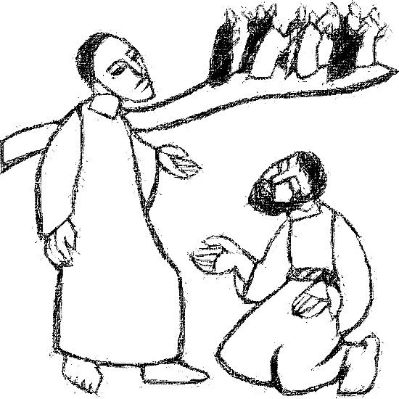

**Welcome to**

**Resurrection Lutheran Church**

740 West 10th Street, Juneau, Alaska 99801

Office: (907) 586-2380 [rlcoffice@ak.net](mailto:rlcoffice@ak.net)

Pastor: (907) 885-6824 (voice only) [rlcpastor@ak.net](mailto:rlcpastor@ak.net)

(808) 782-6653 (text and voice)

[www.rlcjuneau.org](http://www.rlcjuneau.org) [www.rlclive.org](http://www.rlclive.org)

**October 9, 2022 Eighteenth Sunday after Pentecost / Lec. 28C**

**INTRODUCTION TO THE DAY**

*It’s a miracle! Multiple miracles! The waters of holy baptism have healed us. The body and blood of Jesus in holy communion have made us clean. We have died with Christ and been raised with him. For all this we have returned to offer thanks. From this place we are sent on our way rejoicing to share the good news.*

**Welcome and Announcements**

**Prelude**

**GATHERING**

The Holy Spirit calls us together as the people of God.

**Brief Order for Confession and Forgiveness**

Blessed be the holy Trinity, ☩ one God,

who is eager to forgive

and who loves us beyond our days.

**Amen.**

Dear friends, together let us acknowledge

our failure to love this world as Jesus does.

God of mercy and forgiveness,

**we confess that sin still has a hold on us.**

**We have harmed your good creation.**

**We have failed to do justice,**

**love kindness,**

**and walk humbly with you.**

**Turn us in a new direction.**

**Show us the path that leads to life.**

**Be our refuge and strength on the journey,**

**through Jesus Christ, our redeemer and friend.**

**Amen.**

Beloved of God:

your sins are forgiven ☩ and you are made whole.

God points the way to new life in Christ,

who meets us on the road.

Journey now in God’s abiding love

through the power of the Holy Spirit.

**Amen.**

**Gathering Hymn: Praise, My Soul, the King of Heaven**



**Greeting**

The grace of our Lord Jesus Christ, the love of God,

and the communion of the Holy Spirit be with you all.

**And also with you.**

**Kyrie**

**Hymn of Praise**

**Prayer of the Day**

The Lord be with you.

**And also with you.**

Let us pray.

Almighty God, source of every blessing, your generous goodness comes to us anew every day. By the work of your Spirit lead us to acknowledge your goodness, give thanks for your benefits, and serve you in willing obedience; through your Son, Jesus Christ our Lord.

**Amen.**

**WORD**

God speaks to us in scripture reading, preaching, and song.

**First Reading: 2 Kings 5:1-3, 7-15c**

*Naaman, a Syrian general, suffers from leprosy. In this passage Elisha miraculously cures his illness, but only after Naaman realizes, with the help of his servants, that he also needs healing for his pride. This foreign general then acknowledges the sovereignty of the God of Israel.*

A reading from Second Kings.

1Naaman, commander of the army of the king of Aram, was a great man and in high favor with his master, because by him the Lord had given victory to Aram. The man, though a mighty warrior, suffered from leprosy. 2Now the Arameans on one of their raids had taken a young girl captive from the land of Israel, and she served Naaman’s wife. 3She said to her mistress, “If only my lord were with the prophet who is in Samaria! He would cure him of his leprosy.” 7When the king of Israel read the letter, he tore his clothes and said, “Am I God, to give death or life, that this man sends word to me to cure a man of his leprosy? Just look and see how he is trying to pick a quarrel with me.”

8But when Elisha the man of God heard that the king of Israel had torn his clothes, he sent a message to the king, “Why have you torn your clothes? Let him come to me, that he may learn that there is a prophet in Israel.” 9So Naaman came with his horses and chariots, and halted at the entrance of Elisha’s house. 10Elisha sent a messenger to him, saying, “Go, wash in the Jordan seven times, and your flesh shall be restored and you shall be clean.” 11But Naaman became angry and went away, saying, “I thought that for me he would surely come out, and stand and call on the name of the Lord his God, and would wave his hand over the spot, and cure the leprosy! 12Are not Abana and Pharpar, the rivers of Damascus, better than all the waters of Israel? Could I not wash in them, and be clean?” He turned and went away in a rage. 13But his servants approached and said to him, “Father, if the prophet had commanded you to do something difficult, would you not have done it? How much more, when all he said to you was, ‘Wash, and be clean’?” 14So he went down and immersed himself seven times in the Jordan, according to the word of the man of God; his flesh was restored like the flesh of a young boy, and he was clean.

15a-cThen he returned to the man of God, he and all his company; he came and stood before him and said, “Now I know that there is no God in all the earth except in Israel.”

The word of the Lord.

**Thanks be to God.**

**Psalm: Psalm 111**

*I will give thanks to the Lord with my whole heart.*(Ps. 111:1)

1Hallelujah! I will give thanks to the Lord with my whole heart,

  in the assembly of the upright, in the congregation.

2**Great are the deeds of the Lord!**

**They are studied by all who delight in them.** R

3His work is full of majesty and splendor,

  and his righteousness endures forever.

4**He makes his marvelous works to be remembered;**

**the Lord is gracious and full of compassion.**

5He gives food to those who fear him;

  he is ever mindful of his covenant.

6**He has shown his people the power of his works**

**in giving them the lands of the nations.** R

7The works of his hands are faithfulness and justice;

  all his commandments are sure.

8**They stand fast forever and ever,**

**because they are done in truth and equity.**

9He sent redemption to his people;

he commanded his covenant forever;

  holy and awesome is his name.

10**The fear of the Lord is the beginning of wisdom;**

**those who act accordingly have a good understanding.**

**His praise endures forever.** R

**Musical Offering: This Is My Father’s World**

Celebration Ringers

**Second Reading: 2 Timothy 2:8-15**

*Though Paul is chained as a prisoner, the word of God is never shackled or confined. Timothy is encouraged to proclaim that word of freedom in an honest and upright life as well as in his teaching and preaching.*

A reading from Second Timothy.

8Remember Jesus Christ, raised from the dead, a descendant of David—that is my gospel, 9for which I suffer hardship, even to the point of being chained like a criminal. But the word of God is not chained. 10Therefore I endure everything for the sake of the elect, so that they may also obtain the salvation that is in Christ Jesus, with eternal glory. 11The saying is sure:

 If we have died with him, we will also live with him;

12if we endure, we will also reign with him;

 if we deny him, he will also deny us;

13if we are faithless, he remains faithful—

 for he cannot deny himself.

14Remind them of this, and warn them before God that they are to avoid wrangling over words, which does no good but only ruins those who are listening. 15Do your best to present yourself to God as one approved by him, a worker who has no need to be ashamed, rightly explaining the word of truth.

The word of the Lord.

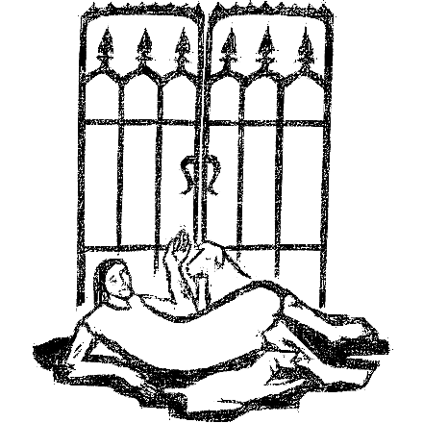**Thanks be to God.**

**Gospel Acclamation**

**Gospel: Luke 17:11-19**

*Jesus’ mission includes making people clean again. Unexpectedly, a Samaritan healed of leprosy becomes a model for those who would praise and worship God and give thanks for God’s mercy.*

The Holy Gospel according to Luke, the 17th chapter.

**Glory to you, O Lord.**

11On the way to Jerusalem Jesus was going through the region between Samaria and Galilee. 12As he entered a village, ten lepers approached him. Keeping their distance, 13they called out, saying, “Jesus, Master, have mercy on us!” 14When he saw them, he said to them, “Go and show yourselves to the priests.” And as they went, they were made clean. 15Then one of them, when he saw that he was healed, turned back, praising God with a loud voice. 16He prostrated himself at Jesus’ feet and thanked him. And he was a Samaritan. 17Then Jesus asked, “Were not ten made clean? But the other nine, where are they? 18Was none of them found to return and give praise to God except this foreigner?” 19Then he said to him, “Get up and go on your way; your faith has made you well.”

The Gospel of the Lord.

**Praise to you, O Christ.**

**Sermon** Pastor Karen Perkins

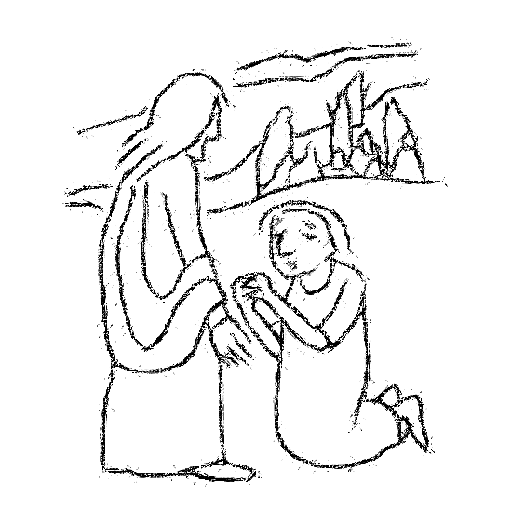

**Hymn of the Day: Wash, O God, Our Sons and Daughters**

**Sacrament of Holy BAPTISM**

**Presentation**

*Candidates for baptism, sponsors, and parents gather with the ministers at the font. The assembly is seated.*

*The presiding minister addresses the assembly:*

In baptism our gracious heavenly Father frees us from sin and death by joining us to the death and resurrection of our Lord Jesus Christ. We are born children of a fallen humanity; by water and the Holy Spirit we are reborn children of God and made members of the church, the body of Christ. Living with Christ and in the communion of saints, we grow in faith, love, and obedience to the will of God.

*A sponsor for the candidate presents the candidate:*

I present  Violet  for baptism.

*The presiding minister addresses parents or others who bring for baptism a child is not able to answer:*

Called by the Holy Spirit, trusting in the grace and love of God, do you desire to have your child baptized into Christ?

*Response:* I do.

As you bring your childto receive the gift of baptism, you are entrusted with responsibilities:

to live with heramong God's faithful people,

bring herto the word of God and the holy supper,

teach herthe Lord's Prayer, the Creed, and the Ten Commandments,

place in herhands the holy scriptures,

and nurture herin faith and prayer,

so that your child may learn to trust God,

proclaim Christ through word and deed,

care for others and the world God made,

and work for justice and peace.

Do you promise to help your childgrow in the Christian faith and life?

*Response:* I do.

*The presiding minister addresses sponsors:*

Sponsors, do you promise to nurture this child in the Christian faith as you are empowered by God's Spirit, and to help them live in the covenant of baptism and in communion with the church?

*Response:* I do.

*The presiding minister addresses the assembly:*

People of God, do you promise to support  Violet  and pray for her in her new life in Christ?

**We do.**

*The assembly stands.*

**Profession of Faith**

*The presiding minister addresses the parents and sponsors of young child. The assembly may join in the responses.*

I ask you to profess your faith in Christ Jesus, reject sin, and confess the faith of the church.

Do you renounce the devil and all the forces that defy God?

*Response:* I renounce them.

Do you renounce the powers of this world that rebel against God?

*Response:* I renounce them.

Do you renounce the ways of sin that draw you from God?

*Response:* I renounce them.

*The presiding minister addresses the candidates and the assembly.*

Do you believe in God the Father?

**I believe in God, the Father almighty,**

**creator of heaven and earth.**

Do you believe in Jesus Christ, the Son of God?

**I believe in Jesus Christ, God’s only Son, our Lord,**

**who was conceived by the Holy Spirit,**

**born of the virgin Mary,**

**suffered under Pontius Pilate,**

**was crucified, died, and was buried;**

**he descended to the dead.**

**On the third day he rose again;**

**he ascended into heaven,**

**he is seated at the right hand of the Father,**

**and he will come to judge the living and the dead.**

Do you believe in God the Holy Spirit?

**I believe in the Holy Spirit,**

**the holy catholic church,**

**the communion of saints,**

**the forgiveness of sins,**

**the resurrection of the body,**

**and the life everlasting.**

**Thanksgiving at the Font**

*Water may be poured into the font before or during the thanksgiving. At the font, the presiding minister begins the thanksgiving:*

The Lord be with you.

**And also with you.**

Let us give thanks to the Lord our God.

**It is right to give our thanks and praise.**

Holy God, holy and merciful, holy and mighty, you are the river of life, you are the everlasting wellspring, you are the fire of rebirth.

Glory to you for oceans and lakes, for rivers and streams. Honor to you for cloud and rain, for dew and snow. Your waters are below us, around us, above us: our life is born in you. You are the fountain of resurrection.

Praise to you for your saving waters: Noah and the animals survive the flood, Hagar discovers your well. The Israelites escape through the sea, and they drink from your gushing rock. Naaman washes his leprosy away, and the Samaritan woman will never be thirsty again.

At this font, holy God, we pray: Praise to you for the water of baptism and for your Word that saves us in this water. Breathe your Spirit into all who are gathered here and into all creation. Illumine our days. Enliven our bones. Dry our tears. Wash away the sin within us, and drown the evil around us.

Satisfy all our thirst with your living water, Jesus Christ, our Savior, who lives and reigns with you and the Holy Spirit, one God, now and forever.

**Amen.**

*The assembly may be seated.*

**Baptism**

*The presiding minister baptizes the candidate. Water is poured on the candidate's head, as the presiding minister says:*

 Violet , I baptize you in the name of the Father,

*Water is poured on the candidate's head a second time:*

and of the Son,

*Water is poured on the candidate's head a third time:*

and of the Holy Spirit.

**Amen.**

*After the baptism, the assembly responds with the following.*

**You belong to Christ,**

**in whom you have been baptized.**

**Alleluia.**

*The presiding minister continues:*

Let us pray.

We give you thanks, O God, that through water and the Holy Spirit you give your daughters and sons new birth, cleanse them from sin, and raise them to eternal life.

*Laying both hands on the head of the newly baptized, the minister prays:*

Sustain  Violet  with the gift of your Holy Spirit: the spirit of wisdom and understanding, the spirit of counsel and might, the spirit of knowledge and the fear of the Lord, the spirit of joy in your presence, both now and forever.

**Amen.**

*The presiding minister marks the sign of the cross on the forehead of the baptized. As the sign of the cross is made, the minister says:*

 Violet , child of God, you have been sealed by the Holy Spirit and marked with the cross of Christ forever.

**Amen.**

**Welcome**

*A lighted candle may be given to the newly baptized (to a sponsor of a young child) as a representative of the congregation says:*

Jesus said, I am the light of the world.

Whoever follows me

will have the light of life.

*The ministers and the baptismal group face the assembly. A representative of the congregation leads the assembly in the welcome.*

Let us welcome the newly baptized.

**We welcome you into the body of Christ and into the mission we share:**

**join us in giving thanks and praise to God**

**and bearing God's creative and redeeming word to all the world.**

**Prayer Refrain: Lord, Listen to Your Children Praying**

**The Prayers**

In gratitude and humility, let us join together in prayer on behalf of all of God’s creation.

Gracious God, we give you thanks for bishops, pastors, and deacons, for Presiding Bishop Elizabeth Eaton, Alaska Synod Bishop Shelly Wickstrom, Bishop Tessa Moon Leiseth of our sister synod, and Pastor Karen Perkins. Inspire leaders of the church to proclaim your mighty deeds, that your saving faith may be known to all. Hear us, O God.

**Your mercy is great.**

Majestic God, we give you thanks for land and water, seedtime and harvest. Break down boundaries we construct between ourselves and the rest of your creation. Bring renewal and restoration to places affected by pollution and deforestation. Hear us, O God.

**Your mercy is great.**

Mighty God, we give you thanks for those in our community, nation, and world who work for justice and peace. Guide those who govern to act on behalf of those marginalized by race, ethnicity, or religion. Hear us, O God.

**Your mercy is great.**

Merciful God, we give you thanks that you hear the cries of those in need. Restore to community those who are stigmatized by illness, feel rejected, or who live in isolation. Send healing to all who suffer. Hear us, O God.

**Your mercy is great.**

Faithful God, we give you thanks for the healing ministries of this congregation. Equip those who visit, care, and pray for the sick. Give insight to doctors, nurses, home health aides, and all practitioners of medical arts. Hear us, O God.

**Your mercy is great.**

Generous God, we give you thanks for this and every congregation. Inspire our neighbors in the Alaska Southeast Cluster, especially Island of Faith Lutheran Church, Wrangell. Hear us, O God.

**Your mercy is great.**

For what else do the people of God pray?

Eternal God, we give you thanks for your faithful people who have gone before us to your glory. Renew our trust in your eternal promises of mercy, redemption, and new life. Hear us, O God.

**Your mercy is great.**

With grateful hearts we commend our spoken and silent prayers to you, O God; through Jesus Christ, our Lord.

**Amen.**

**Repeat Prayer Refrain**

**MEAL**

God feeds us with the presence of Jesus Christ.

**PEACE**

The peace of the Lord be with you always.

**And also with you.**

We greet each other with a gesture of peace. We are conscious there are different comfort levels around social-distancing at this time. A nod, wave, phone call or email may be most appropriate for you. This greeting is a sign of the risen Christ who unites us and calls us to recognize the peace of God in one another.

**OFFERING**

**Presentation of the Gifts**

**Offertory Prayer**

Gracious God,

in your great love you richly provide for our needs.

Make of these gifts a banquet of blessing,

and make us ready to share with all in need;

through Jesus Christ, who sets a table for all.

**Amen.**

**Dialogue**

The Lord be with you.

**And also with you.**

Lift up your hearts.

**We lift them to the Lord.**

Let us give thanks to the Lord our God.

**It is right to give our thanks and praise.**

**Preface**

It is indeed right and salutary that we should

at all times and in all places

offer thanks and praise to you, O Lord, holy Father,

through Christ our Lord;

who on this day overcame death and the grave,

and by his glorious resurrection

opened to us the way of everlasting life.

And so, with the Church on earth

and the hosts of heaven,

we praise your name

and join their unending hymn:

**Sanctus**

**Great Thanksgiving**

Holy God,

our Bread of life, our Table, and our Food,

you created a world in which all might be satisfied by your abundance.

You dined with Abraham and Sarah, promising them life,

and fed your people Israel with manna from heaven.

You sent your Son to eat with sinners

and to become food for the world.

In the night in which he was betrayed,

our Lord Jesus took bread, and gave thanks;

broke it, and gave it to his disciples, saying:

Take and eat; this is my body, given for you.

Do this for the remembrance of me.

Again, after supper, he took the cup, gave thanks,

and gave it for all to drink, saying:

This cup is the new covenant in my blood,

shed for you and for all people for the forgiveness of sin.

Do this for the remembrance of me.

Remembering, therefore,

his life given for us

and his rising from the grave,

we await his coming again to share with us the everlasting feast.

By your Spirit nurture and sustain us with this meal:

strengthen us to serve all in hunger and want,

and by this bread and cup make of us the body of your Son.

Through him all glory and honor is yours,

Almighty Father, with the Holy Spirit,

in your holy Church,

both now and forever.

**Amen**

**Lord’s Prayer**

Lord, remember us in your kingdom, and teach us to pray:

**Our Father, who art in heaven,**

**hallowed be thy name,**

**thy kingdom come,**

**thy will be done,**

**on earth as it is in heaven.**

**Give us this day our daily bread;**

**and forgive us our trespasses,**

**as we forgive those**

**who trespass against us;**

**and lead us not into temptation,**

**but deliver us from evil.**

**For thine is the kingdom,**

**and the power, and the glory,**

**forever and ever. Amen.**

**Communion Information**

All are welcome to the communion table! God is the host and God's love extends to all people. During this period of social distancing due to COVID-19, not all in our community are ready to be present at Resurrection. Nevertheless, there **are** ways for you to participate! We celebrate this holy meal as the community of peace, love and mercy.

* We have resources on our website to help you celebrate Holy Communion at home, either along with a live broadcast or at another time.
* Pastor Karen can bring the Eucharist to you at home. Please contact the office or Pastor Karen to make arrangements.

We would be happy to light a candle in thankfulness, of concern, or in memory of a person at your request.

**Invitation to Communion**

**Christ invites you to this table.**

**Come, taste and see.**

**Communion Hymn**

**Communion Distribution**

The body of Christ, given for you.

**Amen**

The blood of Christ, shed for you.

**Amen**

**Post-Communion Blessing**

The body and blood of our Lord Jesus Christ strengthen you

and keep you in God’s grace.

**Amen**

**Post-Communion Canticle**

**Post-Communion Prayer**

God of the abundant table,

you have refreshed our hearts in this meal

with bread for the journey.

Give us your grace on the road

that we might serve our neighbors with joy;

for the sake of Jesus Christ, our Lord.

**Amen.**

**Mission Statement**

Let us announce together,

**The mission of Resurrection Lutheran Church is to promote spiritual growth in Christ and service to all people.**

**SENDING**

God blesses us and sends us in mission to the world.

**Blessing**

God, who gives life to all things

and frees us from despair,

bless you with truth and peace.

And may the holy Trinity, ☩ one God,

guide you always in faith, hope, and love.

**Amen.**

**Sending Hymn: Baptized and Set Free**

**Dismissal**

Go in peace, with Christ beside you.

**Thanks be to God.**

**Texts for Sunday, October 16, 2022**

**19th Sunday after Pentecost / Lectionary 29C**

Genesis 32:22-31

Psalm 121

2 Timothy 3:14--4:5

Luke 18:1-8

From sundaysandseasons.com.

Copyright © 2022 Augsburg Fortress. All rights reserved.