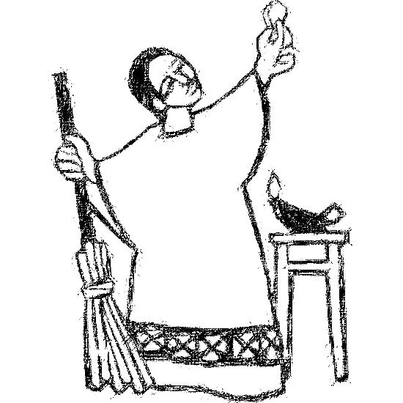

Welcome to
Resurrection Lutheran Church

740 West 10th Street, Juneau, Alaska 99801
Office: (907) 586-2380 rlcoffice@ak.net
Pastor: (907) 885-6824 (voice only) rlcpastor@ak.net
(808) 782-6653 (text and voice)

www.rlcjuneau.org www.rlclive.org

September 11, 2022 Fourteenth Sunday after Pentecost/Lec. 25C

Introduction to the day
The grumbling of the religious leaders in today’s gospel is actually our holy hope: This Jesus welcomes sinners and eats with them. That our God seeks and saves the lost is not only a holy hope, it is our only hope. As the writer of 1 Timothy reminds us, “The saying is sure and worthy of full acceptance, that Christ Jesus came into the world to save sinners.” Thanks be to God.

Prelude

Welcome and Announcements

GATHERING
The Holy Spirit calls us together as the people of God.

Texts for Sunday, September 18, 2022
15th Sunday after Pentecost / Lectionary 25C
Amos 8:4-7
Psalm 113
1 Timothy 2:1-7
Luke 16:1-13

Brief Order for Confession and Forgiveness
Blessed be the holy Trinity, ☩ one God,
who is eager to forgive
and who loves us beyond our days.
Amen.

Dear friends, together let us acknowledge
our failure to love this world as Jesus does.

God of mercy and forgiveness,
we confess that sin still has a hold on us.
We have harmed your good creation.
We have failed to do justice,
love kindness,
and walk humbly with you.
Turn us in a new direction.
Show us the path that leads to life.
Be our refuge and strength on the journey,
through Jesus Christ, our redeemer and friend.
Amen.

Beloved of God:
your sins are forgiven ☩ and you are made whole.
God points the way to new life in Christ,
who meets us on the road.
Journey now in God’s abiding love
through the power of the Holy Spirit.

Amen.

Gathering Song: Come, Thou Fount of Every Blessing

Greeting
The grace of our Lord Jesus Christ, the love of God,
and the communion of the Holy Spirit be with you all.
And also with you.

Kyrie (Ghana)
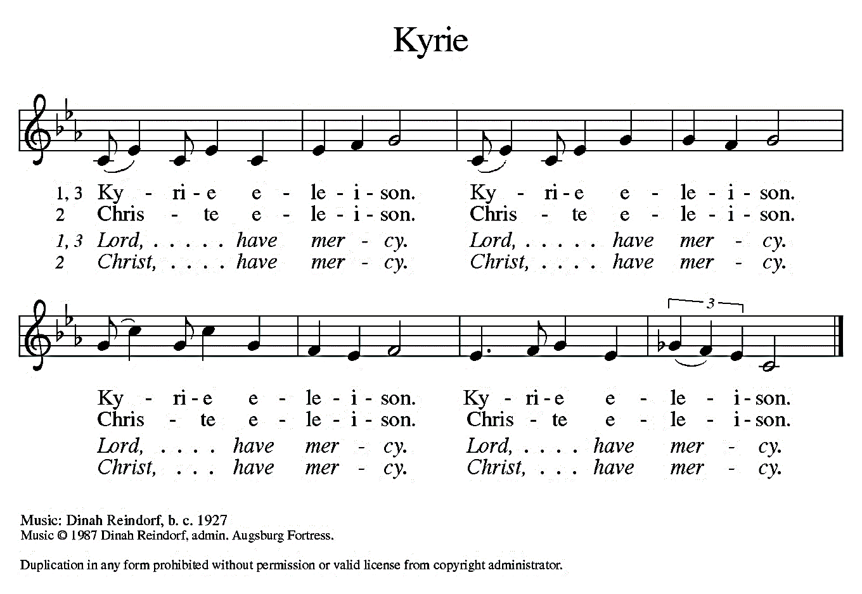


Hymn of Praise (Great Britain)
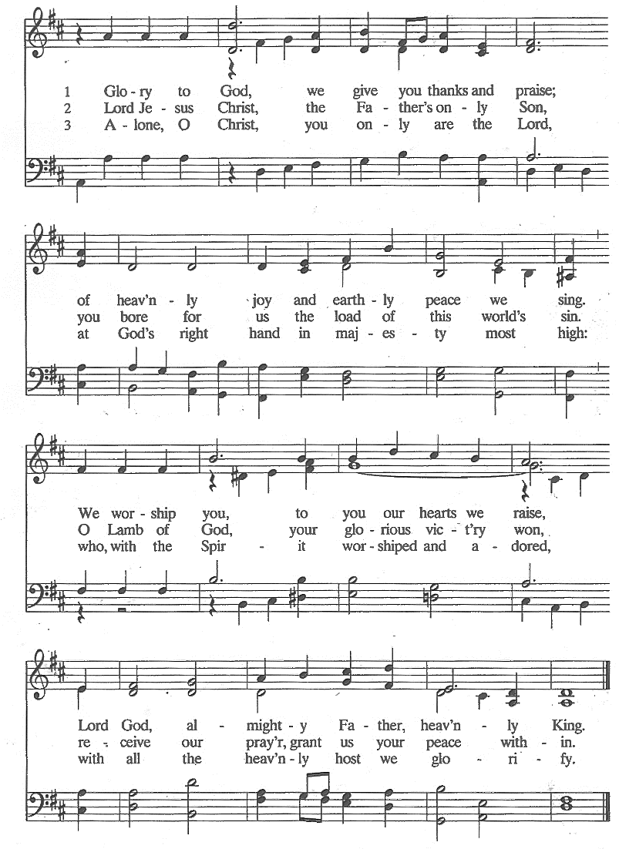
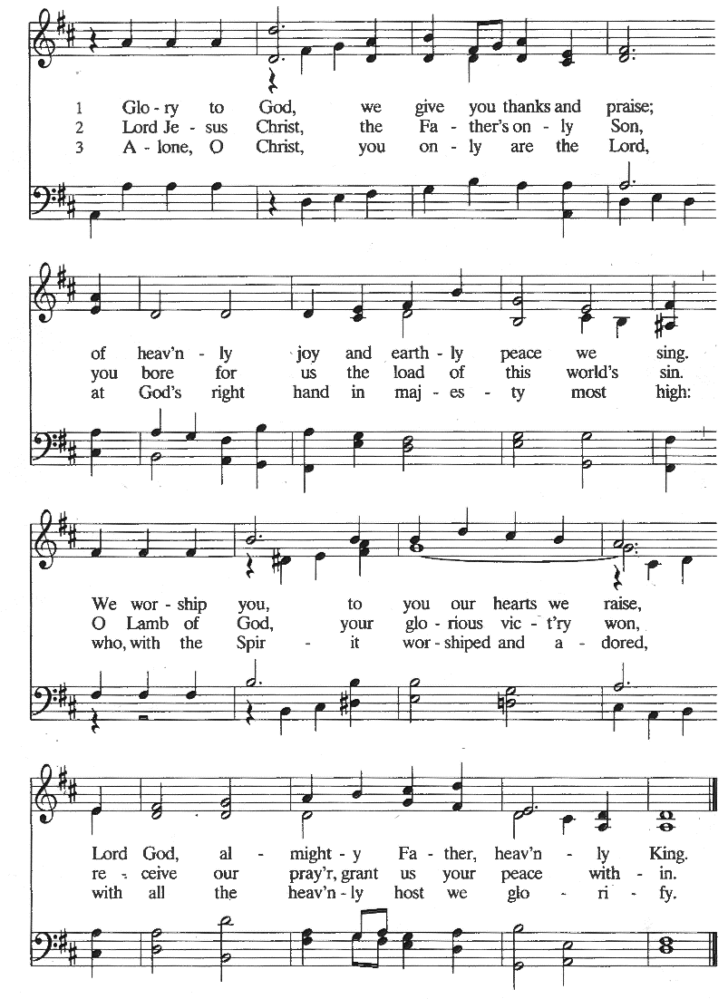


Prayer of the Day
The Lord be with you.
And also with you.

Let us pray.
O God, you declare your almighty power chiefly in showing mercy and pity. Grant us the fullness of your grace, that, pursuing what you have promised, we may share your heavenly glory; through your Son, Jesus Christ our Lord.
Amen.


WORD
God speaks to us in scripture reading, preaching, and song.

First Reading: Exodus 32:7-14
While Moses is on Mount Sinai, the people grow restless and make a golden calf to worship. Today’s reading shows Moses as the mediator between an angry God and a sinful people. Moses reminds God that the Israelites are God’s own people, and boldly asks for mercy for them.

A reading from Exodus.

⁷The Lord said to Moses, “Go down at once! Your people, whom you brought up out of the land of Egypt, have acted perversely; ⁸they have been quick to turn aside from the way that I commanded them; they have cast for themselves an image of a calf, and have worshiped it and sacrificed to it, and said, ‘These are your gods, O Israel, who brought you up out of the land of Egypt!’ ” ⁹The Lord said to Moses, “I have seen this people, how stiff-necked they are. ¹⁰Now let me alone, so that my wrath may burn hot against them and I may consume them; and of you I will make a great nation.”

¹¹But Moses implored the Lord his God, and said, “O Lord, why does your wrath burn hot against your people, whom you brought out of the land of Egypt with great power and with a mighty hand? ¹²Why should the Egyptians say, ‘It was with evil intent that he brought them out to kill them in the mountains, and to consume them from the face of the earth’? Turn from your fierce wrath; change your mind and do not bring disaster on your people. ¹³Remember Abraham, Isaac, and Israel, your servants, how you swore to them by your own self, saying to them, ‘I will multiply your descendants like the stars of heaven, and all this land that I have promised I will give to your descendants, and they shall inherit it forever.’ ” ¹⁴And the Lord changed his mind about the disaster that he planned to bring on his people.

The word of the Lord.
Thanks be to God.

Psalm: Psalm 51:1-11
Have mercy on me, O God, according to your lovingkindness. (Ps. 51:1)

¹Have mercy on me, O God, according to your lovingkindness;
in your great compassion blot out my offenses.
²Wash me through and through from my wickedness,
and cleanse me from my sin.
³For I know my transgressions,
and my sin is ever before me.
⁴Against you only have I sinned
and done what is evil in your sight. R

⁵And so you are justified when you speak
and upright in your judgment.
⁶Indeed, I have been wicked from my birth,
a sinner from my mother’s womb.
⁷For behold, you look for truth deep within me,
and will make me understand wisdom secretly.
⁸Purge me from my sin, and I shall be pure;
wash me, and I shall be clean indeed. R

⁹Make me hear of joy and gladness,
that the body you have broken may rejoice.
¹⁰Hide your face from my sins,
and blot out all my iniquities.
¹¹Create in me a clean heart, O God,
and renew a right spirit within me. R
Second Reading: 1 Timothy 1:12-17
The letters to Timothy and Titus are called the pastoral epistles because they contain advice especially intended for leaders in the church. Here the mercy shown to Paul, who once persecuted the church, is cited as evidence that even the most unworthy may become witnesses to the grace of God.

A reading from First Timothy.

¹²I am grateful to Christ Jesus our Lord, who has strengthened me, because he judged me faithful and appointed me to his service, ¹³even though I was formerly a blasphemer, a persecutor, and a man of violence. But I received mercy because I had acted ignorantly in unbelief, ¹⁴and the grace of our Lord overflowed for me with the faith and love that are in Christ Jesus. ¹⁵The saying is sure and worthy of full acceptance, that Christ Jesus came into the world to save sinners—of whom I am the foremost. ¹⁶But for that very reason I received mercy, so that in me, as the foremost, Jesus Christ might display the utmost patience, making me an example to those who would come to believe in him for eternal life. ¹⁷To the King of the ages, immortal, invisible, the only God, be honor and glory forever and ever. Amen.

The word of the Lord.

Thanks be to God.

Children’s’ Time Amanda Beebe-Bay

Gospel Acclamation (South Africa)

Gospel: Luke 15:1-10
Jesus tells two stories that suggest a curious connection between the lost being found and sinners repenting. God takes the initiative to find sinners, each of whom is so precious to God that their recovery brings joy in heaven.

The Holy Gospel according to Luke, the 15th chapter.
Glory to you, O Lord.

¹Now all the tax collectors and sinners were coming near to listen to [Jesus.] ²And the Pharisees and the scribes were grumbling and saying, “This fellow welcomes sinners and eats with them.”

³So he told them this parable: ⁴“Which one of you, having a hundred sheep and losing one of them, does not leave the ninety-nine in the wilderness and go after the one that is lost until he finds it? ⁵When he has found it, he lays it on his shoulders and rejoices. ⁶And when he comes home, he calls together his friends and neighbors, saying to them, ‘Rejoice with me, for I have found my sheep that was lost.’ ⁷Just so, I tell you, there will be more joy in heaven over one sinner who repents than over ninety-nine righteous persons who need no repentance.

⁸“Or what woman having ten silver coins, if she loses one of them, does not light a lamp, sweep the house, and search carefully until she finds it? ⁹When she has found it, she calls together her friends and neighbors, saying, ‘Rejoice with me, for I have found the coin that I had lost.’ ¹⁰Just so, I tell you, there is joy in the presence of the angels of God over one sinner who repents.”

The Gospel of the Lord.
Praise to you, O Christ.

Message: A Loving Tribute to Larry’s Life & Legacy

As you experience this presentation, pay special attention to the combination of the words and images projected on the screen. Symbolism plays an important part in this presentation whose goal is to inspire us to live our lives meaningfully in the way of Christ.

Preiset Dem Konig (Praise the King)
An instrumental from Amy Grant’s Christmas Album praises God and includes some of Larry’s best photos.

I Was There to Hear Your Borning Cry
By John Ylvisaker sung by various vocalists, features God’s presence throughout Larry's life as a child of God.

Trumpet Voluntary in D
From the album The World of the Trumpet featuring Peter Hurford, is the Wedding processional at Larry and Laura's wedding. This song focuses on their deep love for one another beginning with their courtship, wedding, life in Norway attending the University of Oslo, travels, education at Augustana In Sioux Falls, SD., Luther Seminary and their life before kids. It covers the years 1964-1971. A few pictures of their childhood are included.

Pachelbels Canon in D
With James Galway on Flute, was daughter Angela and Larry Owen's Wedding Processional. This music focuses on Laura and Larry’s life from 1971 to present, with kids, grandkids, the congregations, family activities and travel.

Here I Am, Lord
Sung by John Michael Talbot, focuses on Larry's call to ministry and his legacy to "do unto the least of these, as you would do it unto me". This song inspires us to reach out to the most vulnerable with compassion and love and sends us out into the world to love and serve the Lord.

The Hallelujah Chorus from Handel's Messiah
Praises our majestic God. It features much of Larry’s photography, thanks God for Larry and his legacy and entrusts him into the hands of God. Trusting in God’s promise in baptism that we are claimed by Christ forever, we can rest in the sure hope of the Resurrection.

Hymn of the Day: Amazing Grace, How Sweet the Sound


Apostles’ Creed
I believe in God, the Father almighty,
creator of heaven and earth.

I believe in Jesus Christ, God’s only Son, our Lord.
Who was conceived by the power of the Holy Spirit
and born of the virgin Mary.
He suffered under Pontius Pilate,
was crucified, died, and was buried.
He descended into hell.
On the third day he rose again.
He ascended into heaven,
and is seated at the right hand of the Father.
He will come again to judge the living and the dead.

I believe in the Holy Spirit,
the holy catholic church,

the communion of saints,
the forgiveness of sins,
the resurrection of the body,
and the life everlasting. Amen

Prayer Refrain: Abba, Abba, Hear Us (Korea)

The Prayers
As scattered grains of wheat are gathered together into one bread, so let us gather our prayers for the church, those in need, and all of God’s good creation.

Your people receive mercy and your grace overflows in our lives. Fill your church with faith and love, and give understanding hearts to those who work to strengthen our ecumenical and interreligious commitments. God of grace,
hear our prayer.

Your creation groans as it suffers the impacts of pollution and lack of care. As the seasons change, renew in us the will to protect plants, animals, and habitats. Bless us with bountiful harvests that all may share. God of grace,
hear our prayer.

Your world is shattered and the nations rage. Remember us in your mercy. Teach wisdom to our elected leaders so that we know peace in our world, peace in our homes, and peace in our hearts. God of grace,
hear our prayer.

Your children wander homeless and the hungry cry for bread. Seek out those who are lost or lonely, anxious or depressed, or struggling with addiction or illness. Provide for those in any need. God of grace,
hear our prayer.

Your work is done in this congregation with our hands, feet, voices, minds, and hearts. Build up the ministries of this community, that we serve our neighbors and welcome the stranger in your name. God of grace,
hear our prayer.

Your work is done in the three expressions of the ELCA. Guide Presiding Bishop Elizabeth Eaton, Alaska Synod Bishop Shelly Wickstrom, Bishop Tessa Moon Leiseth of our sister synod, and Pastor Karen Perkins. Bless our neighbors in the Alaska Southeast Cluster, and Our Savior’s Lutheran Church, Nome. God of grace,
hear our prayer.

For what else do the people of God pray?

Your blessed saints who have died now rest in your presence. Give us thankful hearts for those who have been examples of faith in our lives, and receive us with joy when we come to share eternal life with you. God of grace,
hear our prayer.

Gathered together in the sweet communion of the Holy Spirit, gracious God, we offer these and all our prayers to you; through Jesus Christ, our Savior.
Amen.

Repeat Prayer Refrain (Korea)

Peace
The peace of the Lord be with you always.
And also with you.

We greet each other with a gesture of peace. We are conscious there are different comfort levels around social-distancing at this time. A nod, wave, phone call or email may be most appropriate for you. This greeting is a sign of the risen Christ who unites us and calls us to recognize the peace of God in one another.
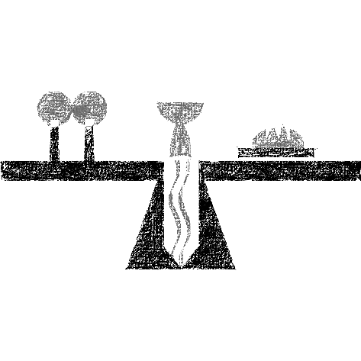

MEAL
God feeds us with the presence of Jesus Christ.

Presentation of the Gifts (Nicaragua)
Offertory Prayer
Gracious God,

in your great love you richly provide for our needs.
Make of these gifts a banquet of blessing,
and make us ready to share with all in need;
through Jesus Christ, who sets a table for all.
Amen.

Amanda Beebe-Bay is authorized to preside today by the synod bishop.

Dialogue
The Lord be with you.
And also with you.

Lift up your hearts.
We lift them to the Lord.

Let us give thanks to the Lord our God.
It is right to give our thanks and praise.

Preface
It is indeed right and salutary that we should
at all times and in all places
offer thanks and praise to you, O Lord, holy Father,
through Christ our Lord;

who on this day overcame death and the grave,
and by his glorious resurrection
opened to us the way of everlasting life.

And so, with the Church on earth
and the hosts of heaven,
we praise your name
and join their unending hymn:

Sanctus (Austria)



Great Thanksgiving
Holy God,
our Maker, Redeemer, and Healer,
in the harmonious world of your creation,
the plants and animals,
the seas and stars
were whole and well in your praise.

When sin had scarred the world,
you sent your Son to heal our ills
and to form us again into one.

In the night in which he was betrayed,
our Lord Jesus took bread, and gave thanks;
broke it, and gave it to his disciples, saying:
Take and eat; this is my body, given for you.
Do this for the remembrance of me.

Again, after supper, he took the cup, gave thanks,
and gave it for all to drink, saying:
This cup is the new covenant in my blood,
shed for you and for all people for the forgiveness of sin.
Do this for the remembrance of me.

Remembering, therefore,
his acts of healing,
his body given up,
and his victory over death,
we await that day when all the peoples of the earth
will come to the river to enjoy the tree of life.

Send your Spirit upon us and this meal:
as grains scattered on the hillside become one bread,
so let your Church be gathered from the ends of the earth,
that all may be fed with the Bread of life, your Son.

Through him all glory and honor is yours,
Almighty Father, with the Holy Spirit,
in your holy Church,
both now and forever.
Amen

Lord’s Prayer
Lord, remember us in your kingdom, and teach us to pray:

Our Father, who art in heaven,
hallowed be thy name,
thy kingdom come,
thy will be done,
on earth as it is in heaven.
Give us this day our daily bread;
and forgive us our trespasses,
as we forgive those
who trespass against us;
and lead us not into temptation,
but deliver us from evil.
For thine is the kingdom,
and the power, and the glory,
forever and ever. Amen.

Communion Distribution
All are welcome to the communion table! God is the host and God's love extends to all people. During this period of social distancing due to COVID-19, not all in our community are ready to be present at Resurrection. Nevertheless, there are ways for you to participate! We celebrate this holy meal as the community of peace, love and mercy.

- We have resources on our website to help you celebrate Holy Communion at home, either along with a live broadcast or at another time.
- Pastor Karen can bring the Eucharist to you at home. Please contact the office or Pastor Karen to make arrangements.

We would be happy to light a candle in thankfulness, of concern, or in memory of a person at your request.

Invitation to Communion
In Christ’s presence there is fullness of joy.
Come to the banquet.

Communion Song (America)

Communion
The body of Christ, given for you.

Amen.
The blood of Christ, shed for you.
Amen.

Communion Blessing
The body and blood of our Lord Jesus Christ
strengthen you and keep you in God's grace.
Amen.

Post-Communion Canticle (South Africa)


Prayer After Communion
God of the abundant table,
you have refreshed our hearts in this meal
with bread for the journey.
Give us your grace on the road
that we might serve our neighbors with joy;
for the sake of Jesus Christ, our Lord.
Amen.

SENDING
God blesses us and sends us in mission to the world.

Mission Statement
Let us announce together,
The mission of Resurrection Lutheran Church is to promote spiritual growth in Christ and service to all people.

Blessing
God, who gives life to all things
and frees us from despair,
bless you with truth and peace.

And may the holy Trinity, ☩ one God,
guide you always in faith, hope, and love.
Amen.

Sending Song: God, Be the Love to Search and Keep Me:
O Christ, Surround Me

Dismissal
Go in peace, with Christ beside you.
Thanks be to God.

From sundaysandseasons.com.
Copyright © 2022 Augsburg Fortress. All rights reserved.

