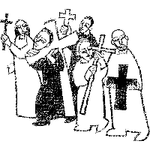

Welcome to
Resurrection Lutheran Church

740 West 10th Street, Juneau, Alaska 99801
Office: (907) 586-2380 rlcoffice@ak.net
Pastor: (907) 885-6824 (voice only) rlcpastor@ak.net
(808) 782-6653 (text and voice)

www.rlcjuneau.org www.rlclive.org

September 4, 2022 Thirteenth Sunday after Pentecost/Lec. 23C

Introduction to the day
Called to contemplate the cost of discipleship, we might be helped by translating Paul’s request to Philemon into our prayer of the day: Refresh my heart in Christ. Strengthened by the company and forgiveness of Christ in holy communion and recalling God’s grace in remembrance of baptism, we can be strengthened in this hour to “choose life”—to choose life in God as our own.

Prelude

Welcome and Announcements

GATHERING
The Holy Spirit calls us together as the people of God.

Texts for Sunday, September 11, 2022
14th Sunday after Pentecost / Lectionary 24C
Exodus 32:7-14
Psalm 51:1-10
1 Timothy 1:12-17
Luke 15:1-10

Brief Order for Confession and Forgiveness
Blessed be the holy Trinity, ☩ one God,
who is eager to forgive
and who loves us beyond our days.
Amen.

Dear friends, together let us acknowledge
our failure to love this world as Jesus does.

God of mercy and forgiveness,
we confess that sin still has a hold on us.
We have harmed your good creation.
We have failed to do justice,
love kindness,
and walk humbly with you.
Turn us in a new direction.
Show us the path that leads to life.
Be our refuge and strength on the journey,
through Jesus Christ, our redeemer and friend.
Amen.

Beloved of God:
your sins are forgiven ☩ and you are made whole.
God points the way to new life in Christ,
who meets us on the road.
Journey now in God’s abiding love
through the power of the Holy Spirit.

Amen.

Gathering Song: Faith Begins by Letting Go

Greeting
The grace of our Lord Jesus Christ, the love of God,
and the communion of the Holy Spirit be with you all.
And also with you.
Kyrie (Ghana)
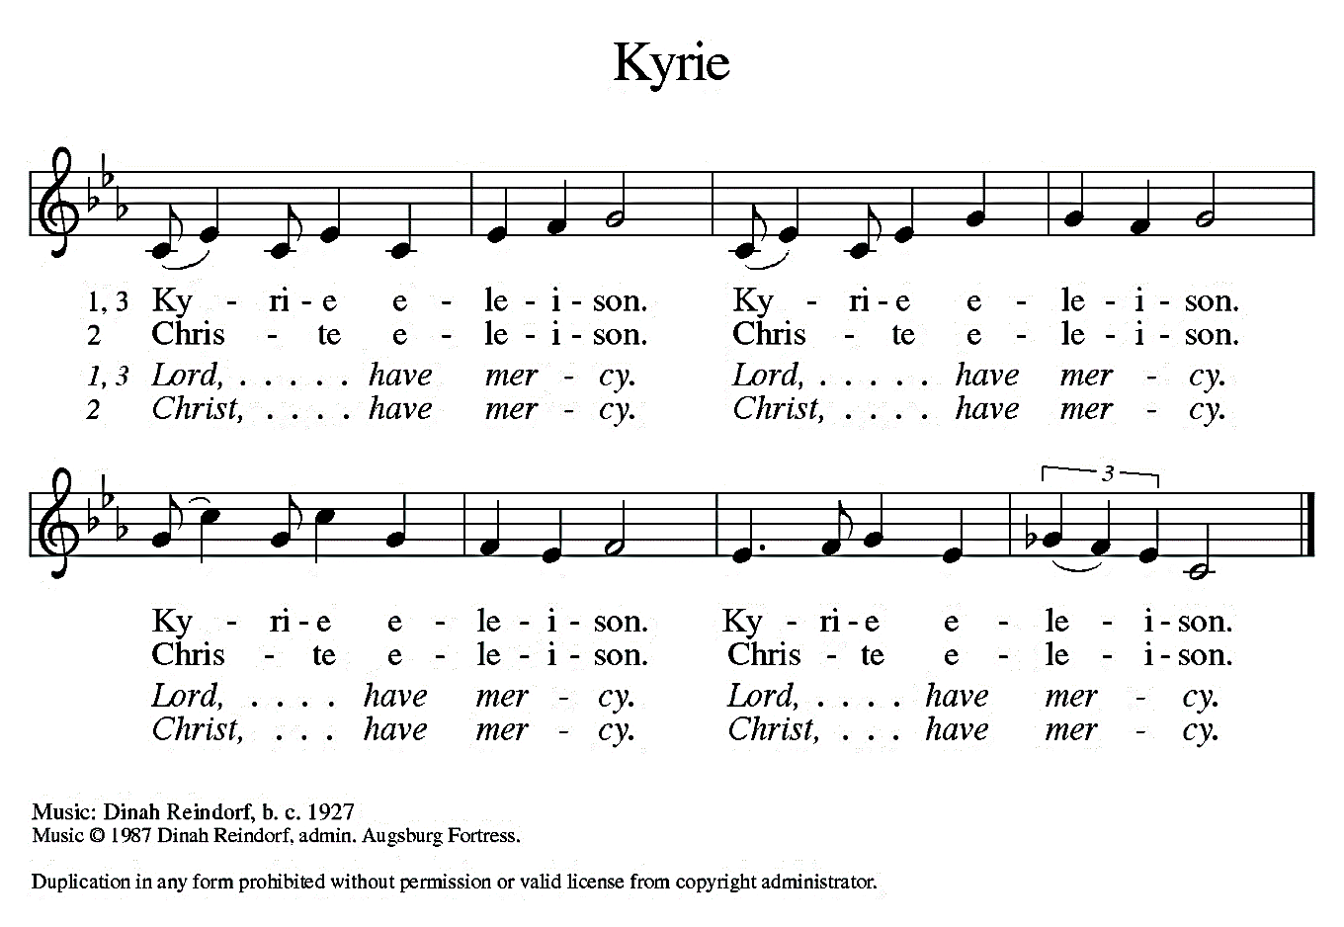


Hymn of Praise (Great Britain)
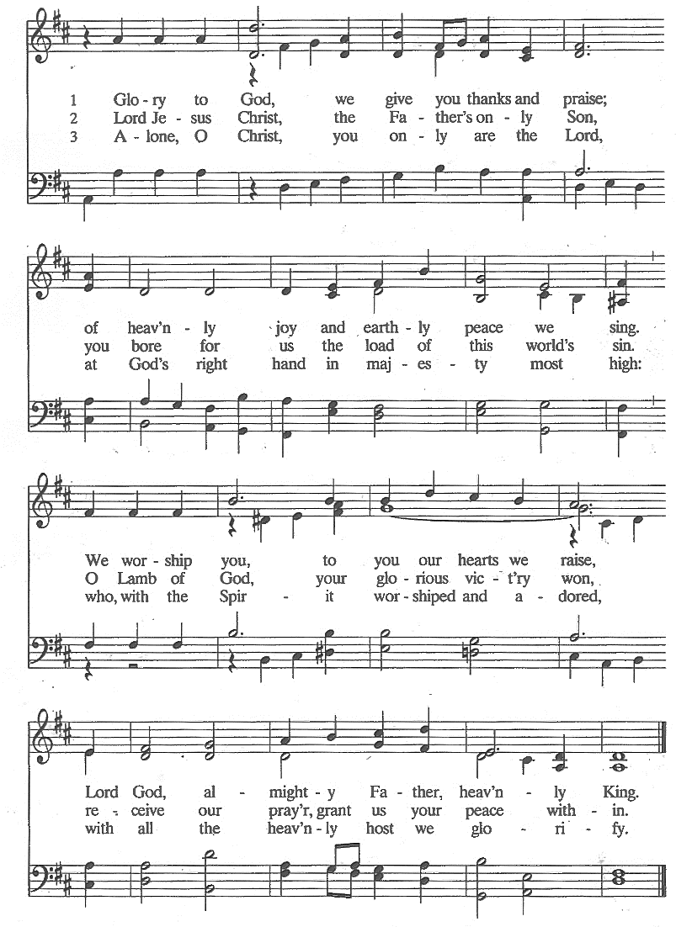
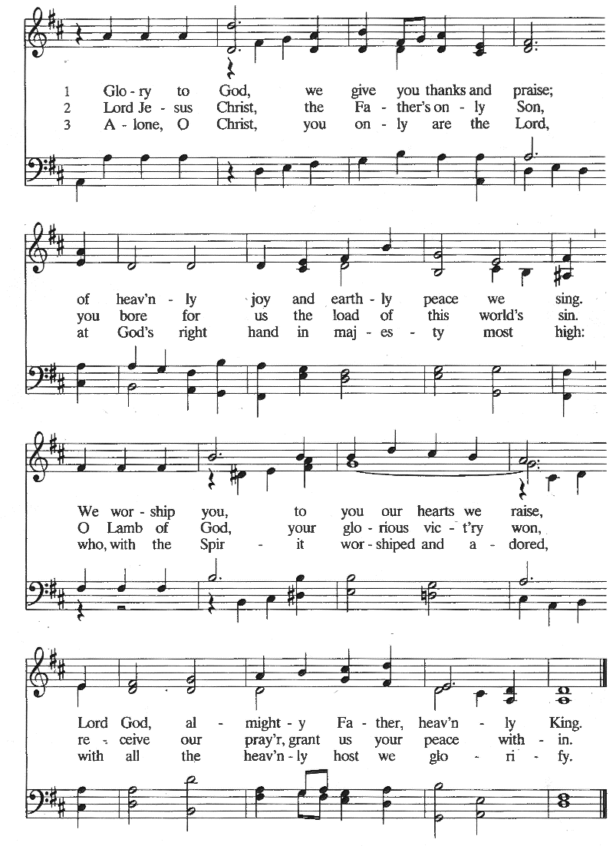


Prayer of the Day
The Lord be with you.
And also with you.

Let us pray.
Almighty and eternal God, you know our problems and our weaknesses better than we ourselves. In your love and by your power help us in our confusion and, in spite of our weakness, make us firm in faith; through your Son, Jesus Christ our Lord.
Amen.

WORD
God speaks to us in scripture reading, preaching, and song.

First Reading: Deuteronomy 30:15-20
Moses speaks to the Israelites, who are about to enter the land promised to their ancestors. In this passage, he lays out the stark choice before them: choose life by loving and obeying the Lord; or choose death by following other gods.

A reading from Deuteronomy.

¹⁵See, I have set before you today life and prosperity, death and adversity. ¹⁶If you obey the commandments of the Lord your God that I am commanding you today, by loving the Lord your God, walking in his ways, and observing his commandments, decrees, and ordinances, then you shall live and become numerous, and the Lord your God will bless you in the land that you are entering to possess. ¹⁷But if your heart turns away and you do not hear, but are led astray to bow down to other gods and serve them, ¹⁸I declare to you today that you shall perish; you shall not live long in the land that you are crossing the Jordan to enter and possess. ¹⁹I call heaven and earth to witness against you today that I have set before you life and death, blessings and curses. Choose life so that you and your descendants may live, ²⁰loving the Lord your God, obeying him, and holding fast to him; for that means life to you and length of days, so that you may live in the land that the Lord swore to give to your ancestors, to Abraham, to Isaac, and to Jacob.

The word of the Lord.
Thanks be to God.

Psalm: Psalm 1
Their delight is in the law of the Lord. (Ps. 1:2)

¹Happy are they who have not walked in the counsel of the wicked,
nor lingered in the way of sinners, nor sat in the seats of the scornful!
²Their delight is in the law of the Lord,
and they meditate on his law day and night. R

³They are like trees planted by streams of water,
bearing fruit in due season, with leaves that do not wither;
everything they do shall prosper.
⁴It is not so with the wicked;
they are like chaff which the wind blows away.
⁵Therefore the wicked shall not stand upright when judgment comes,
nor the sinner in the council of the righteous.
⁶For the Lord knows the way of the righteous,
but the way of the wicked is doomed. R

Second Reading: Philemon 1-21
While Paul was in prison, he was aided by Onesimus, a man who had run away from Philemon, a slaveowner and a Christian friend of Paul. Paul told Onesimus to return to Philemon and encouraged Philemon to receive Onesimus back as a Christian brother.

A reading from Philemon.

¹Paul, a prisoner of Christ Jesus, and Timothy our brother,
To Philemon our dear friend and co-worker, ²to Apphia our sister, to Archippus our fellow soldier, and to the church in your house:
³Grace to you and peace from God our Father and the Lord Jesus Christ.

⁴When I remember you in my prayers, I always thank my God ⁵because I hear of your love for all the saints and your faith toward the Lord Jesus. ⁶I pray that the sharing of your faith may become effective when you perceive all the good that we may do for Christ. ⁷I have indeed received much joy and encouragement from your love, because the hearts of the saints have been refreshed through you, my brother.

⁸For this reason, though I am bold enough in Christ to command you to do your duty, ⁹yet I would rather appeal to you on the basis of love—and I, Paul, do this as an old man, and now also as a prisoner of Christ Jesus. ¹⁰I am appealing to you for my child, Onesimus, whose father I have become during my imprisonment. ¹¹Formerly he was useless to you, but now he is indeed useful both to you and to me. ¹²I am sending him, that is, my own heart, back to you. ¹³I wanted to keep him with me, so that he might be of service to me in your place during my imprisonment for the gospel; ¹⁴but I preferred to do nothing without your consent, in order that your good deed might be voluntary and not something forced. ¹⁵Perhaps this is the reason he was separated from you for a while, so that you might have him back forever, ¹⁶no longer as a slave but more than a slave, a beloved brother—especially to me but how much more to you, both in the flesh and in the Lord.

¹⁷So if you consider me your partner, welcome him as you would welcome me. ¹⁸If he has wronged you in any way, or owes you anything, charge that to my account. ¹⁹I, Paul, am writing this with my own hand: I will repay it. I say nothing about your owing me even your own self. ²⁰Yes, brother, let me have this benefit from you in the Lord! Refresh my heart in Christ. ²¹Confident of your obedience, I am writing to you, knowing that you will do even more than I say.

“The Lord is my helper;
I will not be afraid.
What can anyone do to me?”

⁷Remember your leaders, those who spoke the word of God to you; consider the outcome of their way of life, and imitate their faith. ⁸Jesus Christ is the same yesterday and today and forever. ¹⁵Through him, then, let us continually offer a sacrifice of praise to God, that is, the fruit of lips that confess his name. ¹⁶Do not neglect to do good and to share what you have, for such sacrifices are pleasing to God.

The word of the Lord.
Thanks be to God.


Children’s’ Time Amanda Beebe-Bay

Gospel Acclamation (South Africa)

Gospel: Luke 14:25-33
Jesus speaks frankly about the costs of discipleship. Those who follow him should know from the outset that completing the course of discipleship will finally mean renouncing all other allegiances.

The Holy Gospel according to Luke, the 14th chapter.
Glory to you, O Lord.

²⁵Now large crowds were traveling with [Jesus;] and he turned and said to them, ²⁶“Whoever comes to me and does not hate father and mother, wife and children, brothers and sisters, yes, and even life itself, cannot be my disciple. ²⁷Whoever does not carry the cross and follow me cannot be my disciple. ²⁸For which of you, intending to build a tower, does not first sit down and estimate the cost, to see whether he has enough to complete it? ²⁹Otherwise, when he has laid a foundation and is not able to finish, all who see it will begin to ridicule him, ³⁰saying, ‘This fellow began to build and was not able to finish.’

³¹Or what king, going out to wage war against another king, will not sit down first and consider whether he is able with ten thousand to oppose the one who comes against him with twenty thousand? ³²If he cannot, then, while the other is still far away, he sends a delegation and asks for the terms of peace. ³³So therefore, none of you can become my disciple if you do not give up all your possessions.”

The Gospel of the Lord.
Praise to you, O Christ.

SermoN Pastor Karen Perkins

Hymn of the Day: Take Up Your Cross, the Savior Said




Apostles’ Creed
I believe in God, the Father almighty,
creator of heaven and earth.

I believe in Jesus Christ, God’s only Son, our Lord.
Who was conceived by the power of the Holy Spirit
and born of the virgin Mary.
He suffered under Pontius Pilate,
was crucified, died, and was buried.
He descended into hell.
On the third day he rose again.
He ascended into heaven,
and is seated at the right hand of the Father.
He will come again to judge the living and the dead.

I believe in the Holy Spirit,
the holy catholic church,
the communion of saints,
the forgiveness of sins,
the resurrection of the body,
and the life everlasting. Amen

Prayer Refrain: Abba, Abba, Hear Us (Korea)

The Prayers
As scattered grains of wheat are gathered together into one bread, so let us gather our prayers for the church, those in need, and all of God’s good creation.

We pray for the church around the world and for the mission of the gospel. Refresh the hearts of your people, deepen our understanding of every good thing we share, and strengthen our partnerships in the faith. God of grace,
hear our prayer.

For the well-being of the earth and all its creatures: for trees and forests, for all that will yield fruit this season, and for streams and other bodies of water. God of grace,
hear our prayer.

For the nations and those in authority: for the elected leaders of our towns, states, and country, and for international organizations. Grant wisdom to those who govern and raise up citizens who make decisions in the best interest of their neighbors. God of grace,
hear our prayer.

For all in need: for those who suffer from disease, who struggle with homelessness or food insecurity, for those whose family life is difficult, and for all in this community who need your care, especially those unable to find providers in town. God of grace,
hear our prayer.

For this community of faith: for all our labors—begun, continued, and ended in you—that they glorify your holy name. Bless your people with the strength to live into their many vocations for the sake of the world. God of grace,
hear our prayer.

For the ELCA and its leaders, we pray. Guide Presiding Bishop Elizabeth Eaton, Alaska Synod Bishop Shelly Wickstrom, Bishop Tessa Moon Leiseth of our sister synod, and Pastor Karen Perkins. Bless our neighbors in the Alaska Southeast Cluster, and Our Savior’s Lutheran Church, Nome. God of grace,
hear our prayer.

For what else do the people of God pray?

We give thanks for the saints who now rest from their labors. Give us faith, like them, to love you with all our hearts, and by your mercy, bring us to everlasting life. God of grace,
hear our prayer.

Gathered together in the sweet communion of the Holy Spirit, gracious God, we offer these and all our prayers to you; through Jesus Christ, our Savior.
Amen.
Repeat Prayer Refrain (Korea)


Peace
The peace of the Lord be with you always.
And also with you.

We greet each other with a gesture of peace. We are conscious there are different comfort levels around social-distancing at this time. A nod, wave, phone call or email may be most appropriate for you. This greeting is a sign of the risen Christ who unites us and calls us to recognize the peace of God in one another.
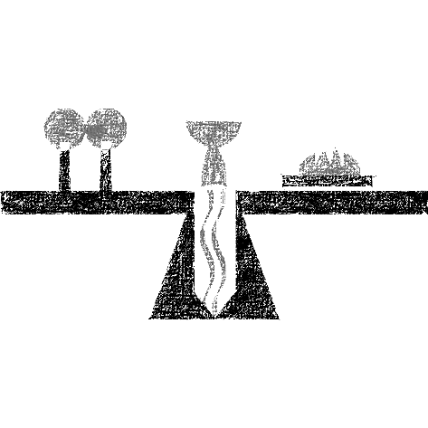

MEAL
God feeds us with the presence of Jesus Christ.

Presentation of the Gifts (Nicaragua)
Offertory Prayer
Gracious God,
in your great love you richly provide for our needs.
Make of these gifts a banquet of blessing,
and make us ready to share with all in need;
through Jesus Christ, who sets a table for all.
Amen.


Dialogue
The Lord be with you.
And also with you.

Lift up your hearts.
We lift them to the Lord.

Let us give thanks to the Lord our God.
It is right to give our thanks and praise.

Preface
It is indeed right and salutary that we should
at all times and in all places
offer thanks and praise to you, O Lord, holy Father,
through Christ our Lord;

who on this day overcame death and the grave,
and by his glorious resurrection
opened to us the way of everlasting life.

And so, with the Church on earth
and the hosts of heaven,
we praise your name
and join their unending hymn:

Sanctus (Austria)



Great Thanksgiving
Holy God,
our Maker, Redeemer, and Healer,
in the harmonious world of your creation,
the plants and animals,
the seas and stars
were whole and well in your praise.

When sin had scarred the world,
you sent your Son to heal our ills
and to form us again into one.

In the night in which he was betrayed,
our Lord Jesus took bread, and gave thanks;
broke it, and gave it to his disciples, saying:
Take and eat; this is my body, given for you.
Do this for the remembrance of me.

Again, after supper, he took the cup, gave thanks,
and gave it for all to drink, saying:
This cup is the new covenant in my blood,
shed for you and for all people for the forgiveness of sin.
Do this for the remembrance of me.

Remembering, therefore,
his acts of healing,
his body given up,
and his victory over death,
we await that day when all the peoples of the earth
will come to the river to enjoy the tree of life.

Send your Spirit upon us and this meal:
as grains scattered on the hillside become one bread,
so let your Church be gathered from the ends of the earth,
that all may be fed with the Bread of life, your Son.

Through him all glory and honor is yours,
Almighty Father, with the Holy Spirit,
in your holy Church,
both now and forever.
Amen

Lord’s Prayer
Lord, remember us in your kingdom, and teach us to pray:

Our Father, who art in heaven,
hallowed be thy name,
thy kingdom come,
thy will be done,
on earth as it is in heaven.
Give us this day our daily bread;
and forgive us our trespasses,
as we forgive those
who trespass against us;
and lead us not into temptation,
but deliver us from evil.
For thine is the kingdom,
and the power, and the glory,
forever and ever. Amen.

Communion Distribution
All are welcome to the communion table! God is the host and God's love extends to all people. During this period of social distancing due to COVID-19, not all in our community are ready to be present at Resurrection. Nevertheless, there are ways for you to participate! We celebrate this holy meal as the community of peace, love and mercy.

- We have resources on our website to help you celebrate Holy Communion at home, either along with a live broadcast or at another time.
- Pastor Karen can bring the Eucharist to you at home. Please contact the office or Pastor Karen to make arrangements.

We would be happy to light a candle in thankfulness, of concern, or in memory of a person at your request.

Invitation to Communion
In Christ’s presence there is fullness of joy.
Come to the banquet.

Communion Song (America)

Communion
The body of Christ, given for you.

Amen.
The blood of Christ, shed for you.
Amen.

Communion Blessing
The body and blood of our Lord Jesus Christ
strengthen you and keep you in God's grace.
Amen.

Post-Communion Canticle (South Africa)

Prayer After Communion
God of the abundant table,
you have refreshed our hearts in this meal
with bread for the journey.
Give us your grace on the road
that we might serve our neighbors with joy;
for the sake of Jesus Christ, our Lord.
Amen.

SENDING
God blesses us and sends us in mission to the world.

Mission Statement
Let us announce together,
The mission of Resurrection Lutheran Church is to promote spiritual growth in Christ and service to all people.

Blessing
God, who gives life to all things
and frees us from despair,
bless you with truth and peace.

And may the holy Trinity, ☩ one God,
guide you always in faith, hope, and love.
Amen.

Sending Song: Lift High the Cross

Dismissal
Go in peace, with Christ beside you.
Thanks be to God.

From sundaysandseasons.com.
Copyright © 2022 Augsburg Fortress. All rights reserved.

