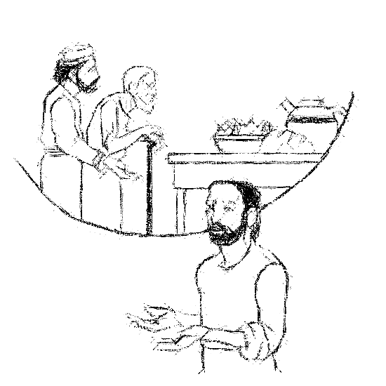

Welcome to
Resurrection Lutheran Church

740 West 10th Street, Juneau, Alaska 99801
Office: (907) 586-2380 rlcoffice@ak.net
Pastor: (907) 885-6824 (voice only) rlcpastor@ak.net
(808) 782-6653 (text and voice)

www.rlcjuneau.org www.rlclive.org

August 28, 2022 Twelfth Sunday after Pentecost/Lectionary 22C

Introduction to the day
Invited and inviting—that is the nature of the church. By God’s grace in holy baptism we have a place at Christ’s banquet table. When, by the power of that same Spirit, humility and mutual love continue among us, the church can be more inviting still.

Prelude

Welcome and Announcements

GATHERING
The Holy Spirit calls us together as the people of God.

Texts for Sunday, September 4, 2022
13th Sunday after Pentecost / Lectionary 23C
Deuteronomy 30:15-20
Psalm 1
Philemon 1-21
Luke 14:25-33

Brief Order for Confession and Forgiveness
Blessed be the holy Trinity,☩ one God,
whose steadfast love endures forever.
Amen.

Let us confess our sin in the presence of God and of one another.

Silence is kept for reflection.

Merciful God,
we confess that we have not followed your path
but have chosen our own way.
Instead of putting others before ourselves,
we long to take the best seats at the table.
When met by those in need,
we have too often passed by on the other side.
Set us again on the path of life.
Save us from ourselves
and free us to love our neighbors.
Amen.

Hear the good news!
God does not deal with us according to our sins
but delights in granting pardon and mercy.
In the name of ☩ Jesus Christ, your sins are forgiven.
You are free to love as God loves.
Amen.





Gathering Song: Look Who Gathers at Christ's Table

Greeting
The grace of our Lord Jesus Christ, the love of God,
and the communion of the Holy Spirit be with you all.
And also with you.

Kyrie (Ghana)
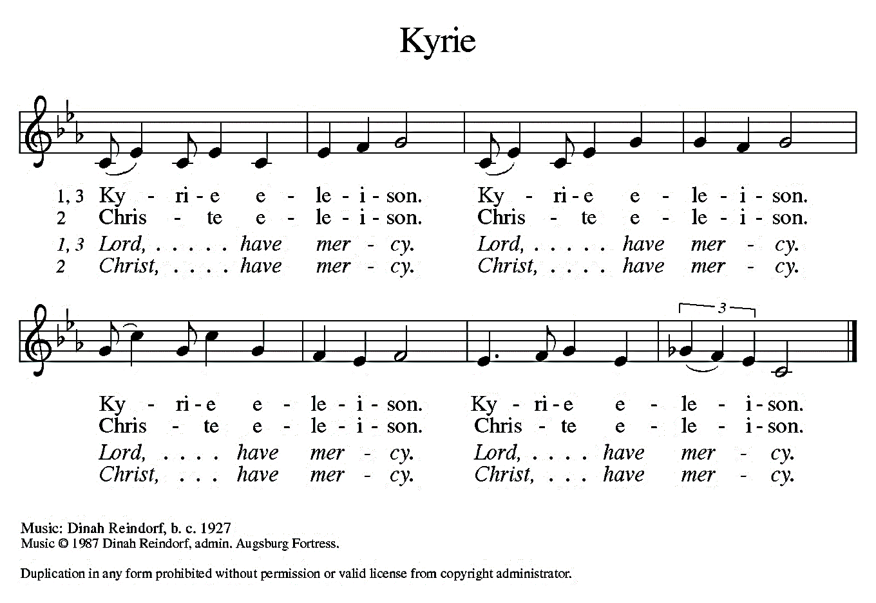


Hymn of Praise (Great Britain)
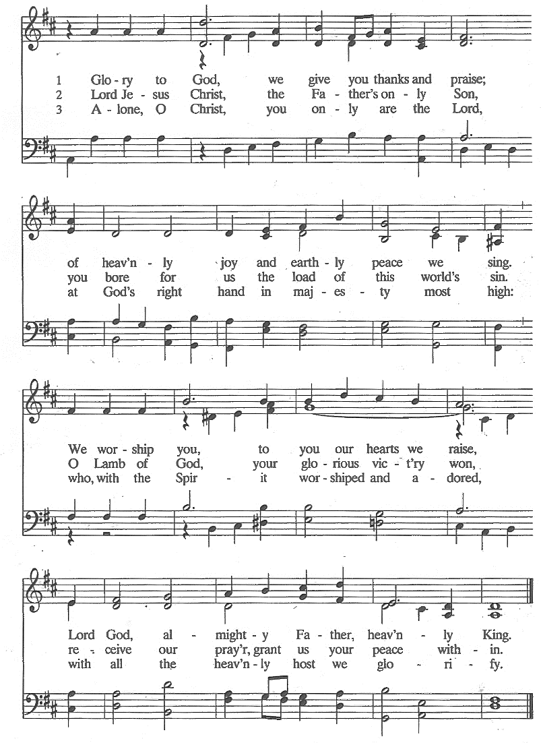
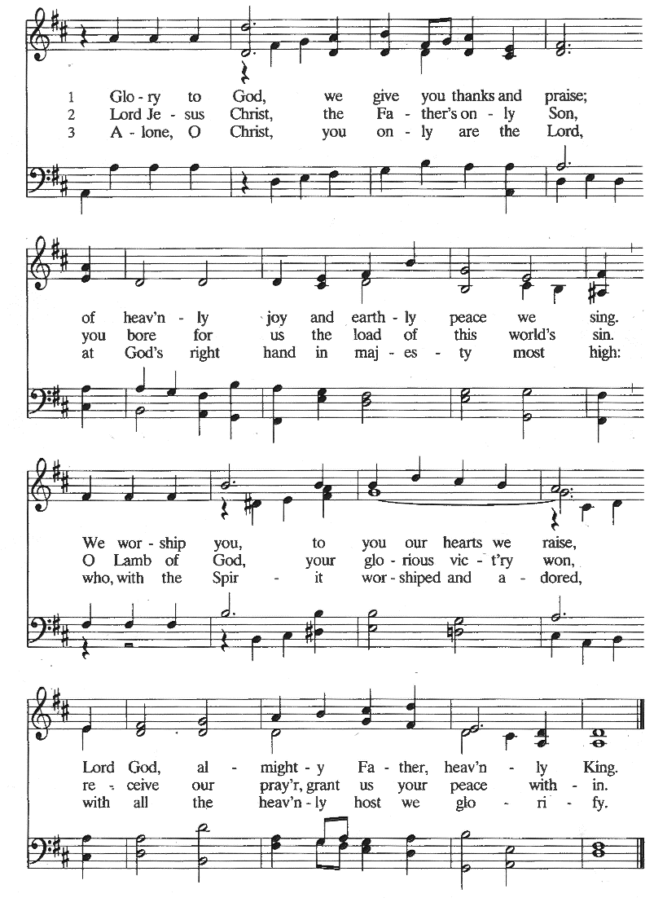

Prayer of the Day
The Lord be with you.
And also with you.

Let us pray.
O God, we thank you for your Son who chose the path of suffering for the sake of the world. Humble us by his example, point us to the path of obedience, and give us strength to follow his commands; through your Son, Jesus Christ our Lord.
Amen.

WORD
God speaks to us in scripture reading, preaching, and song.

First Reading: Proverbs 25:6-7
The book of Proverbs is part of a collection of writings known as wisdom literature. Wisdom literature gave directions to Israel’s leaders and people for the conduct of daily life. Today’s reading is about humility.

A reading from Proverbs.

⁶Do not put yourself forward in the king’s presence
or stand in the place of the great;
⁷for it is better to be told, “Come up here,”
than to be put lower in the presence of a noble.

The word of the Lord.
Thanks be to God.

Psalm: Psalm 112
The righteous are merciful and full of compassion. (Ps. 112:4)

¹Hallelujah! Happy are they who fear the Lord
and have great delight in his commandments!
²Their descendants will be mighty in the land;
the generation of the upright will be blessed. R

³Wealth and riches will be in their house,
and their righteousness will last forever.
⁴Light shines in the darkness for the upright;
the righteous are merciful and full of compassion.
⁵It is good for them to be generous in lending
and to manage their affairs with justice.
⁶For they will never be shaken;
the righteous will be kept in everlasting remembrance. R

⁷They will not be afraid of any evil rumors;
their heart is right; they put their trust in the Lord.
⁸Their heart is established and will not shrink,
until they see their desire upon their enemies.
⁹They have given freely to the poor,
and their righteousness stands fast forever;
they will hold up their head with honor.
¹⁰The wicked will see it and be angry;
they will gnash their teeth and pine away;
the desires of the wicked will perish. R


Second Reading: Hebrews 13:1-8, 15-16
The conclusion of the letter to the Hebrews contains suggestions for the conduct of a holy life, all of which are shaped by God’s love toward us in Jesus Christ.

A reading from Hebrews.

¹Let mutual love continue. ²Do not neglect to show hospitality to strangers, for by doing that some have entertained angels without knowing it. ³Remember those who are in prison, as though you were in prison with them; those who are being tortured, as though you yourselves were being tortured. ⁴Let marriage be held in honor by all, and let the marriage bed be kept undefiled; for God will judge fornicators and adulterers. ⁵Keep your lives free from the love of money, and be content with what you have; for he has said, “I will never leave you or forsake you.” ⁶So we can say with confidence,

“The Lord is my helper;
I will not be afraid.
What can anyone do to me?”

⁷Remember your leaders, those who spoke the word of God to you; consider the outcome of their way of life, and imitate their faith. ⁸Jesus Christ is the same yesterday and today and forever. ¹⁵Through him, then, let us continually offer a sacrifice of praise to God, that is, the fruit of lips that confess his name. ¹⁶Do not neglect to do good and to share what you have, for such sacrifices are pleasing to God.

The word of the Lord.
Thanks be to God.

Children’s’ Time Amanda Beebe-Bay


Gospel Acclamation (South Africa)

Gospel: Luke 14:1, 7-14
Jesus observes guests jockeying for position at the table. He uses the opportunity to teach his hearers to choose humility rather than self-exaltation. Jesus also makes an appeal for hosts to imitate God’s gracious hospitality to those in need.

The Holy Gospel according to Luke, the 14th chapter.
Glory to you, O Lord.

¹On one occasion when Jesus was going to the house of a leader of the Pharisees to eat a meal on the sabbath, they were watching him closely.

⁷When he noticed how the guests chose the places of honor, he told them a parable. ⁸“When you are invited by someone to a wedding banquet, do not sit down at the place of honor, in case someone more distinguished than you has been invited by your host; ⁹and the host who invited both of you may come and say to you, ‘Give this person your place,’ and then in disgrace you would start to take the lowest place. ¹⁰But when you are invited, go and sit down at the lowest place, so that when your host comes, he may say to you, ‘Friend, move up higher’; then you will be honored in the presence of all who sit at the table with you. ¹¹For all who exalt themselves will be humbled, and those who humble themselves will be exalted.”

¹²He said also to the one who had invited him, “When you give a luncheon or a dinner, do not invite your friends or your brothers or your relatives or rich neighbors, in case they may invite you in return, and you would be repaid. ¹³But when you give a banquet, invite the poor, the crippled, the lame, and the blind. ¹⁴And you will be blessed, because they cannot repay you, for you will be repaid at the resurrection of the righteous.”

The Gospel of the Lord.
Praise to you, O Christ.


SermoN Pastor Karen Perkins

Hymn of the Day:


Apostles’ Creed
I believe in God, the Father almighty,
creator of heaven and earth.

I believe in Jesus Christ, God’s only Son, our Lord.
Who was conceived by the power of the Holy Spirit
and born of the virgin Mary.
He suffered under Pontius Pilate,
was crucified, died, and was buried.
He descended into hell.
On the third day he rose again.
He ascended into heaven,
and is seated at the right hand of the Father.
He will come again to judge the living and the dead.

I believe in the Holy Spirit,
the holy catholic church,
the communion of saints,
the forgiveness of sins,
the resurrection of the body,
and the life everlasting. Amen

Prayer Refrain: Abba, Abba, Hear Us (Korea)
The Prayers
Trusting in God’s extraordinary love, let us come near to the Holy One in prayer.

For the church and its leaders, we pray. Uphold all deacons, pastors, and bishops who serve and teach your people. Awaken in your church a spirit of invitation that reaches ever outward. Merciful God,
receive our prayer.

For the well-being of creation and its inhabitants, we pray. Stir in us reverent awe for the beauty of the natural world, for oceans and lakes, rivers and streams, forests and deserts, mountains and glaciers. Merciful God,
receive our prayer.

For the nations and peoples of the world, we pray. Sustain the efforts of those who pursue justice and equity for all. Defend and accompany all immigrants and refugees and all who are persecuted for their ethnic origin or religious beliefs. Merciful God,
receive our prayer.

For all who suffer in body, mind, or spirit, we pray. Be present with those who live in isolation or fear, especially those who are incarcerated or detained, Leora and others seeking housing. Comfort all who are sick or grieving. Merciful God,
receive our prayer.

For this congregation and its ministries, we pray. Prepare children, teachers, and youth ministry directors for a new year of learning. Embolden our witness to invite others to the table. Merciful God,
receive our prayer.

For the ELCA and its leaders, we pray. Guide Presiding Bishop Elizabeth Eaton, Alaska Synod Bishop Shelly Wickstrom, Bishop Tessa Moon Leiseth of our sister synod, and Pastor Karen Perkins. Bless our neighbors in the Alaska Southeast Cluster, and Petersburg Lutheran Church. Merciful God,
receive our prayer.

For what else do the people of God pray?

For all the saints who confessed God’s name, especially Augustine, Bishop of Hippo, and Moses the Black, we give thanks. May we cling to the promise of our risen Savior, Jesus Christ, the same yesterday, today, and forever. Merciful God,
receive our prayer.

Receive the prayers of your children, merciful God, and hold us forever in your steadfast love; through Jesus Christ, our holy Wisdom.
Amen.

Repeat Prayer Refrain (Korea)


Peace
The peace of the Lord be with you always.
And also with you.

We greet each other with a gesture of peace. We are conscious there are different comfort levels around social-distancing at this time. A nod, wave, phone call or email may be most appropriate for you. This greeting is a sign of the risen Christ who unites us and calls us to recognize the peace of God in one another.
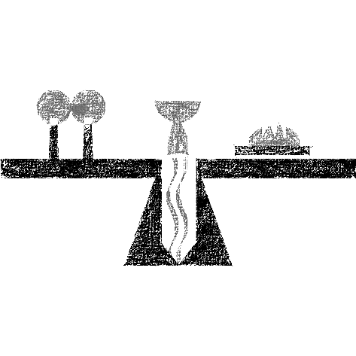

MEAL
God feeds us with the presence of Jesus Christ.

Presentation of the Gifts (Nicaragua)
Offertory Prayer
Let us pray.

God of abundance:
you have set before us a plentiful harvest.
As we feast on your goodness,
strengthen us to labor in your field,
and equip us to bear fruit for the good of all,
in the name of Jesus.

Amen.

Dialogue
The Lord be with you.
And also with you.

Lift up your hearts.
We lift them to the Lord.

Let us give thanks to the Lord our God.
It is right to give our thanks and praise.

Preface
It is indeed right and salutary that we should
at all times and in all places
offer thanks and praise to you, O Lord, holy Father,
through Christ our Lord;

who on this day overcame death and the grave,
and by his glorious resurrection
opened to us the way of everlasting life.

And so, with the Church on earth
and the hosts of heaven,
we praise your name
and join their unending hymn:

Sanctus (Austria)

Great Thanksgiving
Holy God,
our Maker, Redeemer, and Healer,
in the harmonious world of your creation,
the plants and animals,
the seas and stars
were whole and well in your praise.

When sin had scarred the world,
you sent your Son to heal our ills
and to form us again into one.

In the night in which he was betrayed,
our Lord Jesus took bread, and gave thanks;
broke it, and gave it to his disciples, saying:
Take and eat; this is my body, given for you.
Do this for the remembrance of me.

Again, after supper, he took the cup, gave thanks,
and gave it for all to drink, saying:
This cup is the new covenant in my blood,
shed for you and for all people for the forgiveness of sin.
Do this for the remembrance of me.

Remembering, therefore,
his acts of healing,
his body given up,
and his victory over death,
we await that day when all the peoples of the earth
will come to the river to enjoy the tree of life.

Send your Spirit upon us and this meal:
as grains scattered on the hillside become one bread,
so let your Church be gathered from the ends of the earth,
that all may be fed with the Bread of life, your Son.

Through him all glory and honor is yours,
Almighty Father, with the Holy Spirit,
in your holy Church,
both now and forever.
Amen

Lord’s Prayer
Lord, remember us in your kingdom, and teach us to pray:

Our Father, who art in heaven,
hallowed be thy name,
thy kingdom come,
thy will be done,
on earth as it is in heaven.
Give us this day our daily bread;
and forgive us our trespasses,
as we forgive those
who trespass against us;
and lead us not into temptation,
but deliver us from evil.
For thine is the kingdom,
and the power, and the glory,
forever and ever. Amen.

Communion Distribution
All are welcome to the communion table! God is the host and God's love extends to all people. During this period of social distancing due to COVID-19, not all in our community are ready to be present at Resurrection. Nevertheless, there are ways for you to participate! We celebrate this holy meal as the community of peace, love and mercy.

- We have resources on our website to help you celebrate Holy Communion at home, either along with a live broadcast or at another time.
- Pastor Karen can bring the Eucharist to you at home. Please contact the office or Pastor Karen to make arrangements.

We would be happy to light a candle in thankfulness, of concern, or in memory of a person at your request.

Invitation to Communion
In Christ’s presence there is fullness of joy.
Come to the banquet.

Communion Song (America)

Communion
The body of Christ, given for you.

Amen.
The blood of Christ, shed for you.
Amen.

Communion Blessing
The body and blood of our Lord Jesus Christ
strengthen you and keep you in God's grace.
Amen.

Post-Communion Canticle (South Africa)

Prayer After Communion
Life-giving God,
through this meal you have bandaged our wounds
and fed us with your mercy.
Now send us forth to live for others,
both friend and stranger,
that all may come to know your love.
This we pray in the name of Jesus.
Amen.

SENDING
God blesses us and sends us in mission to the world.

Mission Statement
Let us announce together,
The mission of Resurrection Lutheran Church is to promote spiritual growth in Christ and service to all people.

Blessing
The God of peace,

Father, ☩ Son, and Holy Spirit,
bless you, comfort you,
and show you the path of life
this day and always.
Amen.

Sending Song: Will You Let Me Be Your Servant

Dismissal
Go in peace. Love your neighbor.
Thanks be to God.

From sundaysandseasons.com.
Copyright © 2022 Augsburg Fortress. All rights reserved.

