

Welcome to
Resurrection Lutheran Church

740 West 10th Street, Juneau, Alaska 99801
Office: (907) 586-2380 rlcoffice@ak.net
Pastor: (907) 885-6824 (voice only) rlcpastor@ak.net
(808) 782-6653 (text and voice)

www.rlcjuneau.org www.rlclive.org

August 21, 2022 Eleventh Sunday after Pentecost/Lectionary 21C

Introduction to the day
Remember the sabbath day. Call the sabbath a delight. This is the Lord’s day, and the Lord will do for us what the Lord does: feed us, forgive us, help and heal us. Rejoice at all the wonderful things God is doing.

Prelude

Welcome and Announcements

GATHERING
The Holy Spirit calls us together as the people of God.

Texts for Sunday, August 28, 2022
12th Sunday after Pentecost / Lectionary 22C
Proverbs 25:6-7
Psalm 112
Hebrews 13:1-8, 15-16
Luke 14:1, 7-14

From sundaysandseasons.com.
Copyright © 2022 Augsburg Fortress. All rights reserved.

Brief Order for Confession and Forgiveness
Blessed be the holy Trinity,☩ one God,
whose steadfast love endures forever.
Amen.

Let us confess our sin in the presence of God and of one another.

Silence is kept for reflection.

Merciful God,
we confess that we have not followed your path
but have chosen our own way.
Instead of putting others before ourselves,
we long to take the best seats at the table.
When met by those in need,
we have too often passed by on the other side.
Set us again on the path of life.
Save us from ourselves
and free us to love our neighbors.
Amen.

Hear the good news!
God does not deal with us according to our sins
but delights in granting pardon and mercy.
In the name of ☩ Jesus Christ, your sins are forgiven.
You are free to love as God loves.
Amen.



Gathering Song: Praise to the Lord, the Almighty

Greeting
The grace of our Lord Jesus Christ, the love of God,
and the communion of the Holy Spirit be with you all.
And also with you.

Kyrie (Ghana)
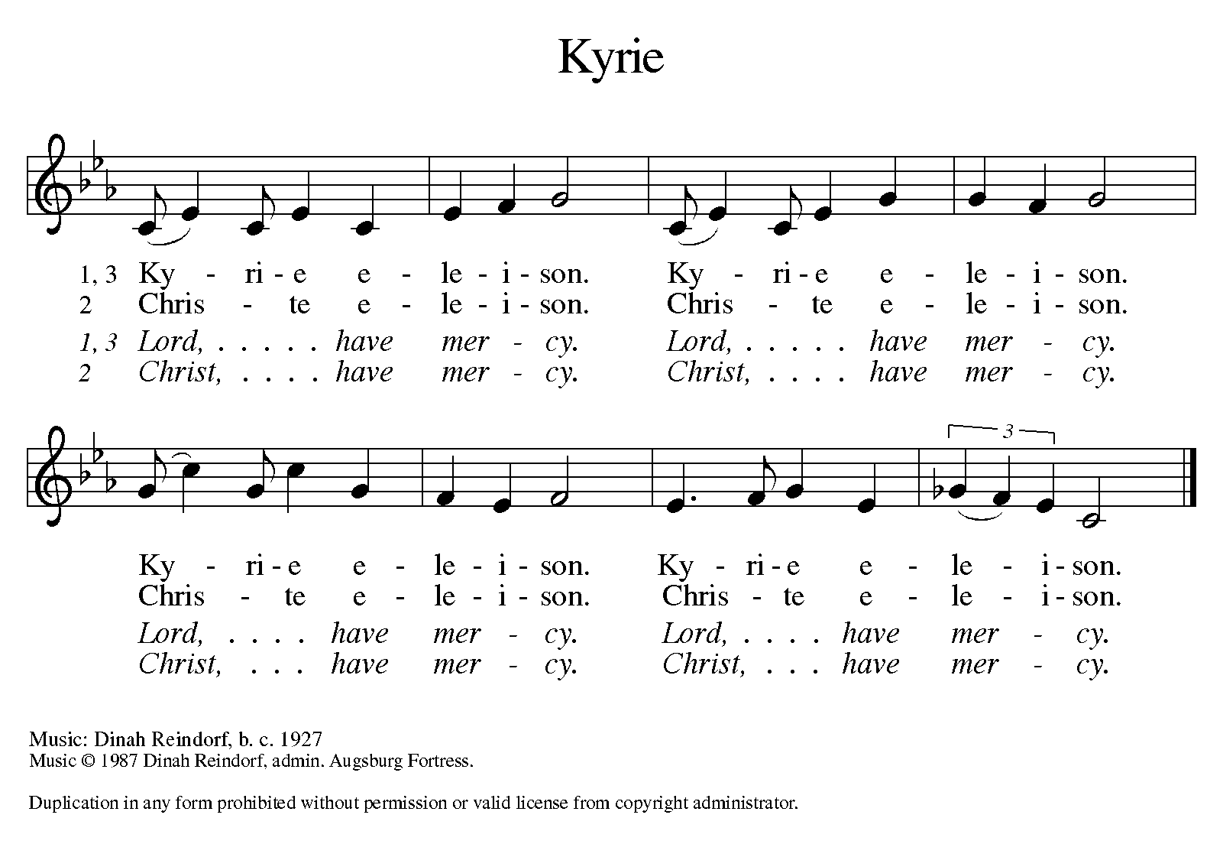

Hymn of Praise (Great Britain)
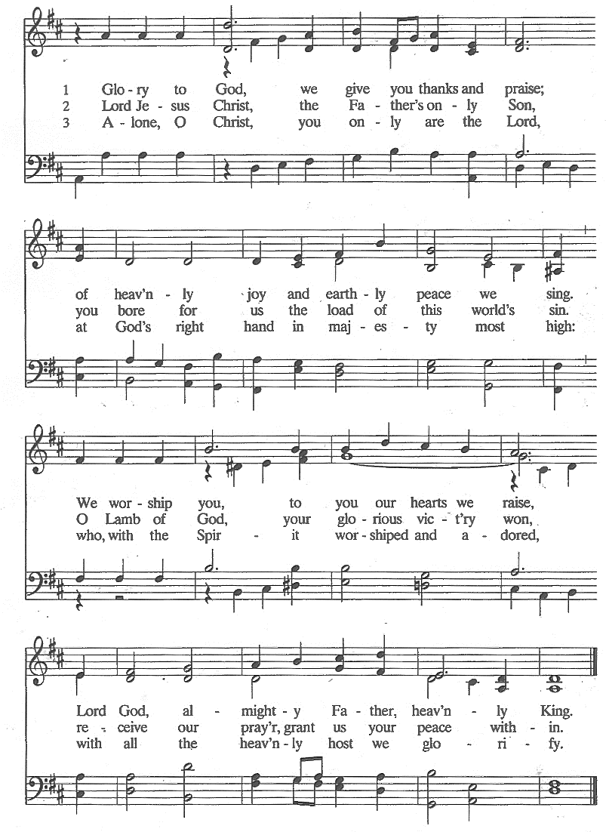
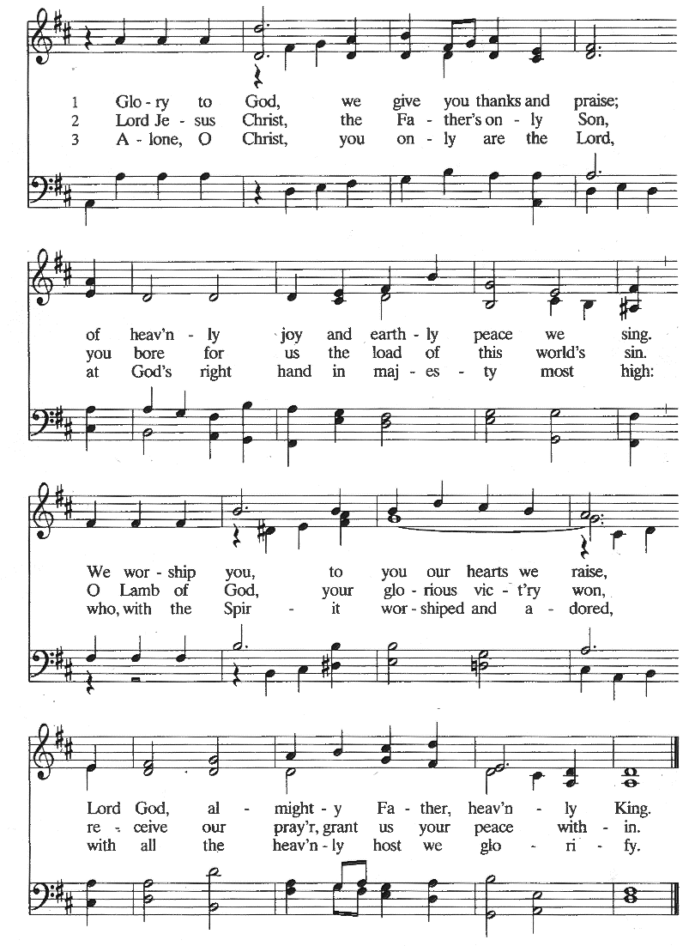

Prayer of the Day
The Lord be with you.
And also with you.

Let us pray.
God of all creation, you reach out to call people of all nations to your kingdom. As you gather disciples from near and far, count us also among those who boldly confess your Son Jesus Christ as Lord.
Amen.

WORD
God speaks to us in scripture reading, preaching, and song.

First Reading: Isaiah 58:9b-14
God promises those who have returned from exile that where justice and mercy prevail, the ruins will be rebuilt and light will rise in the darkness. It is a day for new beginnings.

A reading from Isaiah.

^{9b}If you remove the yoke from among you,
the pointing of the finger, the speaking of evil,
¹⁰if you offer your food to the hungry
and satisfy the needs of the afflicted,
then your light shall rise in the darkness
and your gloom be like the noonday.
¹¹The Lord will guide you continually,
and satisfy your needs in parched places,
and make your bones strong;
and you shall be like a watered garden,
like a spring of water,
whose waters never fail.
¹²Your ancient ruins shall be rebuilt;
you shall raise up the foundations of many generations;
you shall be called the repairer of the breach,
the restorer of streets to live in.

¹³If you refrain from trampling the sabbath,
from pursuing your own interests on my holy day;
if you call the sabbath a delight
and the holy day of the Lord honorable;
if you honor it, not going your own ways,
serving your own interests, or pursuing your own affairs;
¹⁴then you shall take delight in the Lord,
and I will make you ride upon the heights of the earth;
I will feed you with the heritage of your ancestor Jacob,
for the mouth of the Lord has spoken.

The word of the Lord.
Thanks be to God.

Psalm: Psalm 103:1-8
The Lord crowns you with mercy and lovingkindness. (Ps. 103:4)

¹Bless the Lord, O my soul,
and all that is within me, bless his holy name.
²Bless the Lord, O my soul,
and forget not all his benefits.
³He forgives all your sins
and heals all your infirmities;
⁴he redeems your life from the grave
and crowns you with mercy and lovingkindness; R

⁵he satisfies you with good things,
and your youth is renewed like an eagle’s.
⁶The Lord executes righteousness
and judgment for all who are oppressed.
⁷He made his ways known to Moses
and his works to the children of Israel.
⁸The Lord is full of compassion and mercy,
slow to anger and of great kindness. R
Second Reading: Hebrews 12:18-29
Using images of Moses, the writer presents a striking vision of the new covenant of God made possible in Christ. There is no longer fear; only awe in the new promise in Christ into which we are invited.

A reading from Hebrews.

¹⁸You have not come to something that can be touched, a blazing fire, and darkness, and gloom, and a tempest, ¹⁹and the sound of a trumpet, and a voice whose words made the hearers beg that not another word be spoken to them. ²⁰(For they could not endure the order that was given, “If even an animal touches the mountain, it shall be stoned to death.” ²¹Indeed, so terrifying was the sight that Moses said, “I tremble with fear.”) ²²But you have come to Mount Zion and to the city of the living God, the heavenly Jerusalem, and to innumerable angels in festal gathering, ²³and to the assembly of the firstborn who are enrolled in heaven, and to God the judge of all, and to the spirits of the righteous made perfect, ²⁴and to Jesus, the mediator of a new covenant, and to the sprinkled blood that speaks a better word than the blood of Abel.

²⁵See that you do not refuse the one who is speaking; for if they did not escape when they refused the one who warned them on earth, how much less will we escape if we reject the one who warns from heaven! ²⁶At that time his voice shook the earth; but now he has promised, “Yet once more I will shake not only the earth but also the heaven.” ²⁷This phrase, “Yet once more,” indicates the removal of what is shaken—that is, created things—so that what cannot be shaken may remain. ²⁸Therefore, since we are receiving a kingdom that cannot be shaken, let us give thanks, by which we offer to God an acceptable worship with reverence and awe; ²⁹for indeed our God is a consuming fire.

The word of the Lord.
Thanks be to God.

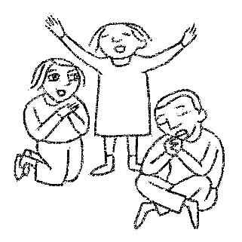
Children’s’ Time Karen Lawfer



Gospel Acclamation (South Africa)

Gospel: Luke 13:10-17
Jesus heals a woman on the sabbath, offering her a new beginning for her life. When challenged by a narrow reading of the sabbath command, Jesus responds by expanding “sabbath work” to include setting people free from bondage.

The Holy Gospel according to Luke, the 13^{h} chapter.
Glory to you, O Lord.

¹⁰Now [Jesus] was teaching in one of the synagogues on the sabbath. ¹¹And just then there appeared a woman with a spirit that had crippled her for eighteen years. She was bent over and was quite unable to stand up straight. ¹²When Jesus saw her, he called her over and said, “Woman, you are set free from your ailment.” ¹³When he laid his hands on her, immediately she stood up straight and began praising God. ¹⁴But the leader of the synagogue, indignant because Jesus had cured on the sabbath, kept saying to the crowd, “There are six days on which work ought to be done; come on those days and be cured, and not on the sabbath day.” ¹⁵But the Lord answered him and said, “You hypocrites! Does not each of you on the sabbath untie his ox or his donkey from the manger, and lead it away to give it water? ¹⁶And ought not this woman, a daughter of Abraham whom Satan bound for eighteen long years, be set free from this bondage on the sabbath day?” ¹⁷When he said this, all his opponents were put to shame; and the entire crowd was rejoicing at all the wonderful things that he was doing.

The Gospel of the Lord.
Praise to you, O Christ.

SermoN Pastor Karen Perkins




Hymn of the Day: Build a Longer Table
Apostles’ Creed
I believe in God, the Father almighty,
creator of heaven and earth.
I believe in Jesus Christ, God’s only Son, our Lord.
Who was conceived by the power of the Holy Spirit
and born of the virgin Mary.
He suffered under Pontius Pilate,
was crucified, died, and was buried.
He descended into hell.
On the third day he rose again.
He ascended into heaven,
and is seated at the right hand of the Father.
He will come again to judge the living and the dead.
I believe in the Holy Spirit,
the holy catholic church,
the communion of saints,
the forgiveness of sins,
the resurrection of the body,
and the life everlasting. Amen

Prayer Refrain: Abba, Abba, Hear Us (Korea)

The Prayers
Trusting in God’s extraordinary love, let us come near to the Holy One in prayer.

You crown your church with steadfast love and mercy. Guide us continually in our baptismal covenant to strive for justice and peace in all the earth. Use our diverse gifts in service to the whole people of God. Merciful God,
receive our prayer.

You satisfy the needs of all creatures. Protect the habitats of fish and birds. Repair ecosystems damaged by misuse, neglect, or natural disasters. Shelter areas suffering severe heat and fires. Let all creation may thrive. Merciful God,
receive our prayer.

You make your ways known to all people. Inspire the rulers and leaders of nations with your compassion and mercy. Raise up activists and community organizers to restore places affected by violence, poverty, and inequality. Merciful God,
receive our prayer.

You provide justice for all who are oppressed and relief to all who are afflicted. Heal those who are bent over by addiction, depression, and anxiety. Set free all who cry out under the weight of mental, emotional, or physical distress. Merciful God,
receive our prayer.

You call us to delight in the sabbath. Renew our bodies, minds, and spirits in this worshiping assembly. Give rest to all who lead our congregation in worship, study, and service, especially our Food Pantry volunteers. Merciful God,
receive our prayer.

Arise, O God, and sustain your church. Guide Presiding Bishop Elizabeth Eaton, Alaska Synod Bishop Shelly Wickstrom, Bishop Tessa Moon Leiseth of our sister synod, and Pastor Karen Perkins. Bless our neighbors in the Alaska Southeast Cluster, and Petersburg Lutheran Church. Merciful God,
receive our prayer.

For what else do the people of God pray?

Generations bless your holy name. We give you thanks for the communion of saints who have gathered in prayer and praise in this place. Support us in your love until we rest forever in you. Merciful God,
receive our prayer.

Receive the prayers of your children, merciful God, and hold us forever in your steadfast love; through Jesus Christ, our holy Wisdom.
Amen.

Repeat Prayer Refrain (Korea)

Peace
The peace of the Lord be with you always.
And also with you.

We greet each other with a gesture of peace. We are conscious there are different comfort levels around social-distancing at this time. A nod, wave, phone call or email may be most appropriate for you. This greeting is a sign of the risen Christ who unites us and calls us to recognize the peace of God in one another.
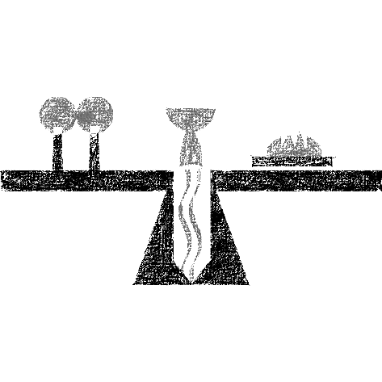

MEAL
God feeds us with the presence of Jesus Christ.

Presentation of the Gifts (Nicaragua)

Offertory Prayer
Let us pray.

God of abundance:
you have set before us a plentiful harvest.
As we feast on your goodness,
strengthen us to labor in your field,
and equip us to bear fruit for the good of all,
in the name of Jesus.

Amen.

Dialogue
The Lord be with you.
And also with you.

Lift up your hearts.
We lift them to the Lord.

Let us give thanks to the Lord our God.
It is right to give our thanks and praise.

Preface
It is indeed right and salutary that we should
at all times and in all places
offer thanks and praise to you, O Lord, holy Father,
through Christ our Lord;

who on this day overcame death and the grave,
and by his glorious resurrection
opened to us the way of everlasting life.

And so, with the Church on earth
and the hosts of heaven,
we praise your name
and join their unending hymn:

Sanctus (Austria)

Great Thanksgiving
Holy God,
our Maker, Redeemer, and Healer,
in the harmonious world of your creation,
the plants and animals,
the seas and stars
were whole and well in your praise.

When sin had scarred the world,
you sent your Son to heal our ills
and to form us again into one.

In the night in which he was betrayed,
our Lord Jesus took bread, and gave thanks;
broke it, and gave it to his disciples, saying:
Take and eat; this is my body, given for you.
Do this for the remembrance of me.

Again, after supper, he took the cup, gave thanks,
and gave it for all to drink, saying:
This cup is the new covenant in my blood,
shed for you and for all people for the forgiveness of sin.
Do this for the remembrance of me.

Remembering, therefore,
his acts of healing,
his body given up,
and his victory over death,
we await that day when all the peoples of the earth
will come to the river to enjoy the tree of life.

Send your Spirit upon us and this meal:
as grains scattered on the hillside become one bread,
so let your Church be gathered from the ends of the earth,
that all may be fed with the Bread of life, your Son.

Through him all glory and honor is yours,
Almighty Father, with the Holy Spirit,
in your holy Church,
both now and forever.
Amen

Lord’s Prayer
Lord, remember us in your kingdom, and teach us to pray:

Our Father, who art in heaven,
hallowed be thy name,
thy kingdom come,
thy will be done,
on earth as it is in heaven.
Give us this day our daily bread;
and forgive us our trespasses,
as we forgive those
who trespass against us;
and lead us not into temptation,
but deliver us from evil.
For thine is the kingdom,
and the power, and the glory,
forever and ever. Amen.

Communion Distribution
All are welcome to the communion table! God is the host and God's love extends to all people. During this period of social distancing due to COVID-19, not all in our community are ready to be present at Resurrection. Nevertheless, there are ways for you to participate! We celebrate this holy meal as the community of peace, love and mercy.

- We have resources on our website to help you celebrate Holy Communion at home, either along with a live broadcast or at another time.
- Pastor Karen can bring the Eucharist to you at home. Please contact the office or Pastor Karen to make arrangements.

We would be happy to light a candle in thankfulness, of concern, or in memory of a person at your request.

Invitation to Communion
In Christ’s presence there is fullness of joy.
Come to the banquet.

Communion Song (America)

Communion
The body of Christ, given for you.
Amen.
The blood of Christ, shed for you.
Amen.

Communion Blessing
The body and blood of our Lord Jesus Christ
strengthen you and keep you in God's grace.
Amen.

Post-Communion Canticle (South Africa)

Prayer After Communion
Life-giving God,
through this meal you have bandaged our wounds
and fed us with your mercy.
Now send us forth to live for others,
both friend and stranger,
that all may come to know your love.
This we pray in the name of Jesus.
Amen.

SENDING
God blesses us and sends us in mission to the world.

Mission Statement
Let us announce together,
The mission of Resurrection Lutheran Church is to promote spiritual growth in Christ and service to all people.

Blessing
The God of peace,

Father, ☩ Son, and Holy Spirit,
bless you, comfort you,
and show you the path of life
this day and always.
Amen.

Sending Song: How Firm a Foundation

Dismissal
Go in peace. Love your neighbor.
Thanks be to God.

