

Welcome to
Resurrection Lutheran Church

740 West 10th Street, Juneau, Alaska 99801
Office: (907) 586-2380 rlcoffice@ak.net
Pastor: (907) 885-6824 (voice only) rlcpastor@ak.net
(808) 782-6653 (text and voice)

www.rlcjuneau.org www.rlclive.org

August 14, 2022 Tenth Sunday after Pentecost/Lectionary 20C

Introduction to the day
The word of God is a refining fire. Jesus is the great divide in human history. He invites our undivided attention and devotion. Today in worship we are surrounded by a great “cloud of witnesses.” In the word and in holy communion we are invited yet again to look to Jesus, “the pioneer and perfecter of our faith.”

Prelude

Welcome and Announcements

GATHERING
The Holy Spirit calls us together as the people of God.

Brief Order for Confession and Forgiveness
Blessed be the holy Trinity,☩ one God,
whose steadfast love endures forever.
Amen.

Let us confess our sin in the presence of God and of one another.

Silence is kept for reflection.

Merciful God,
we confess that we have not followed your path
but have chosen our own way.
Instead of putting others before ourselves,
we long to take the best seats at the table.
When met by those in need,
we have too often passed by on the other side.
Set us again on the path of life.
Save us from ourselves
and free us to love our neighbors.
Amen.

Hear the good news!
God does not deal with us according to our sins
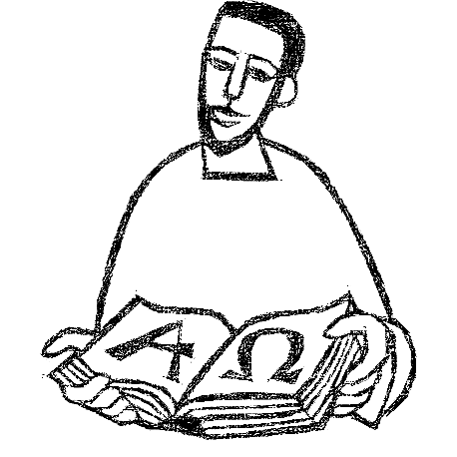
but delights in granting pardon and mercy.
In the name of ☩ Jesus Christ, your sins are forgiven.
You are free to love as God loves.
Amen.

Gathering Song: Thy Strong Word

Greeting
The grace of our Lord Jesus Christ, the love of God,
and the communion of the Holy Spirit be with you all.
And also with you.



Kyrie (Ghana)

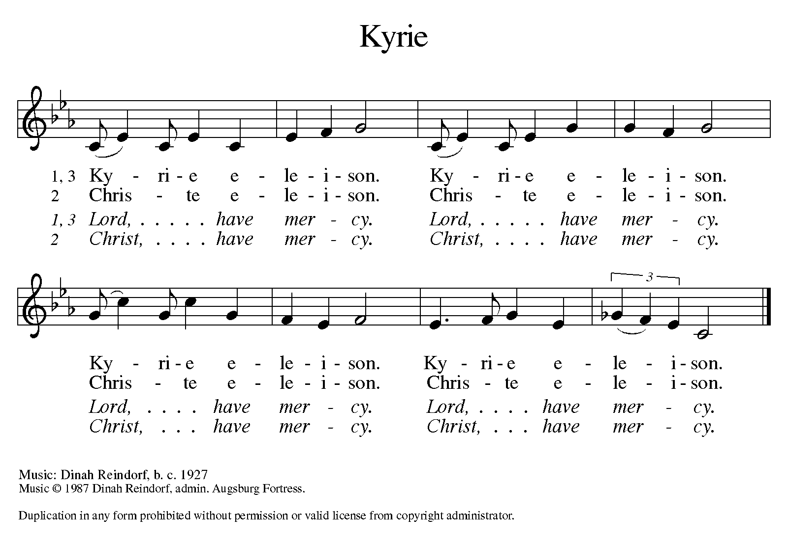

Hymn of Praise (Great Britain)
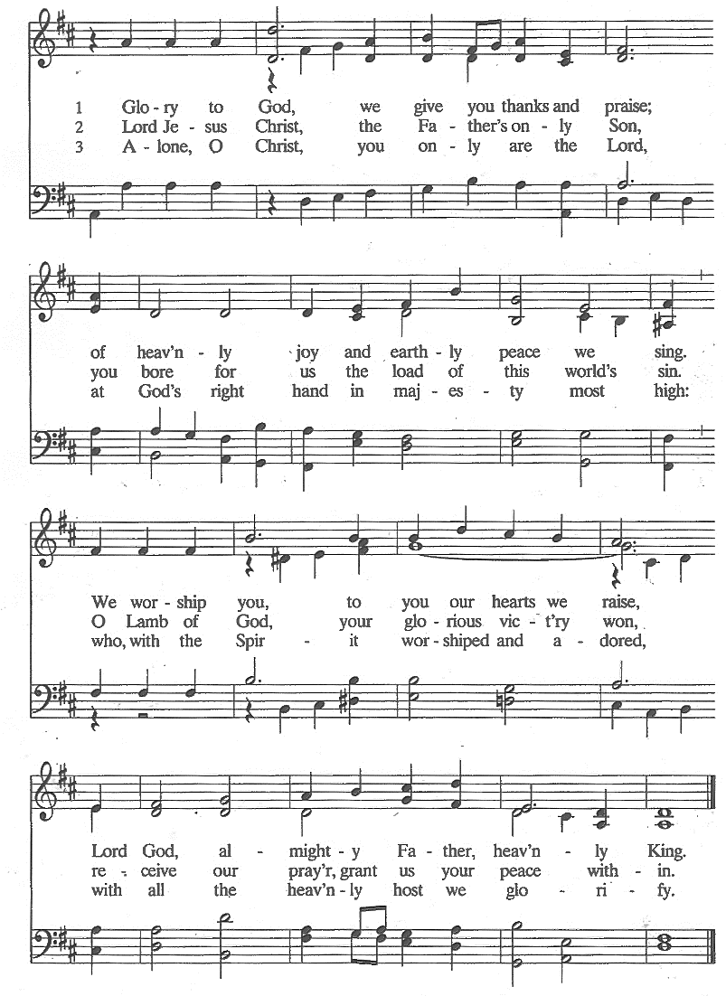

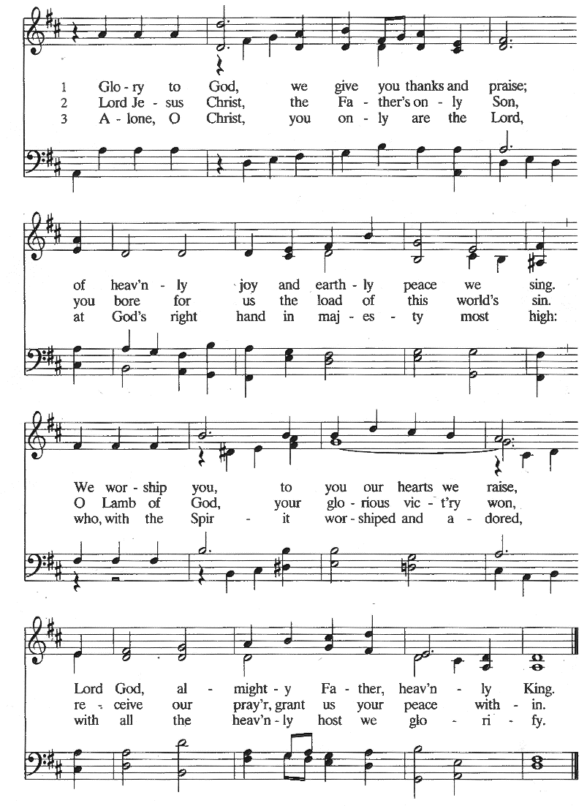

Prayer of the Day
The Lord be with you.
And also with you.

Let us pray.
Almighty and ever-living God, you have given great and precious promises to those who believe. Grant us the perfect faith which overcomes all doubts, through your Son, Jesus Christ our Lord.

Amen.

WORD
God speaks to us in scripture reading, preaching, and song.

First Reading: Jeremiah 23:23-29
Because Jeremiah preaches the unpopular message of God’s judgment, he suffers rejection. Today’s reading distinguishes between the true prophet, like Jeremiah, who speaks God’s word, and the false prophet who misleads the people through dreams. One is like wheat; the other like worthless straw.

A reading from Jeremiah.

²³Am I a God near by, says the Lord, and not a God far off? ²⁴Who can hide in secret places so that I cannot see them? says the Lord. Do I not fill heaven and earth? says the Lord. ²⁵I have heard what the prophets have said who prophesy lies in my name, saying, “I have dreamed, I have dreamed!” ²⁶How long? Will the hearts of the prophets ever turn back—those who prophesy lies, and who prophesy the deceit of their own heart? ²⁷They plan to make my people forget my name by their dreams that they tell one another, just as their ancestors forgot my name for Baal. ²⁸Let the prophet who has a dream tell the dream, but let the one who has my word speak my word faithfully. What has straw in common with wheat? says the Lord. ²⁹Is not my word like fire, says the Lord, and like a hammer that breaks a rock in pieces?

The word of the Lord.
Thanks be to God.

Psalm: Psalm 82
Arise, O God, and rule the earth. (Ps. 82:8)

¹God takes his stand in the council of heaven;
he gives judgment in the midst of the gods:
²“How long will you judge unjustly,
and show favor to the wicked?
³Save the weak and the orphan;
defend the humble and needy;
⁴rescue the weak and the poor;
deliver them from the power of the wicked. R

⁵They do not know, neither do they understand;
they go about in darkness;
all the foundations of the earth are shaken.
⁶Now I say to you, ‘You are gods,
and all of you children of the Most High;
⁷nevertheless, you shall die like mortals,
and fall like any prince.’ ”
⁸Arise, O God, and rule the earth,
for you shall take all nations for your own. R

Second Reading: Hebrews 11:29--12:2
The author of Hebrews presents us with rich stories of faith. In a long list of biblical heroes, we find examples of trust in God that enabled them to face the trials of life faithfully. In addition to this “cloud of witnesses,” we have Jesus, the perfect model of faithful endurance.

A reading from Hebrews.

²⁹By faith the people passed through the Red Sea as if it were dry land, but when the Egyptians attempted to do so they were drowned. ³⁰By faith the walls of Jericho fell after they had been encircled for seven days. ³¹By faith Rahab the prostitute did not perish with those who were disobedient, because she had received the spies in peace.

³²And what more should I say? For time would fail me to tell of Gideon, Barak, Samson, Jephthah, of David and Samuel and the prophets—³³who through faith conquered kingdoms, administered justice, obtained promises, shut the mouths of lions, ³⁴quenched raging fire, escaped the edge of the sword, won strength out of weakness, became mighty in war, put foreign armies to flight. ³⁵Women received their dead by resurrection. Others were tortured, refusing to accept release, in order to obtain a better resurrection. ³⁶Others suffered mocking and flogging, and even chains and imprisonment. ³⁷They were stoned to death, they were sawn in two, they were killed by the sword; they went about in skins of sheep and goats, destitute, persecuted, tormented—³⁸of whom the world was not worthy. They wandered in deserts and mountains, and in caves and holes in the ground.

³⁹Yet all these, though they were commended for their faith, did not receive what was promised, ⁴⁰since God had provided something better so that they would not, apart from us, be made perfect.

^{12:1}Therefore, since we are surrounded by so great a cloud of witnesses, let us also lay aside every weight and the sin that clings so closely, and let us run with perseverance the race that is set before us, ²looking to Jesus the pioneer and perfecter of our faith, who for the sake of the joy that was set before him endured the cross, disregarding its shame, and has taken his seat at the right hand of the throne of God.

The word of the Lord.
Thanks be to God.

Children’s’ Time Amanda Beebe-Bay
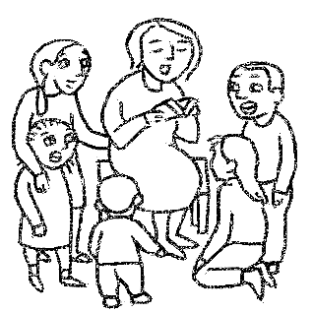

Texts for Sunday, August 21, 2022
11th Sunday after Pentecost / Lectionary 21C
Isaiah 58:9b-14
Psalm 103:1-8
Hebrews 12:18-29
Luke 13:10-17

Gospel Acclamation (South Africa)

Gospel: Luke 12:49-56
Jesus delivers harsh words about the purifying and potentially divisive effects of obedience to God’s call. The way of the cross often leads followers to encounter hostility and rejection, even from those they love.

The Holy Gospel according to Luke, the 12th chapter.
Glory to you, O Lord.

[Jesus said:] ⁴⁹“I came to bring fire to the earth, and how I wish it were already kindled! ⁵⁰I have a baptism with which to be baptized, and what stress I am under until it is completed! ⁵¹Do you think that I have come to bring peace to the earth? No, I tell you, but rather division! ⁵²From now on five in one household will be divided, three against two and two against three; ⁵³they will be divided:
father against son
and son against father,
mother against daughter
and daughter against mother,
mother-in-law against her daughter-in-law
and daughter-in-law against mother-in-law.”
⁵⁴He also said to the crowds, “When you see a cloud rising in the west, you immediately say, ‘It is going to rain’; and so it happens. ⁵⁵And when you see the south wind blowing, you say, ‘There will be scorching heat’; and it happens. ⁵⁶You hypocrites! You know how to interpret the appearance of earth and sky, but why do you not know how to interpret the present time?”

The Gospel of the Lord.
Praise to you, O Christ.

SermoN Pastor Karen Perkins




Hymn of the Day: If God My Lord Be for Me
Apostles’ Creed
I believe in God, the Father almighty,
creator of heaven and earth.
I believe in Jesus Christ, God’s only Son, our Lord.
Who was conceived by the power of the Holy Spirit
and born of the virgin Mary.
He suffered under Pontius Pilate,
was crucified, died, and was buried.
He descended into hell.
On the third day he rose again.
He ascended into heaven,
and is seated at the right hand of the Father.
He will come again to judge the living and the dead.
I believe in the Holy Spirit,
the holy catholic church,
the communion of saints,
the forgiveness of sins,
the resurrection of the body,
and the life everlasting. Amen

Prayer Refrain: Abba, Abba, Hear Us (Korea)

The Prayers
Trusting in God’s extraordinary love, let us come near to the Holy One in prayer.

Arise, O God, and sustain your church. We pray for all who dedicate their lives to serving your people. Renew our commitment to our siblings in faith around the globe, and bless the work of our ecumenical and interfaith partners. Merciful God,
receive our prayer.

Arise, O God, and sustain your creation. We pray for all places affected by natural disasters. Transform the devastation of floods and fires into fertile ground for new life and growth. Fill heaven and earth with your life-giving Spirit. Merciful God,
receive our prayer.

Arise, O God, and sustain the nations. We pray for all elected officials. Kindle in them a desire to administer your justice. Strengthen their resolve to defend those who are vulnerable and to stand publicly against all forms of oppression. Merciful God,
receive our prayer.

Arise, O God, and sustain those who are oppressed. We pray for people harmed by racist discrimination, ableist discrimination, and all people discriminated against based on their gender identity or sexual orientation. Rescue us from all systems that degrade our fellow human beings. Merciful God,
receive our prayer.

Arise, O God, and sustain this assembly. We pray for this community, celebrating with those who rejoice and weeping with those who weep. In our joy and in our tears, be near us. Merciful God,
receive our prayer.

Arise, O God, and sustain your church. Guide Presiding Bishop Elizabeth Eaton, Alaska Synod Bishop Shelly Wickstrom, Bishop Tessa Moon Leiseth of our sister synod, and Pastor Karen Perkins. Bless our neighbors in the Alaska Southeast Cluster, and Petersburg Lutheran Church. Merciful God,
receive our prayer.

For what else do the people of God pray?

With thanksgiving we remember all who have died in faith and now rest in you. As they placed their hope in you, so strengthen us to trust in your promise of new life. Merciful God,
receive our prayer.

Receive the prayers of your children, merciful God, and hold us forever in your steadfast love; through Jesus Christ, our holy Wisdom.
Amen.

Repeat Prayer Refrain (Korea)

Peace
The peace of the Lord be with you always.
And also with you.

We greet each other with a gesture of peace. We are conscious there are different comfort levels around social-distancing at this time. A nod, wave, phone call or email may be most appropriate for you. This greeting is a sign of the risen Christ who unites us and calls us to recognize the peace of God in one another.


MEAL
God feeds us with the presence of Jesus Christ.

Presentation of the Gifts (Nicaragua)

Offertory Prayer
Let us pray.

God of abundance:
you have set before us a plentiful harvest.
As we feast on your goodness,
strengthen us to labor in your field,
and equip us to bear fruit for the good of all,

in the name of Jesus.
Amen.

Dialogue
The Lord be with you.
And also with you.

Lift up your hearts.
We lift them to the Lord.

Let us give thanks to the Lord our God.
It is right to give our thanks and praise.

Preface
It is indeed right and salutary that we should
at all times and in all places
offer thanks and praise to you, O Lord, holy Father,
through Christ our Lord;

who on this day overcame death and the grave,
and by his glorious resurrection
opened to us the way of everlasting life.

And so, with the Church on earth
and the hosts of heaven,
we praise your name
and join their unending hymn:

Sanctus (Austria)

Great Thanksgiving
Holy God,
our Maker, Redeemer, and Healer,
in the harmonious world of your creation,
the plants and animals,
the seas and stars
were whole and well in your praise.

When sin had scarred the world,
you sent your Son to heal our ills
and to form us again into one.

In the night in which he was betrayed,
our Lord Jesus took bread, and gave thanks;
broke it, and gave it to his disciples, saying:
Take and eat; this is my body, given for you.
Do this for the remembrance of me.

Again, after supper, he took the cup, gave thanks,
and gave it for all to drink, saying:
This cup is the new covenant in my blood,
shed for you and for all people for the forgiveness of sin.
Do this for the remembrance of me.

Remembering, therefore,
his acts of healing,
his body given up,
and his victory over death,
we await that day when all the peoples of the earth
will come to the river to enjoy the tree of life.

Send your Spirit upon us and this meal:
as grains scattered on the hillside become one bread,
so let your Church be gathered from the ends of the earth,
that all may be fed with the Bread of life, your Son.

Through him all glory and honor is yours,
Almighty Father, with the Holy Spirit,
in your holy Church,
both now and forever.
Amen

Lord’s Prayer
Lord, remember us in your kingdom, and teach us to pray:

Our Father, who art in heaven,
hallowed be thy name,
thy kingdom come,
thy will be done,
on earth as it is in heaven.
Give us this day our daily bread;
and forgive us our trespasses,
as we forgive those
who trespass against us;
and lead us not into temptation,
but deliver us from evil.
For thine is the kingdom,
and the power, and the glory,
forever and ever. Amen.

Communion Distribution
All are welcome to the communion table! God is the host and God's love extends to all people. During this period of social distancing due to COVID-19, not all in our community are ready to be present at Resurrection. Nevertheless, there are ways for you to participate! We celebrate this holy meal as the community of peace, love and mercy.

- We have resources on our website to help you celebrate Holy Communion at home, either along with a live broadcast or at another time.
- Pastor Karen can bring the Eucharist to you at home. Please contact the office or Pastor Karen to make arrangements.

We would be happy to light a candle in thankfulness, of concern, or in memory of a person at your request.

Invitation to Communion
In Christ’s presence there is fullness of joy.
Come to the banquet.

Communion Song (America)

Communion
The body of Christ, given for you.
Amen.
The blood of Christ, shed for you.
Amen.

Communion Blessing
The body and blood of our Lord Jesus Christ
strengthen you and keep you in God's grace.
Amen.

Post-Communion Canticle (South Africa)

Prayer After Communion
Life-giving God,
through this meal you have bandaged our wounds
and fed us with your mercy.
Now send us forth to live for others,
both friend and stranger,
that all may come to know your love.
This we pray in the name of Jesus.
Amen.

SENDING
God blesses us and sends us in mission to the world.

Mission Statement
Let us announce together,
The mission of Resurrection Lutheran Church is to promote spiritual growth in Christ and service to all people.

Blessing
The God of peace,
Father, ☩ Son, and Holy Spirit,
bless you, comfort you,
and show you the path of life
this day and always.
Amen.


Sending Song: Lead On, O King Eternal!

Dismissal
Go in peace. Love your neighbor.
Thanks be to God.

From sundaysandseasons.com.
Copyright © 2022 Augsburg Fortress. All rights reserved.

