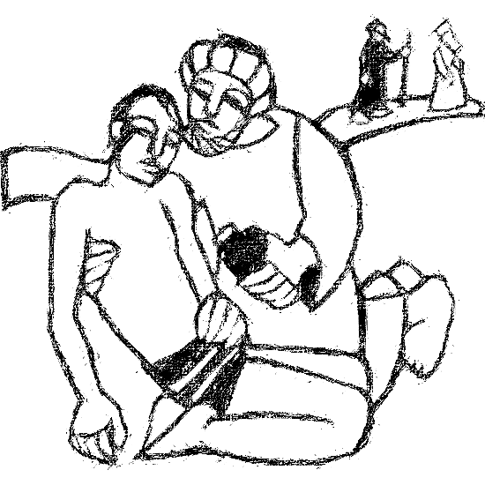

**Welcome to**

**Resurrection Lutheran Church**

740 West 10th Street, Juneau, Alaska 99801

Office: (907) 586-2380 [rlcoffice@ak.net](mailto:rlcoffice@ak.net)

Pastor: (907) 885-6824 (voice only) [rlcpastor@ak.net](mailto:rlcpastor@ak.net)

(808) 782-6653 (text and voice)

[www.rlcjuneau.org](http://www.rlcjuneau.org) [www.rlclive.org](http://www.rlclive.org)

**July 10, 2022 Lectionary 15 / 5th Sunday after Pentecost**

**Introduction to the day**

*This Sunday’s texts paint startling pictures of the horrific nature of sin. The church’s repeated celebration of holy communion counters that tragic reality in a continued showing forth of the death of Jesus until he comes again. It is a dramatic declaration of “how much God has done for you.”*

**Welcome and Announcements**

**Prelude**

**GATHERING**

The Holy Spirit calls us together as the people of God.

**Confession and Forgiveness**

Blessed be the holy Trinity,☩ one God,

whose steadfast love endures forever.

**Amen.**

Let us confess our sin in the presence of God and of one another.

Merciful God,

**we confess that we have not followed your path**

**but have chosen our own way.**

**Instead of putting others before ourselves,**

**we long to take the best seats at the table.**

**When met by those in need,**

**we have too often passed by on the other side.**

**Set us again on the path of life.**

**Save us from ourselves**

**and free us to love our neighbors.**

**Amen.**

Hear the good news!

God does not deal with us according to our sins

but delights in granting pardon and mercy.

In the name of ☩ Jesus Christ, your sins are forgiven.

You are free to love as God loves.

**Amen.**

**Gathering Song: I Love to Tell the Story**



**Greeting**

The grace of our Lord Jesus Christ, the love of God,

and the communion of the Holy Spirit be with you all.

**And also with you.**

**KyriE**

**Canticle of Praise**

**Prayer of the Day**

Let us pray.

O Lord God, your mercy delights us, and the world longs for your loving care. Hear the cries of everyone in need, and turn our hearts to love our neighbors with the love of your Son, Jesus Christ, our Savior and Lord.

**Amen.**

**WORD**

God speaks to us in scripture reading, preaching, and song.

**First Reading: Deuteronomy 30:9-14**

*Moses calls the people who are about to enter the promised land to renew the covenant God made with their ancestors. Through this covenant God gives life and asks for obedience. God’s commandment is neither burdensome nor too far off, but dwells in the people’s hearts.*

A reading from Deuteronomy.

9The Lord your God will make you abundantly prosperous in all your undertakings, in the fruit of your body, in the fruit of your livestock, and in the fruit of your soil. For the Lord will again take delight in prospering you, just as he delighted in prospering your ancestors, 10when you obey the Lord your God by observing his commandments and decrees that are written in this book of the law, because you turn to the Lord your God with all your heart and with all your soul.

11Surely, this commandment that I am commanding you today is not too hard for you, nor is it too far away. 12It is not in heaven, that you should say, “Who will go up to heaven for us, and get it for us so that we may hear it and observe it?” 13Neither is it beyond the sea, that you should say, “Who will cross to the other side of the sea for us, and get it for us so that we may hear it and observe it?” 14No, the word is very near to you; it is in your mouth and in your heart for you to observe.

The word of the Lord.

**Thanks be to God.**

**Psalm: Psalm 25:1-10**

*Show me your ways, O Lord, and teach me your paths.*(Ps. 25:4)

1To you, O Lord,

  I lift up my soul.

2**My God, I put my trust in you; let me not be put to shame,**

**nor let my enemies triumph over me.**

3Let none who look to you be put to shame;

  rather let those be put to shame who are treacherous.

4**Show me your ways, O Lord,**

**and teach me your paths.** R

5Lead me in your truth and teach me,

  for you are the God of my salvation; in you have I trusted all the day long.

6**Remember, O Lord, your compas sion and love,**

**for they are from everlasting.**

7Remember not the sins of my youth and my transgressions;

  remember me according to your steadfast love

and for the sake of your goodness, O Lord.

8**You are gracious and upright, O Lord;**

**therefore you teach sinners in your way.**

9You lead the lowly in justice

  and teach the lowly your way.

10**All your paths, O Lord, are steadfast love and faithfulness**

**to those who keep your covenant and your testimonies.** R

**Second Reading: Colossians 1:1-14**

*The letter to the Colossians was written to warn its readers of various false teachings. The first part of the letter is an expression of thanks for the faith, hope, and love that mark this community, including a prayer for strength and courage.*

A reading from Colossians.

1Paul, an apostle of Christ Jesus by the will of God, and Timothy our brother,

2To the saints and faithful brothers and sisters in Christ in Colossae:

  Grace to you and peace from God our Father.

3In our prayers for you we always thank God, the Father of our Lord Jesus Christ, 4for we have heard of your faith in Christ Jesus and of the love that you have for all the saints, 5because of the hope laid up for you in heaven. You have heard of this hope before in the word of the truth, the gospel 6that has come to you. Just as it is bearing fruit and growing in the whole world, so it has been bearing fruit among yourselves from the day you heard it and truly comprehended the grace of God. 7This you learned from Epaphras, our beloved fellow servant. He is a faithful minister of Christ on your behalf, 8and he has made known to us your love in the Spirit.

9For this reason, since the day we heard it, we have not ceased praying for you and asking that you may be filled with the knowledge of God’s will in all spiritual wisdom and understanding, 10so that you may lead lives worthy of the Lord, fully pleasing to him, as you bear fruit in every good work and as you grow in the knowledge of God. 11May you be made strong with all the strength that comes from his glorious power, and may you be prepared to endure everything with patience, while joyfully 12giving thanks to the Father, who has enabled you to share in the inheritance of the saints in the light. 13He has rescued us from the power of darkness and transferred us into the kingdom of his beloved Son, 14in whom we have redemption, the forgiveness of sins.

The word of the Lord.

**Thanks be to God.**

**Gospel Acclamation**

**Gospel: Luke 10:25-37**

*Jesus is challenged to explain what is involved in obeying the greatest commandment. He tells a parable rich in surprises: those expected to show pity display hard hearts while the lowly give and receive unexpected and lavish mercy.*

The holy gospel according to Luke.

**Glory to you, O Lord.**

25Just then a lawyer stood up to test Jesus. “Teacher,” he said, “what must I do to inherit eternal life?” 26He said to him, “What is written in the law? What do you read there?” 27He answered, “You shall love the Lord your God with all your heart, and with all your soul, and with all your strength, and with all your mind; and your neighbor as yourself.” 28And he said to him, “You have given the right answer; do this, and you will live.”

29But wanting to justify himself, he asked Jesus, “And who is my neighbor?” 30Jesus replied, “A man was going down from Jerusalem to Jericho, and fell into the hands of robbers, who stripped him, beat him, and went away, leaving him half dead. 31Now by chance a priest was going down that road; and when he saw him, he passed by on the other side. 32So likewise a Levite, when he came to the place and saw him, passed by on the other side. 33But a Samaritan while traveling came near him; and when he saw him, he was moved with pity. 34He went to him and bandaged his wounds, having poured oil and wine on them. Then he put him on his own animal, brought him to an inn, and took care of him. 35The next day he took out two denarii, gave them to the innkeeper, and said, ‘Take care of him; and when I come back, I will repay you whatever more you spend.’ 36Which of these three, do you think, was a neighbor to the man who fell into the hands of the robbers?” 37He said, “The one who showed him mercy.” Jesus said to him, “Go and do likewise.”

The gospel of the Lord.

**Praise to you, O Christ.**

**Message** Randy Sutak

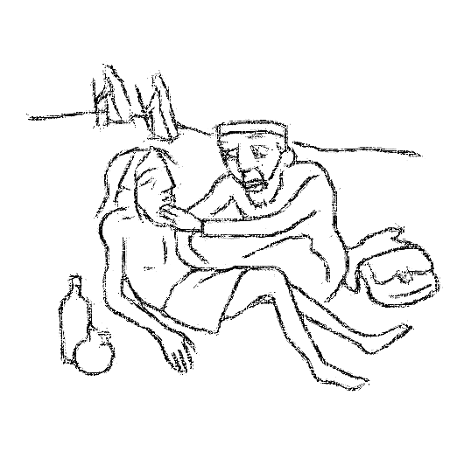

**Hymn of the Day: Will You Let Me Be Your Servant**

**Apostles’ Creed**

Let us confess together,

**I believe in God, the Father almighty,**

**creator of heaven and earth.**

**I believe in Jesus Christ, God’s only Son, our Lord,**

**who was conceived by the Holy Spirit,**

**born of the virgin Mary,**

**suffered under Pontius Pilate,**

**was crucified, died, and was buried;**

**he descended to the dead.**

**On the third day he rose again;**

**he ascended into heaven,**

**he is seated at the right hand of the Father,**

**and he will come to judge the living and the dead.**

**I believe in the Holy Spirit,**

**the holy catholic church,**

**the communion of saints,**

**the forgiveness of sins,**

**the resurrection of the body,**

**and the life everlasting. Amen.**

**Prayer Refrain: O Living Breath of God**

**The Prayers**

United in Christ and guided by the Spirit, we pray for the church, the creation, and all in need.

Good and gracious God, you have placed your word of love in the heart of your church. Fill your church with compassion, that we bear the fruit of your healing mercy to a broken world. God of grace,

**hear our prayer.**

You created the earth with seeds sprouting up to new life. We pray for the flourishing of fruit trees and orchards, vines and bushes. Prosper the work of those who plant, tend, harvest, and gather. God of grace,

**hear our prayer.**

Show us your ways and teach us your paths of justice and love. Raise up community and national leaders to challenge and dismantle societal structures that perpetuate ethnic, racial, and religious profiling and discrimination. God of grace,

**hear our prayer.**

Come near to all in need. Orchestrate kindness in the face of cruelty, hope where there is despair, love in the face of neglect, comfort where there is death, and healing in illness. God of grace,

**hear our prayer.**

Turn this community toward neighbors in need. Bring aid and support to those who are poor, beaten down, abused, forgotten, silenced, or avoided. God of grace,

**hear our prayer.**

You hear the cries of those who seek wisdom. Guide all bishops, pastors, missionaries, and other ministers of the gospel, especially Presiding Bishop Elizabeth Eaton, Alaska Synod Bishop Shelly Wickstrom, Bishop Tessa Moon Leiseth of our sister synod, and Pastor Karen Perkins. Bless our neighbors in the Alaska Southeast Cluster, and in River of Life Lutheran Church, Chugiak. God, in your mercy,

**hear our prayer.**

For what else do the people of God pray?

We give thanks for the saints who revealed your love and mercy in this life. Inspired by their witness, strengthen us to live in hope. God of grace,

**hear our prayer.**

God of every time and place, in Jesus’ name and filled with your Holy Spirit, we entrust these spoken prayers and those in our hearts into your holy keeping.

**Amen.**

**Repeat Prayer Refrain**

**Peace**

The peace of the Lord be with you always.

**And also with you.**

We greet each other with a gesture of peace. We are conscious there are different comfort levels around social-distancing at this time. A nod, wave, phone call or email may be most appropriate for you. This greeting is a sign of the risen Christ who unites us and calls us to recognize the peace of God in one another.

**MEAL**

God feeds us with the presence of Jesus Christ.

**Presentation of the Gifts**

**Offering Prayer**

Let us pray.

God of abundance:

you have set before us a plentiful harvest.

As we feast on your goodness,

strengthen us to labor in your field,

and equip us to bear fruit for the good of all,

in the name of Jesus.

**Amen.**

**Dialogue**

The Lord be with you.

**And also with you.**

Lift up your hearts.

**We lift them to the Lord.**

Let us give thanks to the Lord our God.

**It is right to give our thanks and praise.**

**Preface**

It is indeed right, our duty and our joy,

that we should at all times and in all places

give thanks and praise to you, almighty and merciful God.

through our Savior Jesus Christ;

who on this day overcame death and the grave,

and by his glorious resurrection opened to us the way of everlasting life.

And so, with all the choirs of angels,

with the church on earth and the hosts of heaven,

we praise your name and join their unending hymn:

**Holy, Holy, Holy**

**Thanksgiving at the Table**

Holy God,

our Maker, Redeemer, and Healer,

in the harmonious world of your creation,

the plants and animals,

the seas and stars

were whole and well in your praise.

When sin had scarred the world,

you sent your Son to heal our ills

and to form us again into one.

In the night in which he was betrayed,

our Lord Jesus took bread, and gave thanks;

broke it, and gave it to his disciples, saying:

Take and eat; this is my body, given for you.

Do this for the remembrance of me.

Again, after supper, he took the cup, gave thanks,

and gave it for all to drink, saying:

This cup is the new covenant in my blood,

shed for you and for all people for the forgiveness of sin.

Do this for the remembrance of me.

Remembering, therefore,

his acts of healing,

his body given up,

and his victory over death,

we await that day when all the peoples of the earth

will come to the river to enjoy the tree of life.

Send your Spirit upon us and this meal:

as grains scattered on the hillside become one bread,

so let your Church be gathered from the ends of the earth,

that all may be fed with the Bread of life, your Son.

Through him all glory and honor is yours,

Almighty Father, with the Holy Spirit,

in your holy Church,

both now and forever.

**Amen**



**Lord’s Prayer**

Gathered into one by the Holy Spirit, let us pray as Jesus taught us.

**Our Father, who art in heaven,**

**hallowed be thy name,**

**thy kingdom come,**

**thy will be done,**

**on earth as it is in heaven.**

**Give us this day our daily bread;**

**and forgive us our trespasses,**

**as we forgive those**

**who trespass against us;**

**and lead us not into temptation,**

**but deliver us from evil.**

**For thine is the kingdom,**

**and the power, and the glory,**

**forever and ever. Amen.**

**Communion Distribution**

All are welcome to the communion table! God is the host and God's love extends to all people. During this period of social distancing due to COVID-19, not all in our community are ready to be present at Resurrection. Nevertheless, there **are** ways for you to participate! We celebrate this holy meal as the community of peace, love and mercy.

* We have resources on our website to help you celebrate Holy Communion at home, either along with a live broadcast or at another time.
* Pastor Karen can bring the Eucharist to you at home. Please contact the office or Pastor Karen to make arrangements.

We would be happy to light a candle in thankfulness, of concern, or in memory of a person at your request.

**Invitation to Communion**

In Christ’s presence there is fullness of joy.

Come to the banquet.



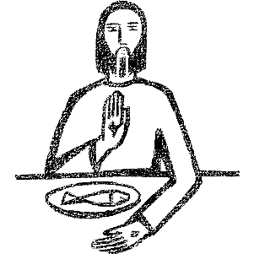

**Communion Song**

**Communion**

The body of Christ, given for you.

**Amen.**

The blood of Christ, shed for you.

**Amen**

**Post Communion Blessing**

The body and blood of our Lord Jesus Christ

strengthen you and keep you in God's grace. **Amen.**

**Song after Communion**

**Prayer After Communion**

Life-giving God,

through this meal you have bandaged our wounds

and fed us with your mercy.

Now send us forth to live for others,

both friend and stranger,

that all may come to know your love.

This we pray in the name of Jesus.

**Amen.**

**SENDING**

God blesses us and sends us in mission to the world.

**Texts for Sunday, June 17, 2022**

**Lectionary 16 / 6th Sunday after Pentecost**

Genesis 18:1-10a

Psalm 15

Colossians 1:15-28

Luke 10:38-42

**Mission Statement**

**Let us announce together:**

**The mission of Resurrection Lutheran Church is to promote spiritual growth in Christ and service to all people.**

**Blessing**

The God of peace,

Father, ☩ Son, and Holy Spirit,

bless you, comfort you,

and show you the path of life

this day and always.

**Amen.**

**Sending Song: Oh, for a Thousand Tongues to Sing**



**Dismissal**

Go in peace. Love your neighbor.

**Thanks be to God.**

*From sundaysandseasons.com. Copyright © 2022 Augsburg Fortress.*

*All rights reserved. Used by permission.*