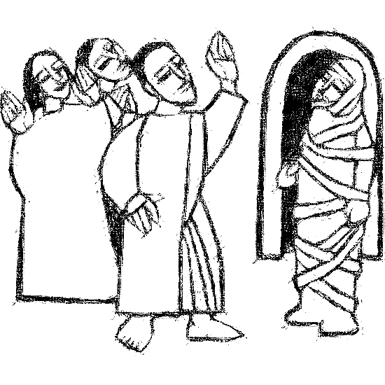

**Welcome to**

**Resurrection Lutheran Church**

740 West 10th Street, Juneau, Alaska 99801

Office: (907) 586-2380 [rlcoffice@ak.net](mailto:rlcoffice@ak.net)

Pastor: (907) 885-6824 (voice only) [rlcpastor@ak.net](mailto:rlcpastor@ak.net)

(808) 782-6653 (text and voice)

[www.rlcjuneau.org](http://www.rlcjuneau.org) [www.rlclive.org](http://www.rlclive.org)

**November 7, 2021 All Saints’ Sunday**

**Introduction to the day**

*Of all three years of the lectionary cycle, this year’s All Saints readings have the most tears. Isaiah and Revelation look forward to the day when God will wipe away all tears; in John’s gospel, Jesus weeps along with Mary and all the gathered mourners before he demonstrates his power over death. On All Saints Day we celebrate the victory won for all the faithful dead, but we grieve for our beloved dead as well, knowing that God honors our tears. We bring our grief to the table and find there a foretaste of Isaiah’s feast to come.*

**Prelude**

**GATHERING**

The Holy Spirit calls us together as the people of God.

**WELCOME AND ANNOUNCEMENTS**

### Confession and Forgiveness

Blessed be the holy Trinity, ☩ one God,

whose teaching is life,

whose presence is sure,

and whose love is endless.

**Amen.**

Let us confess our sins to the one who welcomes us with an open heart.

God our comforter:

**like lost sheep, we have gone astray.**

**We gaze upon abundance and see scarcity.**

**We turn our faces away from injustice and oppression.**

**We exploit the earth with our apathy and greed.**

**Free us from our sin, gracious God.**

**Listen when we call out to you for help.**

**Lead us by your love to love our neighbors as ourselves.**

**Amen.**

All have sinned and fall short of the glory of God.

By the gift of grace in ☩ Christ Jesus, God makes you righteous.

Receive with glad hearts the forgiveness of all your sins.

**Amen.**

**Gathering Song: For All the Saints (vv 1-3, 6-7)**

**Greeting**

The grace of our Lord Jesus Christ, the love of God,

and the communion of the Holy Spirit be with you all.

**And also with you.**





**Kyrie**

**Hymn of Praise**

**Prayer of the Day**

Let us pray.

Almighty God, you have knit your people together in one communion in the mystical body of your Son, Jesus Christ our Lord. Grant us grace to follow your blessed saints in lives of faith and commitment, and to know the inexpressible joys you have prepared for those who love you, through Jesus Christ, our Savior and Lord, who lives and reigns with you and the Holy Spirit, one God, now and forever.

**Amen.**



**WORD**

God speaks to us in scripture reading, preaching, and song.

**First Reading: Isaiah 25:6-9**

*Isaiah sees a vision of the end of days, when God will gather all people on God’s holy mountain and will prepare for them a rich feast. At this banquet God will wipe the tears from all eyes. And there will be no more sorrow, for God will destroy death itself.*

A reading from Isaiah.

6On this mountain the Lord of hosts will make for all peoples

  a feast of rich food, a feast of well-aged wines,

  of rich food filled with marrow, of well-aged wines strained clear.

7And he will destroy on this mountain

  the shroud that is cast over all peoples,

  the sheet that is spread over all nations;

8he will swallow up death forever.

 Then the Lord God will wipe away the tears from all faces,

  and the disgrace of his people he will take away from all the earth,

  for the Lord has spoken.

9It will be said on that day,

  Lo, this is our God; we have waited for him, so that he might save us.

  This is the Lord for whom we have waited;

  let us be glad and rejoice in his salvation.

The word of the Lord.

**Thanks be to God.**

**Psalm: Psalm 24**

*They shall receive blessing from the God of their salvation.*(Ps. 24:5)

1The earth is the Lord’s and all that is in it,

  the world and those who dwell therein.

2**For the Lord has founded it upon the seas**

**and established it upon the rivers.** R

3Who may ascend the mountain of the Lord,

  and who may stand in God’s holy place?

4**Those of innocent hands and purity of heart,**

**who do not swear on God’s being, nor do they pledge by what is false.**

5They shall receive blessing from the Lord

  and righteousness from the God of their salvation.

6**Such is the generation of those who seek you, O Lord,**

**of those who seek your face, O God of Jacob.** R

7Lift up your heads, O gates; and be lifted up, O everlasting doors,

  that the King of glory may come in.

8**Who is this King of glory?**

**The Lord, strong and mighty, the Lord, mighty in battle!**

9Lift up your heads, O gates; and be lifted up, O everlasting doors,

  that the King of glory may come in.

10**Who is this King of glory?**

**Truly, the Lord of hosts is the King of glory.** R

**musical offering: Deep River** Celebration Ringers

**Second Reading: Revelation 21:1-6a**

*Here is a vision of the new heaven and new earth in which God resides fully with God’s people so that mourning, despair, and pain have been eradicated. These renewing words from the God who spans all of time are trustworthy and true.*

A reading from Revelation.

1I saw a new heaven and a new earth; for the first heaven and the first earth had passed away, and the sea was no more. 2And I saw the holy city, the new Jerusalem, coming down out of heaven from God, prepared as a bride adorned for her husband. 3And I heard a loud voice from the throne saying,

 “See, the home of God is among mortals.

 He will dwell with them;

 they will be his peoples,

 and God himself will be with them;

4he will wipe every tear from their eyes.

 Death will be no more;

 mourning and crying and pain will be no more,

 for the first things have passed away.”

5And the one who was seated on the throne said, “See, I am making all things new.” Also he said, “Write this, for these words are trustworthy and true.” 6aThen he said to me, “It is done! I am the Alpha and the Omega, the beginning and the end.”

The word of the Lord.

**Thanks be to God.**

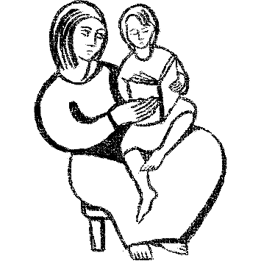

**Children's Time/Reflection**

**Gospel Acclamation**

**Gospel: John 11:32-44**

*Through the raising of Lazarus, Jesus offers the world a vision of the life to come, when death and weeping will be no more.*

The holy gospel according to John.

**Glory to you, O Lord.**

32When Mary came where Jesus was and saw him, she knelt at his feet and said to him, “Lord, if you had been here, my brother would not have died.” 33When Jesus saw her weeping, and the Jews who came with her also weeping, he was greatly disturbed in spirit and deeply moved. 34He said, “Where have you laid him?” They said to him, “Lord, come and see.” 35Jesus began to weep. 36So the Jews said, “See how he loved him!” 37But some of them said, “Could not he who opened the eyes of the blind man have kept this man from dying?”

38Then Jesus, again greatly disturbed, came to the tomb. It was a cave, and a stone was lying against it. 39Jesus said, “Take away the stone.” Martha, the sister of the dead man, said to him, “Lord, already there is a stench because he has been dead four days.” 40Jesus said to her, “Did I not tell you that if you believed, you would see the glory of God?” 41So they took away the stone. And Jesus looked upward and said, “Father, I thank you for having heard me. 42I knew that you always hear me, but I have said this for the sake of the crowd standing here, so that they may believe that you sent me.” 43When he had said this, he cried with a loud voice, “Lazarus, come out!” 44The dead man came out, his hands and feet bound with strips of cloth, and his face wrapped in a cloth. Jesus said to them, “Unbind him, and let him go.”

The gospel of the Lord.

**Praise to you, O Christ.**

**Sermon** Rev. Karen Perkins

**Hymn of the Day: Death Be Never Last**



**Nicene Creed**

**We believe in one God,**

**the Father, the Almighty,**

**maker of heaven and earth,**

**of all that is, seen and unseen.**

**We believe in one Lord, Jesus Christ,**

**the only Son of God,**

**eternally begotten of the Father,**

**God from God, Light from Light,**

**true God from true God,**

**begotten, not made,**

**of one Being with the Father;**

**through him all things were made.**

**For us and for our salvation**

**he came down from heaven,**

**was incarnate of the Holy Spirit and the virgin Mary**

**and became truly human.**

**For our sake he was crucified under Pontius Pilate;**

**he suffered death and was buried.**

**On the third day he rose again**

**in accordance with the scriptures;**

**he ascended into heaven**

**and is seated at the right hand of the Father.**

**He will come again in glory to judge the living and the dead,**

**and his kingdom will have no end.**

**We believe in the Holy Spirit, the Lord, the giver of life,**

**who proceeds from the Father and the Son,\***

**who with the Father and the Son is worshiped and glorified,**

**who has spoken through the prophets.**

**We believe in one holy catholic and apostolic church.**

**We acknowledge one baptism for the forgiveness of sins.**

**We look for the resurrection of the dead,**

**and the life of the world to come. Amen.**

**PRAYER REFRAIN**

**Prayers of Intercession**

Eternal God, you hold firm amid the changes of this world. Hear us now as we pray for the church, the world, and everyone in need.

Merciful God, we give thanks for all missionaries who have brought your message of hope to new communities and wiped tears away Continue to raise up courageous missionaries to share your gospel of hope. Hear us, O God.

**Your mercy is great.**

Creating God, we praise you for abundant harvests and the goodness of creation. Create communities of care for your earth so that all land, water, and soil will be celebrated and cherished by future generations of saints. Hear us, O God.

**Your mercy is great.**

God of peace, we give you thanks for nations of peace that serve as a refuge for all whose homelands are afflicted with violence. Strengthen those who continue to work for peace and support all veterans who carry the scars of war. Hear us, O God.

**Your mercy is great.**

God of healing, we give you thanks for health care workers who labor around the clock to answer cries for help. Bring wholeness to all who struggle with post-traumatic stress disorder, anxiety, depression, addiction, and all who long for healing in any way. Hear us, O God.

**Your mercy is great.**

God of justice, we praise you for the feeding ministries and for all meals that bring people together for nourishment and fellowship. Bless chefs, bakers, servers, dishwashers, communion assistants, and meal ministry coordinators. Hear us, O God.

**Your mercy is great.**

God of wisdom, we pray for all who serve in ministry, especially: Bishop Elizabeth Eaton, Alaska Synod Bishop Shelly Wickstrom, Bishop Terry Brandt of our sister synod; the Alaska Southeast Cluster, Pastor Karen Perkins, and Thornton Memorial Lutheran Church, Wales, that they continue to be formed for the sake of the gospel. Hear us, O God.

**Your mercy is great.**

For what else do the people of God pray?

God of the ages, we give you thanks for the saints of this congregation who have inspired, challenged, loved, and taught us. Wipe away our tears and lead us by their example until we feast together on your holy mountain. Hear us, O God.

**Your mercy is great.**

God our protection and strength, we entrust to you all for whom we pray. Remain with us always, through Jesus Christ, our Savior.

**Amen.**

**Final PRAYER REFRAIN**

**THANKSGIVING FOR THE SAINTS**

O God of the pilgrim’s way, we give thanks for those in generations past who have been examples for us of God’s love at work in the world. As we pray, we know that we are surrounded by this great, rejoicing cloud of witnesses. Yet even as we name these holy ancestors, we thank God for others whose names we never knew or have forgotten, who showed us the meaning of life in Christ.

**Naming the Saints: Remembering**

Celebration Ringers

*Names of our saints will be shown simultaneously with the music.*

For all the saints, we give thanks.

**Holy God, we honor these, our ancestors in faith**

**and members of our family.**

**We, too, seek to do your will: guide us.**

**We, too, desire to be your servants: strengthen us.**

**We, too, long to know you clearly: teach us.**

**And in time, bring us to our eternal home of peace and joy. Amen.**



**PEACE**

The peace of the Lord be with you always.

**And also with you.**

We greet each other with a gesture of peace. We are conscious there are different comfort levels around social-distancing at this time. A nod, wave, phone call or email may be most appropriate for you. This greeting is a sign of the risen Christ who unites us and calls us to recognize the peace of God in one another.

**MEAL**

God feeds us with the presence of Jesus Christ.

**OFFERING**

**Presentation of the Gifts**

**Offering Prayer**

God of abundance,

you cause streams to break forth in the desert

and manna to rain from the heavens.

Accept the gifts you have first given us.

Unite them with the offering of our lives

****to nourish the world you love so dearly;

through Jesus Christ, our Savior and Lord.

**Amen.**

**GREAT tHANKSGIVING**

**Dialogue**

The Lord be with you.

**And also with you.**

Lift up your hearts.

**We lift them to the Lord.**

Let us give thanks to the Lord our God.

**It is right to give our thanks and praise.**

**Preface**

It is indeed right, our duty and our joy,

that we should at all times and in all places

give thanks and praise to you, almighty and merciful God,

through our Savior Jesus Christ;

who on this day overcame death and the grave,

and by his glorious resurrection opened to us the way of everlasting life.

And so, with all the choirs of angels,

with the church on earth and the hosts of heaven,

we praise your name and join their unending hymn:

**HOLY, HOLY, HOLY**



**Thanksgiving at the Table**

Holy God,

our Maker, Redeemer, and Healer,

in the harmonious world of your creation,

the plants and animals,

the seas and stars

were whole and well in your praise.

When sin had scarred the world,

you sent your Son to heal our ills

and to form us again into one.

In the night in which he was betrayed,

our Lord Jesus took bread, and gave thanks;

broke it, and gave it to his disciples, saying:

Take and eat; this is my body, given for you.

Do this for the remembrance of me.

Again, after supper, he took the cup, gave thanks,

and gave it for all to drink, saying:

This cup is the new covenant in my blood,

shed for you and for all people for the forgiveness of sin.

Do this for the remembrance of me.

Remembering, therefore,

his acts of healing,

his body given up,

and his victory over death,

we await that day when all the peoples of the earth

will come to the river to enjoy the tree of life.

Send your Spirit upon us and this meal:

as grains scattered on the hillside become one bread,

so let your Church be gathered from the ends of the earth,

that all may be fed with the Bread of life, your Son.

Through him all glory and honor is yours,

Almighty Father, with the Holy Spirit,

in your holy Church,

both now and forever.

**Amen**

**Lord’s Prayer**

Gathered into one by the Holy Spirit, let us pray as Jesus taught us.

**Our Father, who art in heaven,**

**hallowed be thy name,**

**thy kingdom come,**

**thy will be done,**

**on earth as it is in heaven.**

**Give us this day our daily bread;**

**and forgive us our trespasses,**

**as we forgive those**

**who trespass against us;**

**and lead us not into temptation,**

**but deliver us from evil.**

**For thine is the kingdom,**

**and the power, and the glory,**

**forever and ever. Amen.**

**Communion Distribution**

All are welcome to the communion table! God is the host and God's love extends to all people. During this period of social distancing due to the COVID-19, not all in our community are ready to be present at Resurrection. Nevertheless, there ***are*** ways for you to participate! We celebrate this holy meal as the community of peace, love and mercy.

* We have resources on our website to help you celebrate Holy Communion at home, either along with a live broadcast or at another time.
* Pastor Karen can bring the Eucharist to you at home. Please contact the office or Pastor Karen to make arrangements.

We would be happy to light a candle in thankfulness, of concern, or in memory of a person at your request.

**Invitation to Communion**

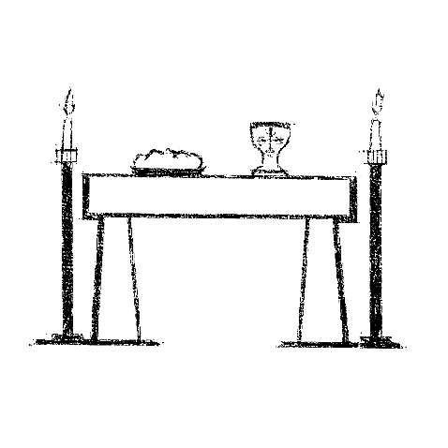All who hunger and thirst, come.

The table is ready.

**Communion Hymn**

**Communion**

The body of Christ, given for you. **Amen.**

The blood of Christ, shed for you. **Amen.**

**POST COMMUNION BLESSING**

The body and blood of our Lord Jesus Christ

strengthen you and keep you in God's grace.

**Amen.**

**SONG AFTER COMMUNION**

**Prayer after Communion**

Lord of life,

in the gift of your body and blood

you turn the crumbs of our faith into a feast of salvation.

Send us forth into the world with shouts of joy,

bearing witness to the abundance of your love

in Jesus Christ, our Savior and Lord.

**Amen.**

**SENDING**

God blesses us and sends us in mission to the world.

**MISSION Statement**

Let us announce together:

**The mission of Resurrection Lutheran Church is to promote**

**spiritual growth in Christ and service to all people.**

**Blessing**

People of God,

you are Christ’s body,

bringing new life to a suffering world.

The holy Trinity, ☩ one God,

bless you now and forever.

**Amen.**

**Sending Song: When Memory Fades (FINLANDIA)**

**Dismissal**

Go in peace. The living Word dwells in you.

**Thanks be to God.**



**Texts for November 14, 2021**

Daniel 12:1-3

Psalm 16

Hebrews 10:11-14 [15-18] 19-25

Mark 13:1-8

From sundaysandseasons.com. Copyright © 2021 Augsburg Fortress. All rights reserved. Used by permission.