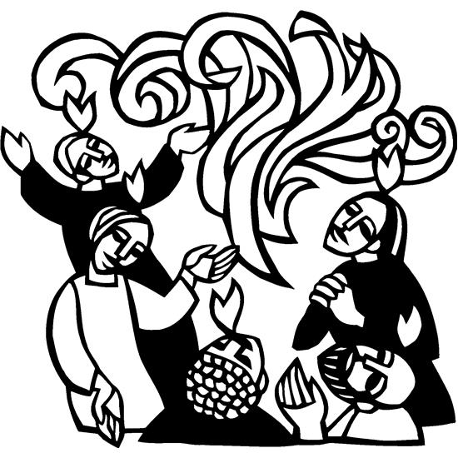

**Welcome to**

**Resurrection Lutheran Church**

740 West 10th Street, Juneau, Alaska 99801

Office: (907) 586-2380 [rlcoffice@ak.net](mailto:rlcoffice@ak.net)

Pastor: (907) 885-6824 (voice only) [rlcpastor@ak.net](mailto:rlcpastor@ak.net)

(808) 782-6653 (text and voice)

[www.rlcjuneau.org](http://www.rlcjuneau.org) [www.rlclive.org](http://www.rlclive.org)

May 23, 2021 **Day of Pentecost**

**Introduction to the day**

*Fifty days after Easter, we celebrate the outpouring of the Holy Spirit on Pentecost. Crossing all boundaries that would separate us, the Spirit brings the wideness of God’s mercy to places we least expect it—to a crowd of strangers of different lands and tongues, to dry bones, to our weak hearts. Jesus promises his disciples that they will be accompanied by the Holy Spirit, and that this Spirit reveals the truth. We celebrate that we too have been visited with this same Spirit. Guided by the truth, we join together in worship, and then disperse to share the fullness of Christ’s love with the world.*

**Prelude: Spirit of God, Descend Upon My Heart**

Celebration Ringers

**GATHERING**

The Holy Spirit calls us together as the people of God.

**WELCOME AND ANNOUNCEMENTS**

### Confession and Forgiveness

Blessed be the holy Trinity, ☩ one God,

the God of manna,

the God of miracles,

the God of mercy.

**Amen.**

Drawn to Christ and seeking God’s abundance,

let us confess our sin.

*Silence is kept for reflection.*

God, our provider,

**help us.**

**It is hard to believe there is enough to share.**

**We question your ways when they differ from the ways**

**of the world in which we live.**

**We turn to our own understanding**

**rather than trusting in you.**

**We take offense at your teachings and your ways.**

**Turn us again to you.**

**Where else can we turn?**

**Share with us the words of eternal life**

**and feed us for life in the world.**

**Amen.**

Beloved people of God:

in Jesus, the manna from heaven,

you are fed and nourished.

By Jesus, the worker of miracles,

there is always more than enough.

Through Jesus, ☩ the bread of life,

you are shown God’s mercy:

you are forgiven and loved into abundant life.

**Amen.**

**Gathering Hymn: God of Tempest, God of Whirlwind**



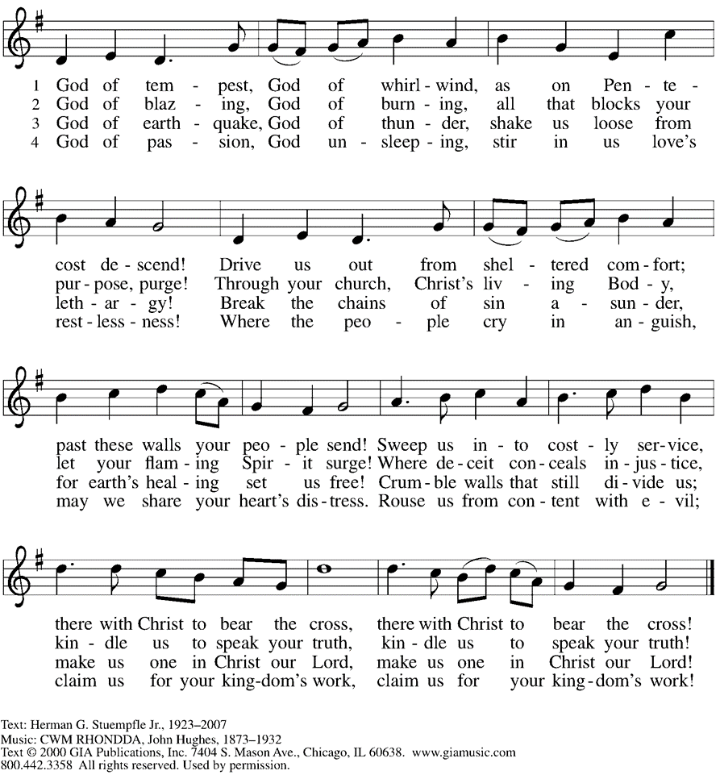

**Greeting**

The grace of our Lord Jesus Christ, the love of God,

and the communion of the Holy Spirit be with you all.

**And also with you.**

**Kyrie**

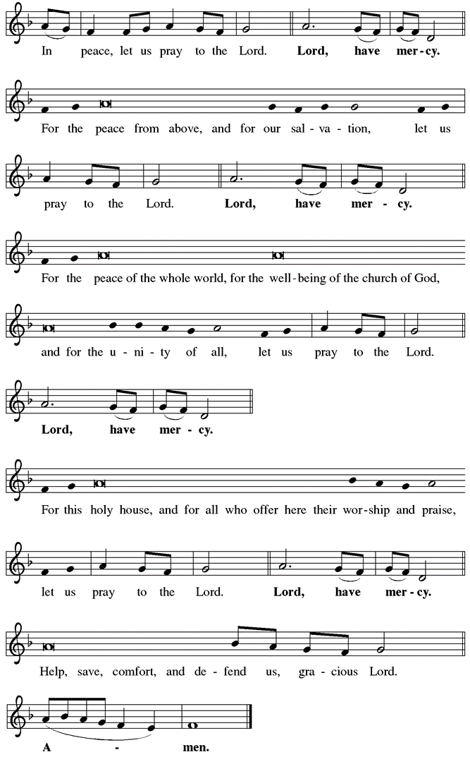



**Hymn of Praise**



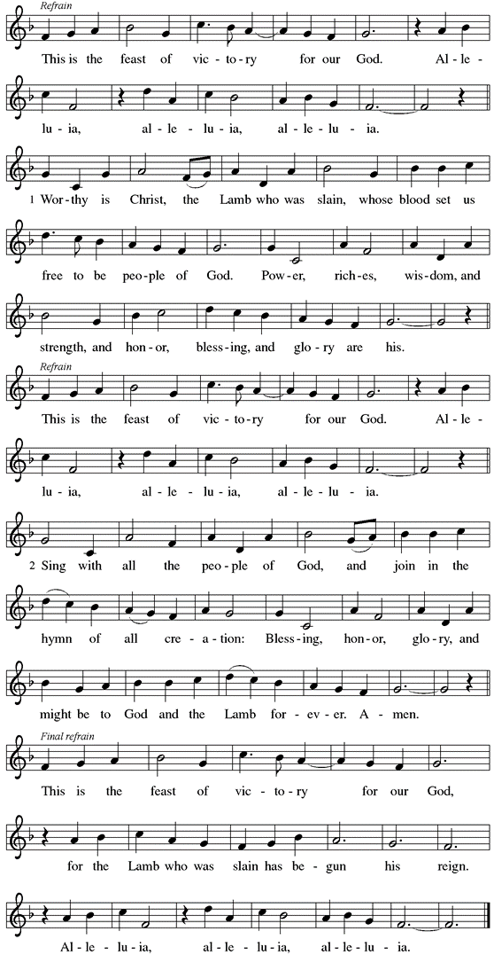

**Prayer of the Day**

Let us pray.

Mighty God, you breathe life into our bones, and your Spirit brings truth to the world. Send us this Spirit, transform us by your truth, and give us language to proclaim your gospel, through Jesus Christ, our Savior and Lord, who lives and reigns with you and the Holy Spirit, one God, now and forever.

**Amen.**

**WORD**

God speaks to us in scripture reading, preaching, and song.

**First Reading: Acts 2:1-21**

*Originally Pentecost was a Jewish thanksgiving-type festival celebrated seven weeks after Passover. On this particular Pentecost, however, the Holy Spirit is poured out upon the entire community of believers just as Jesus had promised and the scriptures had prophesied. Empowered by the Spirit, the entire community bears witness to God’s activity in multiple languages.*

A reading from Acts.

1When the day of Pentecost had come, [the apostles] were all together in one place. 2And suddenly from heaven there came a sound like the rush of a violent wind, and it filled the entire house where they were sitting. 3Divided tongues, as of fire, appeared among them, and a tongue rested on each of them. 4All of them were filled with the Holy Spirit and began to speak in other languages, as the Spirit gave them ability.  
  5Now there were devout Jews from every nation under heaven living in Jerusalem. 6And at this sound the crowd gathered and was bewildered, because each one heard them speaking in the native language of each. 7Amazed and astonished, they asked, “Are not all these who are speaking Galileans? 8And how is it that we hear, each of us, in our own native language? 9Parthians, Medes, Elamites, and residents of Mesopotamia, Judea and Cappadocia, Pontus and Asia, 10Phrygia and Pamphylia, Egypt and the parts of Libya belonging to Cyrene, and visitors from Rome, both Jews and proselytes, 11Cretans and Arabs—in our own languages we hear them speaking about God’s deeds of power.” 12All were amazed and perplexed, saying to one another, “What does this mean?” 13But others sneered and said, “They are filled with new wine.”  
  14But Peter, standing with the eleven, raised his voice and addressed them, “Men of Judea and all who live in Jerusalem, let this be known to you, and listen to what I say. 15Indeed, these are not drunk, as you suppose, for it is only nine o’clock in the morning. 16No, this is what was spoken through the prophet Joel:  
 17‘In the last days it will be, God declares,  
 that I will pour out my Spirit upon all flesh,  
  and your sons and your daughters shall prophesy,  
 and your young men shall see visions,  
  and your old men shall dream dreams.  
 18Even upon my slaves, both men and women,  
  in those days I will pour out my Spirit;  
   and they shall prophesy.  
 19And I will show portents in the heaven above  
  and signs on the earth below,  
   blood, and fire, and smoky mist.  
 20The sun shall be turned to darkness  
  and the moon to blood,  
   before the coming of the Lord’s great and glorious day.  
 21Then everyone who calls on the name of the Lord shall be saved.’ ”

The word of the Lord.

**Thanks be to God.**

**Psalm: Psalm 104:24-34, 35b**

*Send forth your Spirit and renew the face of the earth.*(Ps. 104:30)

24How manifold are your works, O Lord!  
  In wisdom you have made them all; the earth is full of your creatures.  
 25**Yonder is the sea, great and wide, with its swarms too many to number,**  
  **living things both small and great.**  
 26There go the ships to and fro,  
  and Leviathan, which you made for the sport of it.  
 27**All of them look to you**  
  **to give them their food in due season.**   
 28You give it to them; they gather it;  
  you open your hand, and they are filled with good things.  
 29**When you hide your face, they are terrified;**  
  **when you take away their breath, they die and return to their dust.**  
 30You send forth your Spirit, and they are created;  
  and so you renew the face of the earth.  
 31**May the glory of the Lord endure forever;**  
  **O Lord, rejoice in all your works.**   
 32You look at the earth and it trembles;  
  you touch the mountains and they smoke.  
 33**I will sing to the Lord as long as I live;**  
  **I will praise my God while I have my being.**  
 34May these words of mine please God.  
  I will rejoice in the Lord.  
 35b**Bless the Lord, O my soul.**  
  **Hallelujah!**

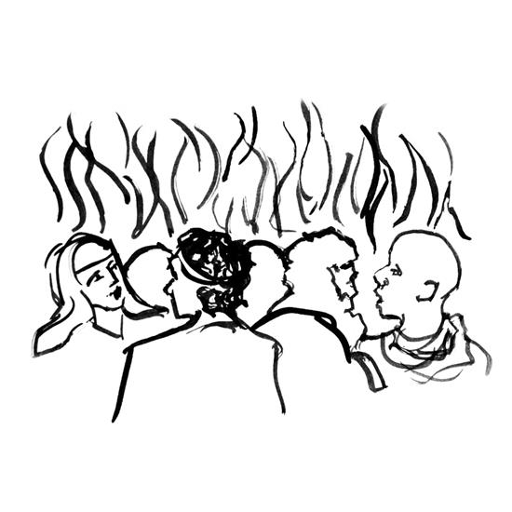

**Second Reading: Romans 8:22-27**

*By pouring the Holy Spirit into our hearts, God gives us the promised first fruit of eternal life so that we await God’s future in hope. In the meantime, the Spirit also intercedes for us by carrying the prayers of our weak human hearts to God.*

A reading from Romans.

22We know that the whole creation has been groaning in labor pains until now; 23and not only the creation, but we ourselves, who have the first fruits of the Spirit, groan inwardly while we wait for adoption, the redemption of our bodies. 24For in hope we were saved. Now hope that is seen is not hope. For who hopes for what is seen? 25But if we hope for what we do not see, we wait for it with patience.  
  26Likewise the Spirit helps us in our weakness; for we do not know how to pray as we ought, but that very Spirit intercedes with sighs too deep for words. 27And God, who searches the heart, knows what is the mind of the Spirit, because the Spirit intercedes for the saints according to the will of God.

The word of the Lord.

**Thanks be to God.**

**Reflection** Mike Schroeder

**Special Music: I’m Gonna Sing When the Spirit Says Sing**

Celebration Ringers

**Gospel Acclamation**



**Gospel: John 15:26-27; 16:4b-15**

*While speaking to his disciples before his death, Jesus refers to the Holy Spirit as “the Helper” and describes the difference the Spirit will make in their lives and in the world.*

The holy gospel according to John.

**Glory to you, O Lord.**

[Jesus said,] 26“When the Advocate comes, whom I will send to you from the Father, the Spirit of truth who comes from the Father, he will testify on my behalf. 27You also are to testify because you have been with me from the beginning.  
 16:4b“I did not say these things to you from the beginning, because I was with you. 5But now I am going to him who sent me; yet none of you asks me, ‘Where are you going?’ 6But because I have said these things to you, sorrow has filled your hearts. 7Nevertheless I tell you the truth: it is to your advantage that I go away, for if I do not go away, the Advocate will not come to you; but if I go, I will send him to you. 8And when he comes, he will prove the world wrong about sin and righteousness and judgment: 9about sin, because they do not believe in me; 10about righteousness, because I am going to the Father and you will see me no longer; 11about judgment, because the ruler of this world has been condemned.  
  12“I still have many things to say to you, but you cannot bear them now. 13When the Spirit of truth comes, he will guide you into all the truth; for he will not speak on his own, but will speak whatever he hears, and he will declare to you the things that are to come. 14He will glorify me, because he will take what is mine and declare it to you. 15All that the Father has is mine. For this reason I said that he will take what is mine and declare it to you.”

The gospel of the Lord.

**Praise to you, O Christ.**

**Message** Randy Sutak

**Hymn of the Day: O Living Breath of God**



**NicEne Creed**

**We believe in one God,**

**the Father, the Almighty,**

**maker of heaven and earth,**

**of all that is, seen and unseen.**

**We believe in one Lord, Jesus Christ,**

**the only Son of God,**

**eternally begotten of the Father,**

**God from God, Light from Light,**

**true God from true God,**

**begotten, not made,**

**of one Being with the Father.**

**Through him all things were made.**

**For us and for our salvation**

**he came down from heaven;**

**by the power of the Holy Spirit**

**he became incarnate from the virgin Mary,**

**and was made man.**

**For our sake he was crucified under Pontius Pilate;**

**he suffered death and was buried.**

**On the third day he rose again**

**in accordance with the Scriptures;**

**he ascended into heaven**

**and is seated at the right hand of the Father.**

**He will come again in glory to judge the living and the dead,**

**and his kingdom will have no end.**

**We believe in the Holy Spirit, the Lord, the giver of life,**

**who proceeds from the Father and the Son.**

**With the Father and the Son he is worshiped and glorified.**

**He has spoken through the prophets.**

**We believe in one holy catholic and apostolic Church.**

**We acknowledge one Baptism for the forgiveness of sins.**

**We look for the resurrection of the dead,**

**and the life of the world to come. Amen**

**PRAYER REFRAIN**



**Prayers of Intercession**

Alive in the risen Christ by the power of the Holy Spirit, we bring our prayers before God who promises to hear us and answer in steadfast love.

Gracious God, you give the Holy Spirit to your church, filling it with many and varied gifts. In the church throughout the world, strengthen us in our visioning and dreaming, that it may discover anew the Spirit’s creative work. Hear us, O God.

**Your mercy is great.**

God of life, your mighty works are too numerous to count. The earth is full of your creatures, living things both great and small. Open your hand and give them the necessities of this life. Send your fresh Spirit over the face of the earth. Hear us, O God.

**Your mercy is great.**

God of the nations, at the sound of the rushing wind, people speaking different languages proclaimed and heard together your deeds of power. Fill the leaders of nations with your Holy Spirit, so that they exercise your gracious will in the lives of people. Hear us, O God.

**Your mercy is great.**

God of faithfulness, you tend to the needs of your people, even the sighs of our hearts. Hear those who cry out to you in distress. Restore to wholeness all who are in any need this day. Hear us, O God.

**Your mercy is great.**

God of love, fill this congregation Resurrection Lutheran with gratitude for the gifts we have received from you. Renew our ministries, heal our divisions, and open us to the needs of our neighbors. Hear us, O God.

**Your mercy is great.**

God of guidance, you promised the disciples they would be accompanied by the Holy Spirit. Reveal your truth to those in leadership. We pray for: ELCA Bishop Elizabeth Eaton, Alaska Synod Bishop Shelly Wickstrom, and Bishop Terry Brandt of our sister synod; the Alaska Southeast Cluster, Pastor Karen Perkins; for Christ Lutheran Church, Soldotna and for all who strive to serve your kingdom. Hear us, O God.

**Your mercy is great.**

For what else do the people of God pray?

God of hope, those who have died in you raise their eternal song of praise. We give you thanks for the many gifts of your people and rejoice in the witness of your saints. Hear us, O God.

**Your mercy is great.**

In the hope of new life in Christ, we raise our prayers to you, trusting in your never-ending goodness and mercy; through Jesus Christ our Lord.

**Amen.**

**REPEAT PRAYER REFRAIN**

**PEACE**

The peace of the Lord be with you always.

**And also with you.**

We greet each other with a gesture of peace. We are incorporating social-distancing recommendations at this time, so a nod, wave, phone call or email are most appropriate. This greeting is a sign of the risen Christ who unites us and calls us to recognize the peace of God in one another.

**MEAL**

God feeds us with the presence of Jesus Christ.

**OFFERING**

**Presentation of the Gifts**



**Offering Prayer**

God of love,

you call us beloved children and welcome us to your table.

Receive our lives and the gifts we offer.

Abide with us and send us in service to a suffering world;

for the sake of your beloved Child, Jesus Christ.

**Amen.**



**GREAT tHANKSGIVING**

**Dialogue**

The Lord be with you.

**And also with you.**

Lift up your hearts.

**We lift them to the Lord.**

Let us give thanks to the Lord our God.

**It is right to give our thanks and praise.**

**Preface**

It is indeed right, our duty and our joy,

that we should at all times and in all places

give thanks and praise to you, almighty and merciful God,

through our Savior Jesus Christ.

Fulfilling the promise of the resurrection,

you pour out the fire of your Spirit,

uniting in one body people of every nation and tongue.

And so, with Mary Magdalene and Peter and all the witnesses of the resurrection,

with earth and sea and all their creatures,

and with angels and archangels, cherubim and seraphim,

we praise your name and join their unending hymn:

**HOLY, HOLY, HOLY**





**Thanksgiving at the Table**

Holy God,

Breath of life and Fire of love:

with a mighty wind you brought creation into being,

and by a pillar of fire you led your people into freedom.

We praise you for the gift of your Son,

who poured out your Spirit on his disciples of every race and nation.

In the night in which he was betrayed,

our Lord Jesus took bread, and gave thanks;

broke it, and gave it to his disciples, saying:

Take and eat; this is my body, given for you.

Do this for the remembrance of me.

Again, after supper, he took the cup, gave thanks,

and gave it for all to drink, saying:

This cup is the new covenant in my blood,

shed for you and for all people for the forgiveness of sin.

Do this for the remembrance of me.

Remembering, therefore,

his death, resurrection,

and the sending of the holy and life-giving Spirit,

we await his coming again to renew the face of the earth.

Send now your Holy Spirit upon us and upon this meal:

anoint us with your gifts of faith, hope, and love,

that, with thankful hearts,

we may be witnesses to your Son.

Through him all glory and honor is yours,

Almighty Father, with the Holy Spirit,

in your holy Church,

both now and forever.

**Amen**

**Lord’s Prayer**

Gathered into one by the Holy Spirit, let us pray as Jesus taught us.

**Our Father, who art in heaven,**

**hallowed be thy name,**

**thy kingdom come,**

**thy will be done,**

**on earth as it is in heaven.**

**Give us this day our daily bread;**

**and forgive us our trespasses,**

**as we forgive those**

**who trespass against us;**

**and lead us not into temptation,**

**but deliver us from evil.**

**For thine is the kingdom,**

**and the power, and the glory,**

**forever and ever. Amen.**

**Invitation to Communion**

The risen Christ invites us to this table.

Come, eat and be satisfied.

**Communion Distribution**

All are welcome to the communion table! God is the host and God's love extends to all people. During this period of social distancing due to the COVID-19, few in our community can be present at Resurrection. Nevertheless, there ***are*** ways for you to participate! We celebrate this holy meal as the community of peace, love and mercy.

* We have resources on our website to help you celebrate Holy Communion at home, either along with a live broadcast or at another time.
* Pastor Karen can bring the Eucharist to you at home. Please contact the office or Pastor Karen to make arrangements.

We would be happy to light a candle in thankfulness, of concern, or in memory of a person at your request.

**Communion Hymn**



**Communion**

The body of Christ, given for you.

**Amen.**

The blood of Christ, shed for you.

**Amen.**

**POST COMMUNION BLESSING**

The body and blood of our Lord Jesus Christ strengthen

you and keep you in God's grace.

**Amen.**

**SONG AFTER COMMUNION**



**Prayer after Communion**

Wellspring of joy,

through this meal you have put gladness in our hearts.

Satisfy the hunger still around us,

and send us as joyful witnesses,

that your love may bring joy to the hearts of all people,

through Jesus Christ our Lord.

**Amen.**

**SENDING**

God blesses us and sends us in mission to the world.

**MISSION Statement**

Let us announce together:

**The mission of Resurrection Lutheran Church is to promote**

**spiritual growth in Christ and service to all people.**

**Blessing**

May our glorious God grant you a spirit of wisdom

to know and to love the risen Lord Jesus.

The God of life,

Father, ☩ Son, and Holy Spirit,

bless you now and forever.

**Amen.**

**Sending HYMN: O Day Full of Grace**





**Dismissal**

Alleluia! Christ is risen.

**Christ is risen indeed. Alleluia!**

Go in peace. Share the good news. Alleluia!

**Thanks be to God. Alleluia!**

From sundaysandseasons.com. Copyright © 2021 Augsburg Fortress. All rights reserved. Used by permission.